Contents

COPYRIGHT NOTICE ...................................................................................................... II

DOCUMENT REVISION HISTORY ......................................................................................... I

CONTENTS ..................................................................................................................1

CONTEXT ....................................................................................................................3

DAY 1 ASSIGNMENTS .....................................................................................................3

ASSIGNMENT 1: CASE STUDY .................................................................................................. 3

ASSIGNMENT 2: OOP FEATURES ............................................................................................... 4

ASSIGNMENT 3: CLASSES AND OBJECTS ........................................................................................ 5

ASSIGNMENT 4: FIRST JAVA PROGRAM ........................................................................................ 6

ASSIGNMENT 5: LOCAL VARIABLES ............................................................................................. 8

ASSIGNMENT 6: OPERATORS ................................................................................................... 9

ASSIGNMENT 7: BOOLEAN DATA TYPE ....................................................................................... 10

ASSIGNMENT 8: BYTE DATA TYPE ........................................................................................... 11

DAY 2 ASSIGNMENTS ................................................................................................... 12

ASSIGNMENT 1: TYPECASTING ............................................................................................... 12

ASSIGNMENT 2: CONTROL STATEMENT ...................................................................................... 13

ASSIGNMENT 3: SWITCH CASE STATEMENT ................................................................................... 14

ASSIGNMENT 4: CLASSES AND OBJECTS ...................................................................................... 15

ASSIGNMENT 5: DEFAULT CONSTRUCTOR .................................................................................... 16

ASSIGNMENT 6: DEFAULT AND PARAMETERIZED CONSTRUCTORS .............................................................. 17

ASSIGNMENT 7: PASS BY VALUE AND REFERENCE ............................................................................. 18

ASSIGNMENT 8: CODING STANDARDS ......................................................................................... 19

ASSIGNMENT 9: USAGE OF “THIS” KEYWORD ................................................................................ 20

SELF REVIEW ................................................................................................................ 21

DAY 3 ASSIGNMENTS ................................................................................................... 23

ASSIGNMENT 1:STATIC VARIABLE, BLOCK AND METHOD ....................................................................... 23

ASSIGNMENT 2: 2D ARRAYS .................................................................................................. 24

ASSIGNMENT 3: MULTIDIMENSIONAL ARRAY(JAGGED ARRAY) ................................................................ 25

ASSIGNMENT 4:STRINGS ..................................................................................................... 25

ASSIGNMENT 5: JAVA DOC EXPLORATORY ASSIGNMENT ...................................................................... 27

ASSIGNMENT 6: USER INPUT(COMMAND LINE ARGUMENT) ................................................................... 27

ASSIGNMENT 7:COMMAND LINE ARGUMENT .................................................................................. 28

ASSIGNMENT 8:OVERLOADED METHODS ...................................................................................... 29

SELF REVIEW ................................................................................................................ 30

DAY 4 ASSIGNMENTS ................................................................................................... 33

ASSIGNMENT 1: INHERITANCE ................................................................................................ 33 ASSIGNMENT 2: ‘PROTECTED’ ACCESS SPECIFIER ............................................................................ 34

ASSIGNMENT 3: METHOD OVERRIDING ,SUPER KEYWORD AND DYNAMIC BINDING ............................................. 36

ASSIGNMENT 4: SUPER KEYWORD ............................................................................................ 38

ASSIGNMENT 5: CONSTRUCTOR INVOCATION ................................................................................. 42

ASSIGNMENT 6 : DYNAMIC POLYMORPHISM ................................................................................... 44

ASSIGNMENT 7:FINAL KEYWORD .............................................................................................. 45

ASSIGNMENT 8:ABSTRACT CLASS ............................................................................................ 47

REVIEW ...................................................................................................................... 48

DAY 5 ASSIGNMENTS ................................................................................................... 52

ASSIGNMENT 1: PACKAGE (CREATE, COMPILE & EXECUTE ) ................................................................. 52

ASSIGNMENT 2 : ACCESS SPECIFIER.......................................................................................... 57

ASSIGNMENT 3:INTERFACES .................................................................................................. 59

ASSIGNMENT 4: UML – USE CASE DIAGRAM ................................................................................. 60

ASSIGNMENT 5: UML – CLASS DIAGRAM ..................................................................................... 61

ASSIGNMENT 6: CASE STUDY OF D-RAIL INC. ................................................................................ 62

SELF REVIEW ................................................................................................................. 63

CASE STUDY BASED ASSIGNMENTS .................................................................................. 65

CASE STUDY 1 – BANKING SYSTEM ........................................................................................... 65 DAY 2 ASSIGNMENT 1: IF-ELSE CONDITION ................................................................................... 65

CASE STUDY 2 – TRAVEL MANAGEMENT SYSTEM .............................................................................. 65

DAY 2 ASSIGNMENT 1: IF-ELSE CONDITION ................................................................................... 65

DAY 3 ASSIGNMENT 2: STRINGS .............................................................................................. 66

DAY 4 ASSIGNMENT 3: INHERITANCE ......................................................................................... 67

Context

This document contains assignments to be completed as part of the hands on for the subject Introduction to Object Oriented Programming using Java.

Note: In order to complete the course, assignments in this document must be completed in the sequence mentioned.

Day 1 Assignments

Assignment 1: Case Study

Objective: Analysis of the case study and identify the complex system attributes and using OO features to overcome the same.

Problem Description: Course Management System

A Course Management System needs ~~to be develop~~ed for an engineering college. The college wants an automated system to replace its manual system for purpose of allocation of students to courses and lecturers to courses. There are 10000 students and 500 faculty members in the college. The engineering college provides graduation and post graduation in the various branches of engineering.

In any branch, the entire duration is divided into semesters. Each semester includes various courses. Students admitted into the college can apply for various courses. The courses are elective in nature. The student needs to select two electives. The electives are offered from 5th semester onwards for graduate students and from 3rd semester onwards for the post graduate students. The graduate students need to undergo a final year project in the fourth year of eng~~ineering whe~~reas the post graduate student undergoes a thesis submission in the second year. The complete list of courses, lecturers and students is maintained in the college. The list is constant and cannot be updated by the system. The automated system uses this list for allocation of courses.

The lecture~~rs can be cat~~egorized into full time lecturers and visiting members. The full time lecturers have target days and are paid salary every month. The visiting members get paid per lecture basis and do not have any target days.

The system is used by the admin staff to register students admitted to college to the courses opted. The system needs to be authenticated with a login id and password. The system would be used by the student to view the marks and the attendance details also. The system is used by the HOD (Head of the department) to allocate courses to the lecturers. At the beginning of the semester, the HOD will do the allocation of lecturers to the classes for his department. The HOD may make changes in the allocation during the progress of the course. The system maintains a history of all the lecturers who have handled the courses throughout the semester .The lecturer will use the system to update the marks of the student (project, assignment, internal test marks and the semester end examination marks). The lecturer will also mark the attendance of the students through the system.

In addition to the above, the system also keeps track of the residential status of the student. The student may be a host-elite or a day scholar. If he is host-elite, the system will maintain his / her hostels name, room number and the fees pertaining to the same.

Answer the following:

1. Identify two cases of hierarchy in the given problem statement
2. Identify the common behavior among the day scholar, host-elite, graduate and post graduate students
3. Identify the different layers possible in this system in terms of the users of the systems
4. 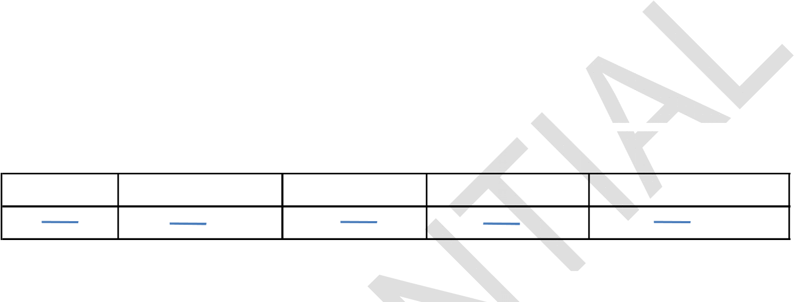The admin staff wants to generate a report containing the scores of students in a batch in the following manner:

Student Id Student Name Marks scored Lecturer Name Course registered

What details should the admin staff accumulate to arrive at this detailed report?

Estimated time: 20 mins

Summary of this assignment:

In this assignment, you have learnt

• To understand a complex software system and identify the attributes

Assignment 2: OOP features

Objective: Analyze the OOP features

Problem Description: Consider the case study provided in Assignment 1 for this assignment.

1. Identify the attributes of the Student class. What are the details that can be exposed and what details can be hidden?
2. Consider the calculation of grade for the Student. There are several student types. Let us assume that we need to write a method for the calculation. How many methods would be written? Will they have the same name and signature? Will the functionality /code in these functions remain same?
3. The fees have to be paid by the host-elite and by the day scholars. The host-elites need to pay hostel fees along with semester fees. The day scholars need to pay only semester fees. How many function/s would you code in the Student class and why?
4. For the options a,b and c identify the OOP features that would be implemented

Estimated time: 20 mins

Summary of this assignment:

In this assignment, you have learnt

* + Analyze a complex system and apply object oriented approach to solve the problem

Assignment 3: Classes and Objects

Objective: Understand the terms -class, objects, state, behavior and identity

Problem Description: Fill the crossword based on the clues given

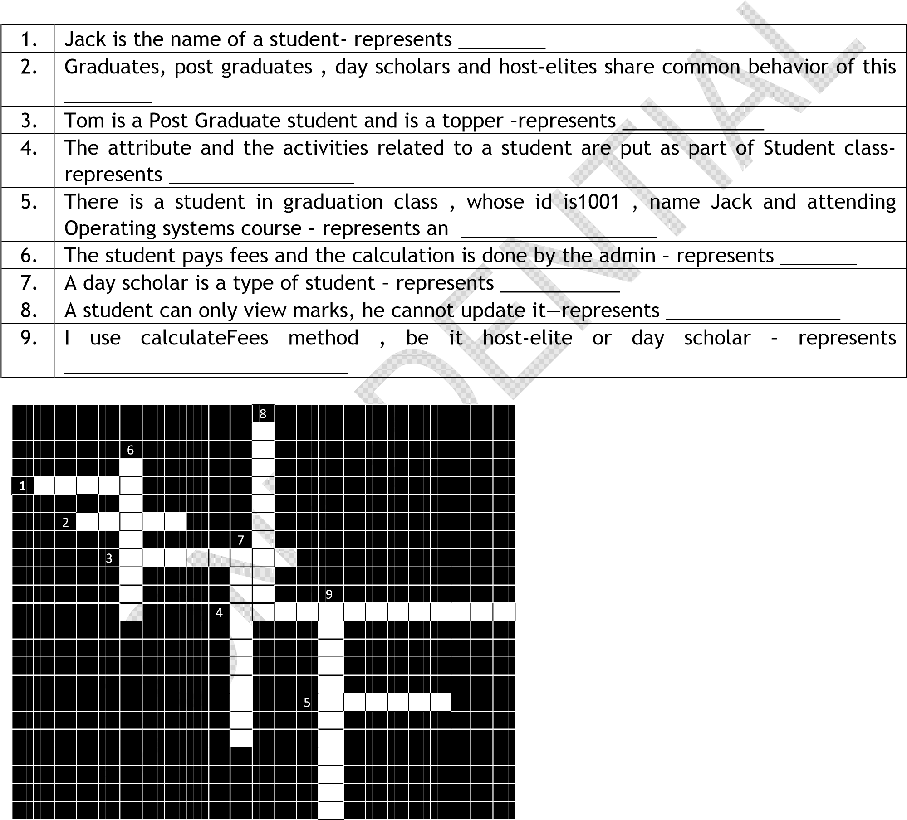

Estimated time: 20 mins

Summary of this assignment:

In this assignment, you have learnt

* + Object Oriented terminologies

Assignment 4: First Java Program

Objective: Create, save, compile and execute a Java Program using text pad.

Problem Description: To display “Welcome message” using Java program

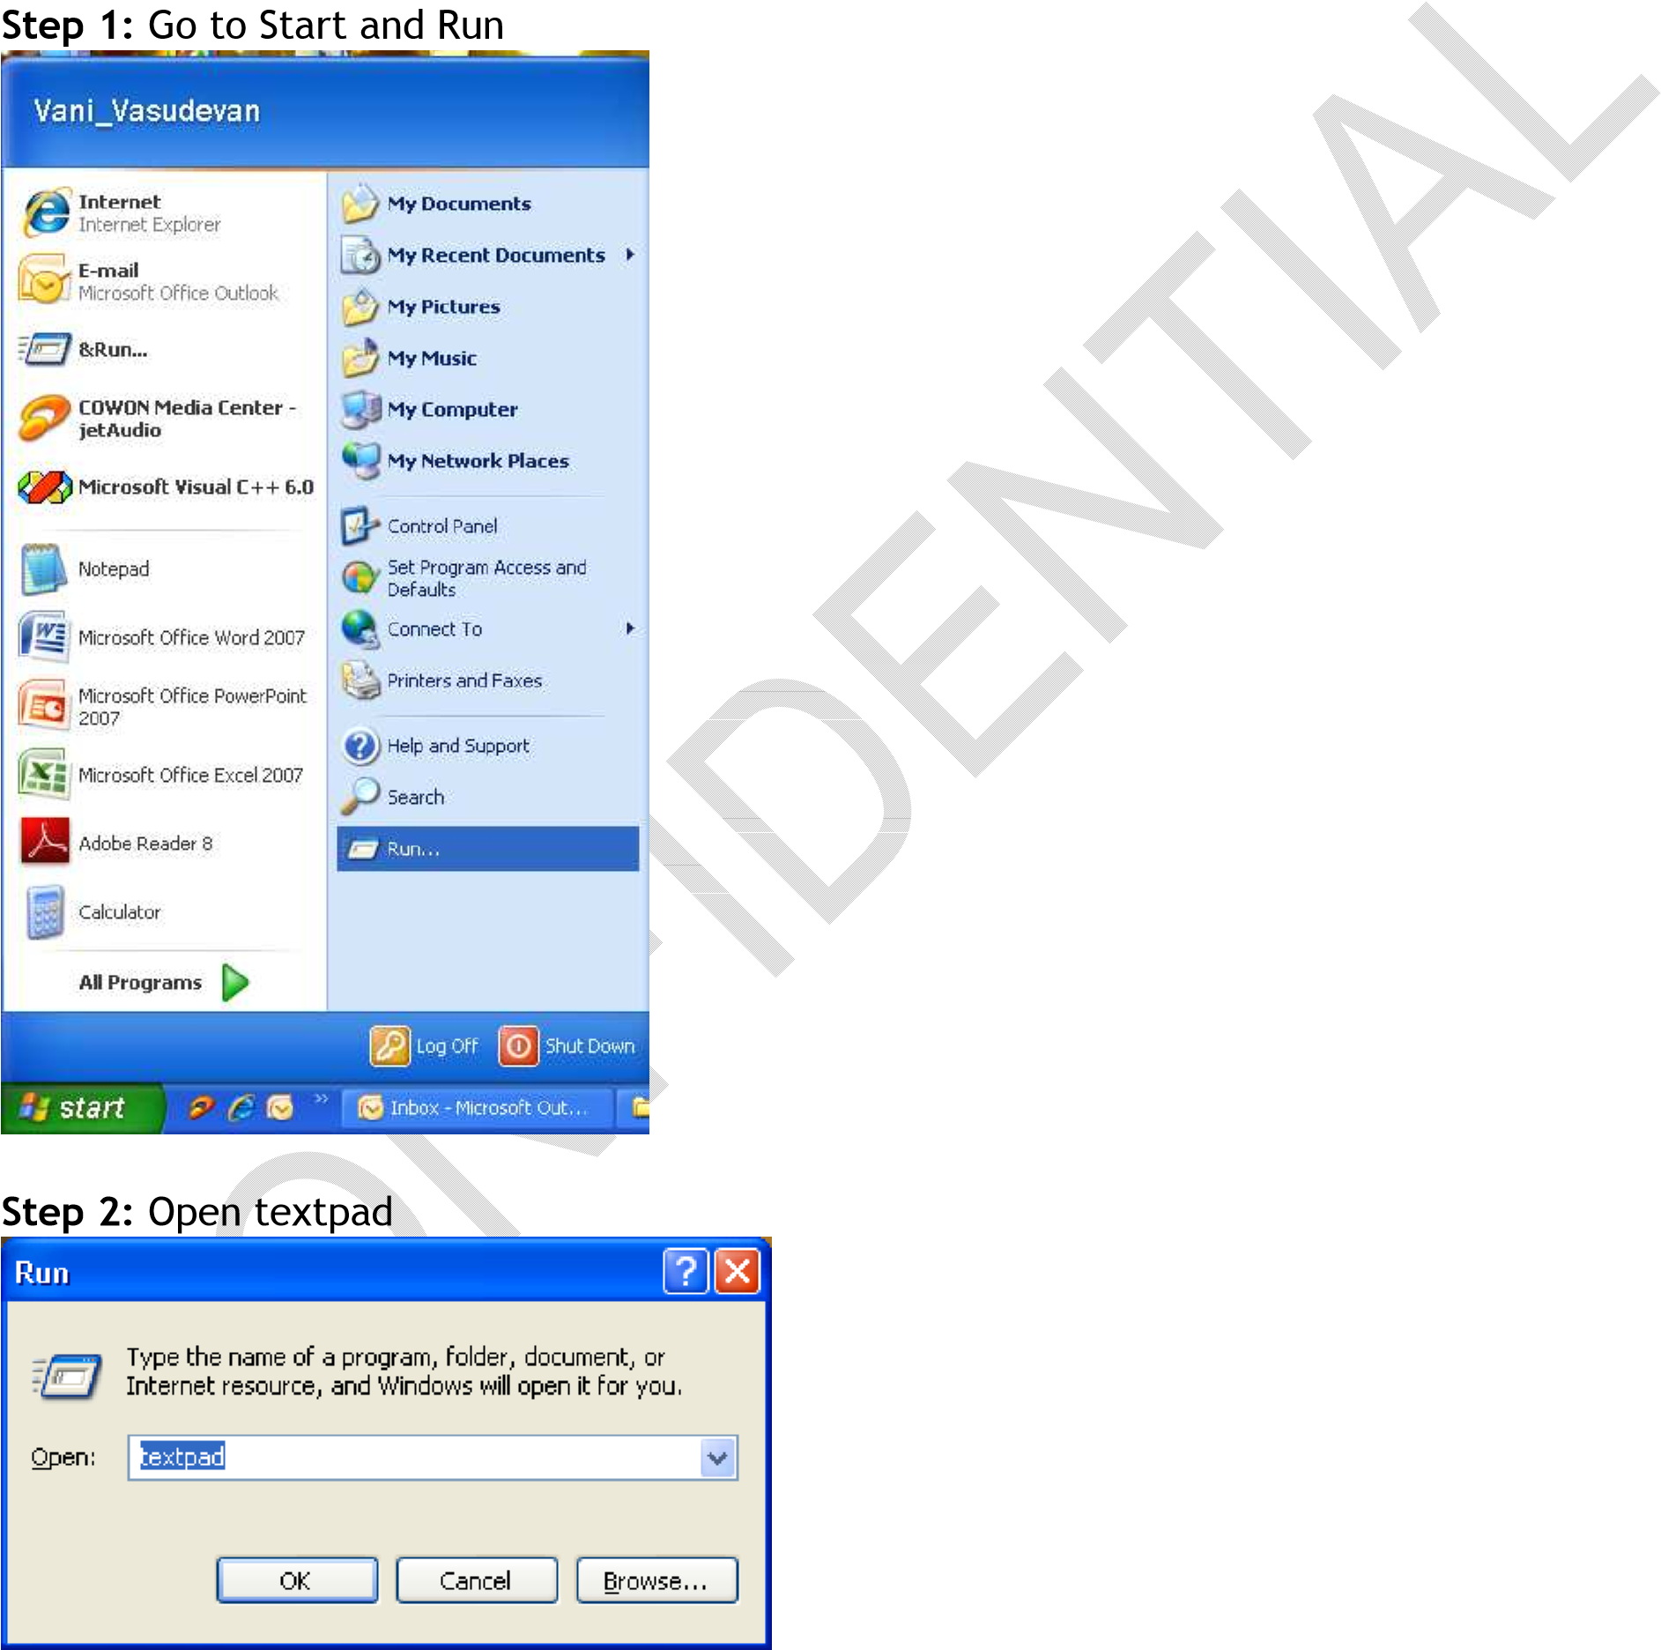

Step 3: Text editor is opened as below

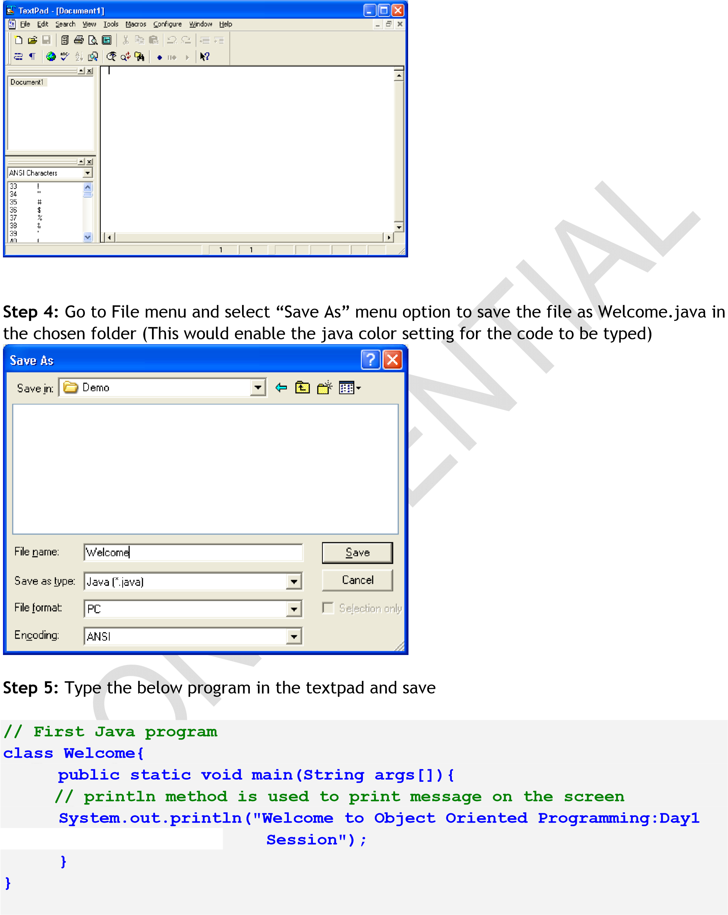

Step 6: Compile the program (press Ctrl + 1 or go to Tools menu and select “Compile Java”)

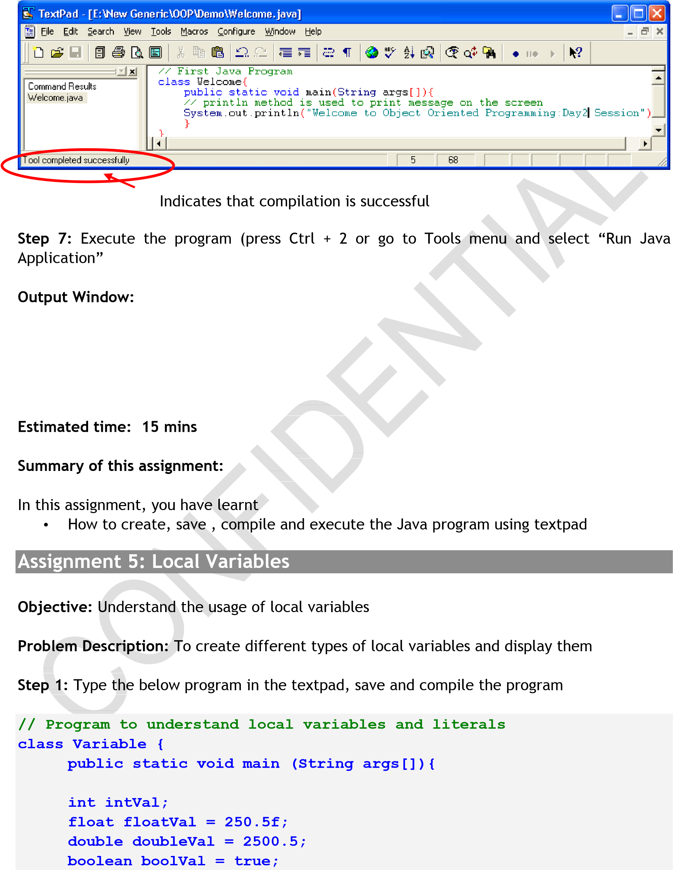

**System.out.println("Integer\t:" + intVal + "\nFloat\t:" + floatVal+"\nDouble\t:" + doubleVal + "\nBoolean\t:" + boolVal);**

**}**

**}**

Step 2: Observe that there is a compilation error. Debug the code so that it compiles and executes successfully.

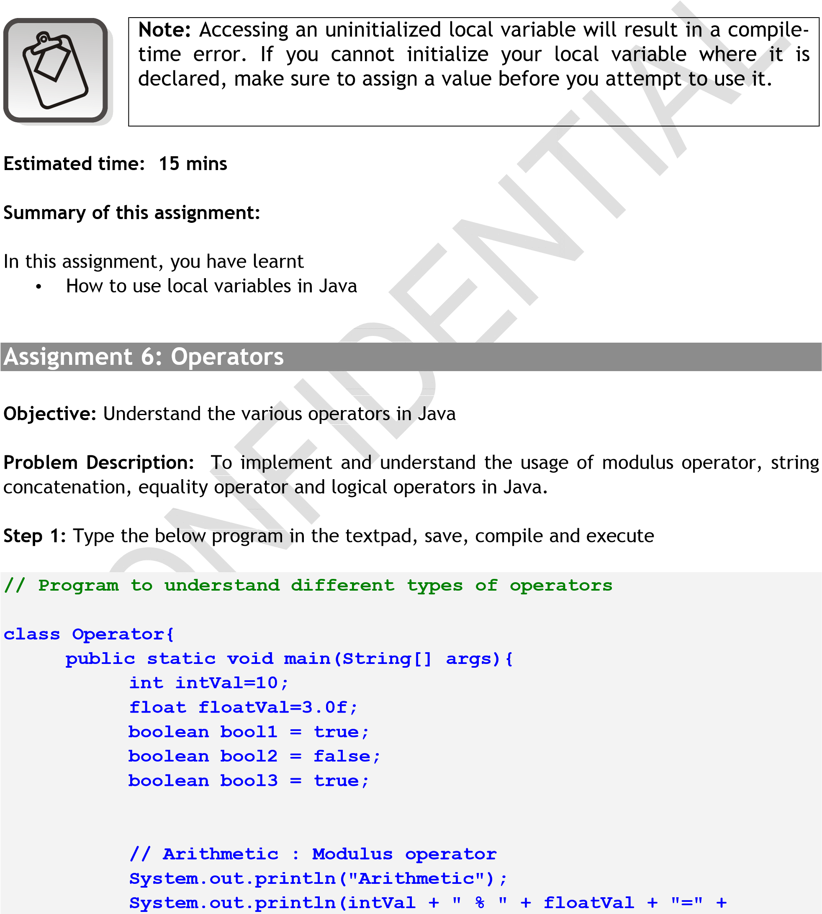

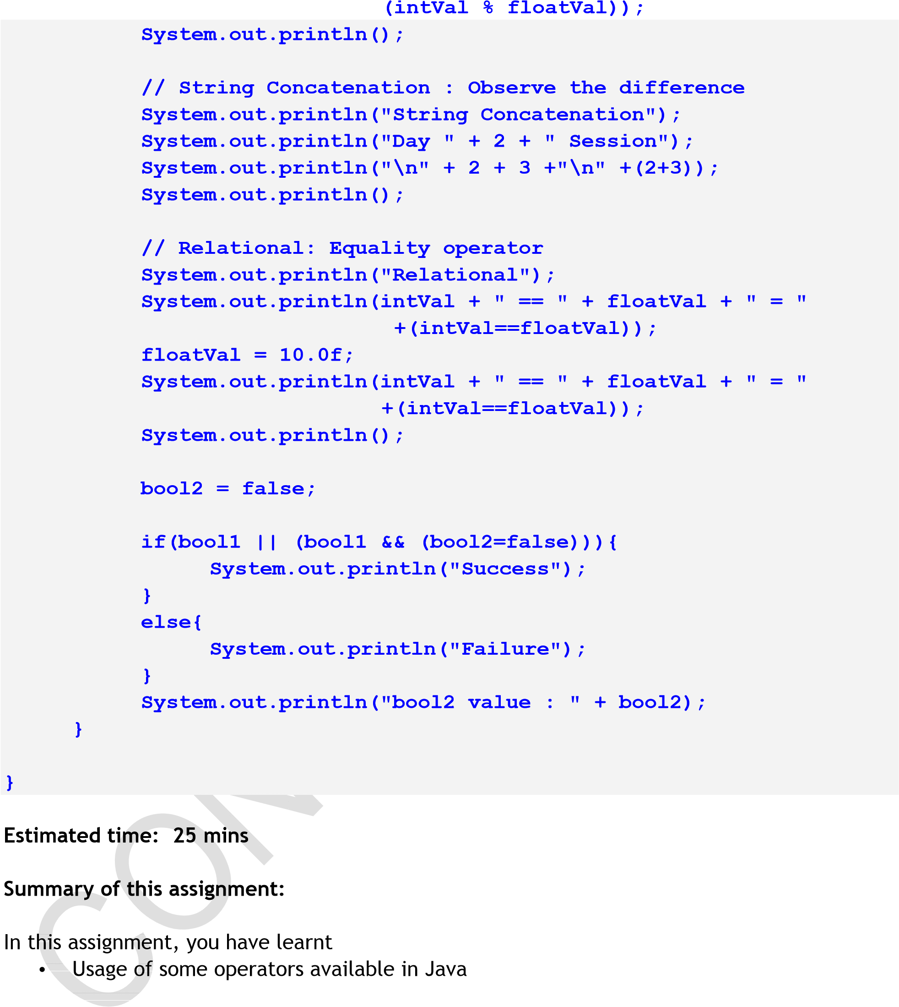

Assignment 7: Boolean Data Type

Objective: Understand the Boolean data type

Problem Description: To implement and understand the usage Boolean datatype in Java Step 1: Type the below program in the textpad and save the file Step 2: When executed, the output is :

Failure bool2 value : true

Press any key to continue . . .

Step 3: Make changes to the code so that the output reads :

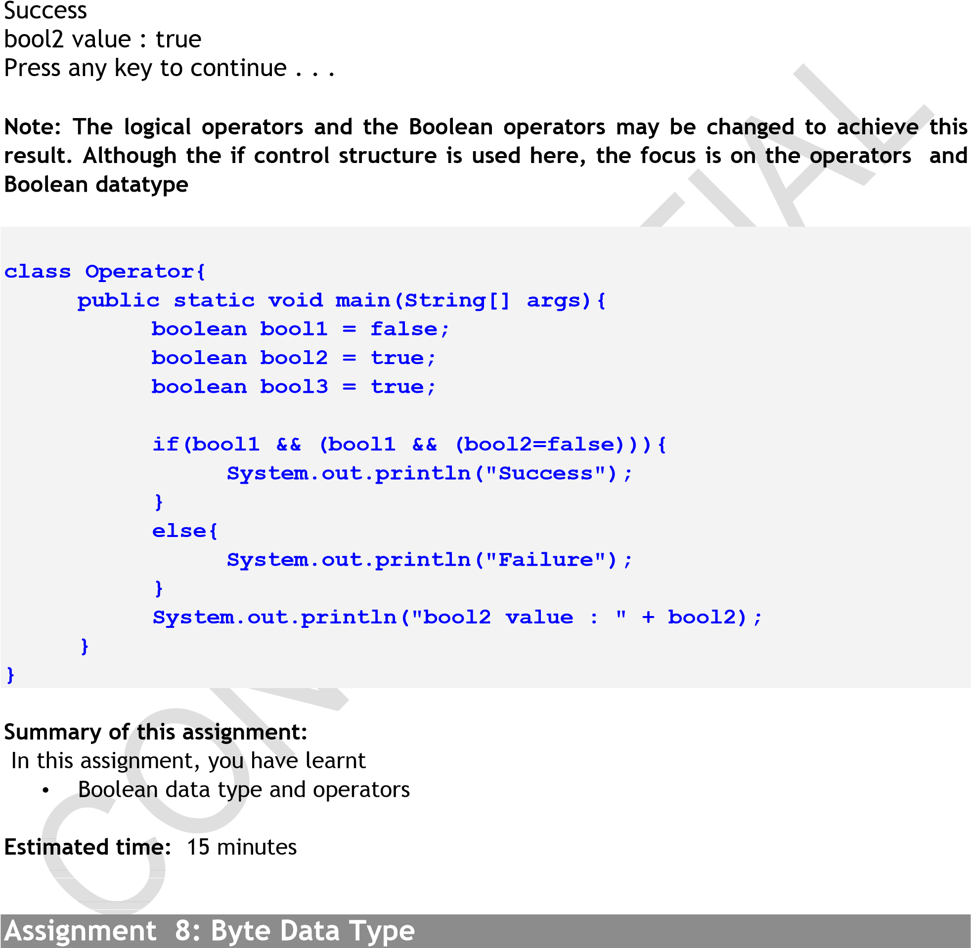

Objective: Understand the byte data type

Problem Description: Understand the range for datatypes and strong typechecking.

Step 1: Consider the program given below:

**public class Operator {**

|  |
| --- |
|  |

**public static void main(String args[]){**

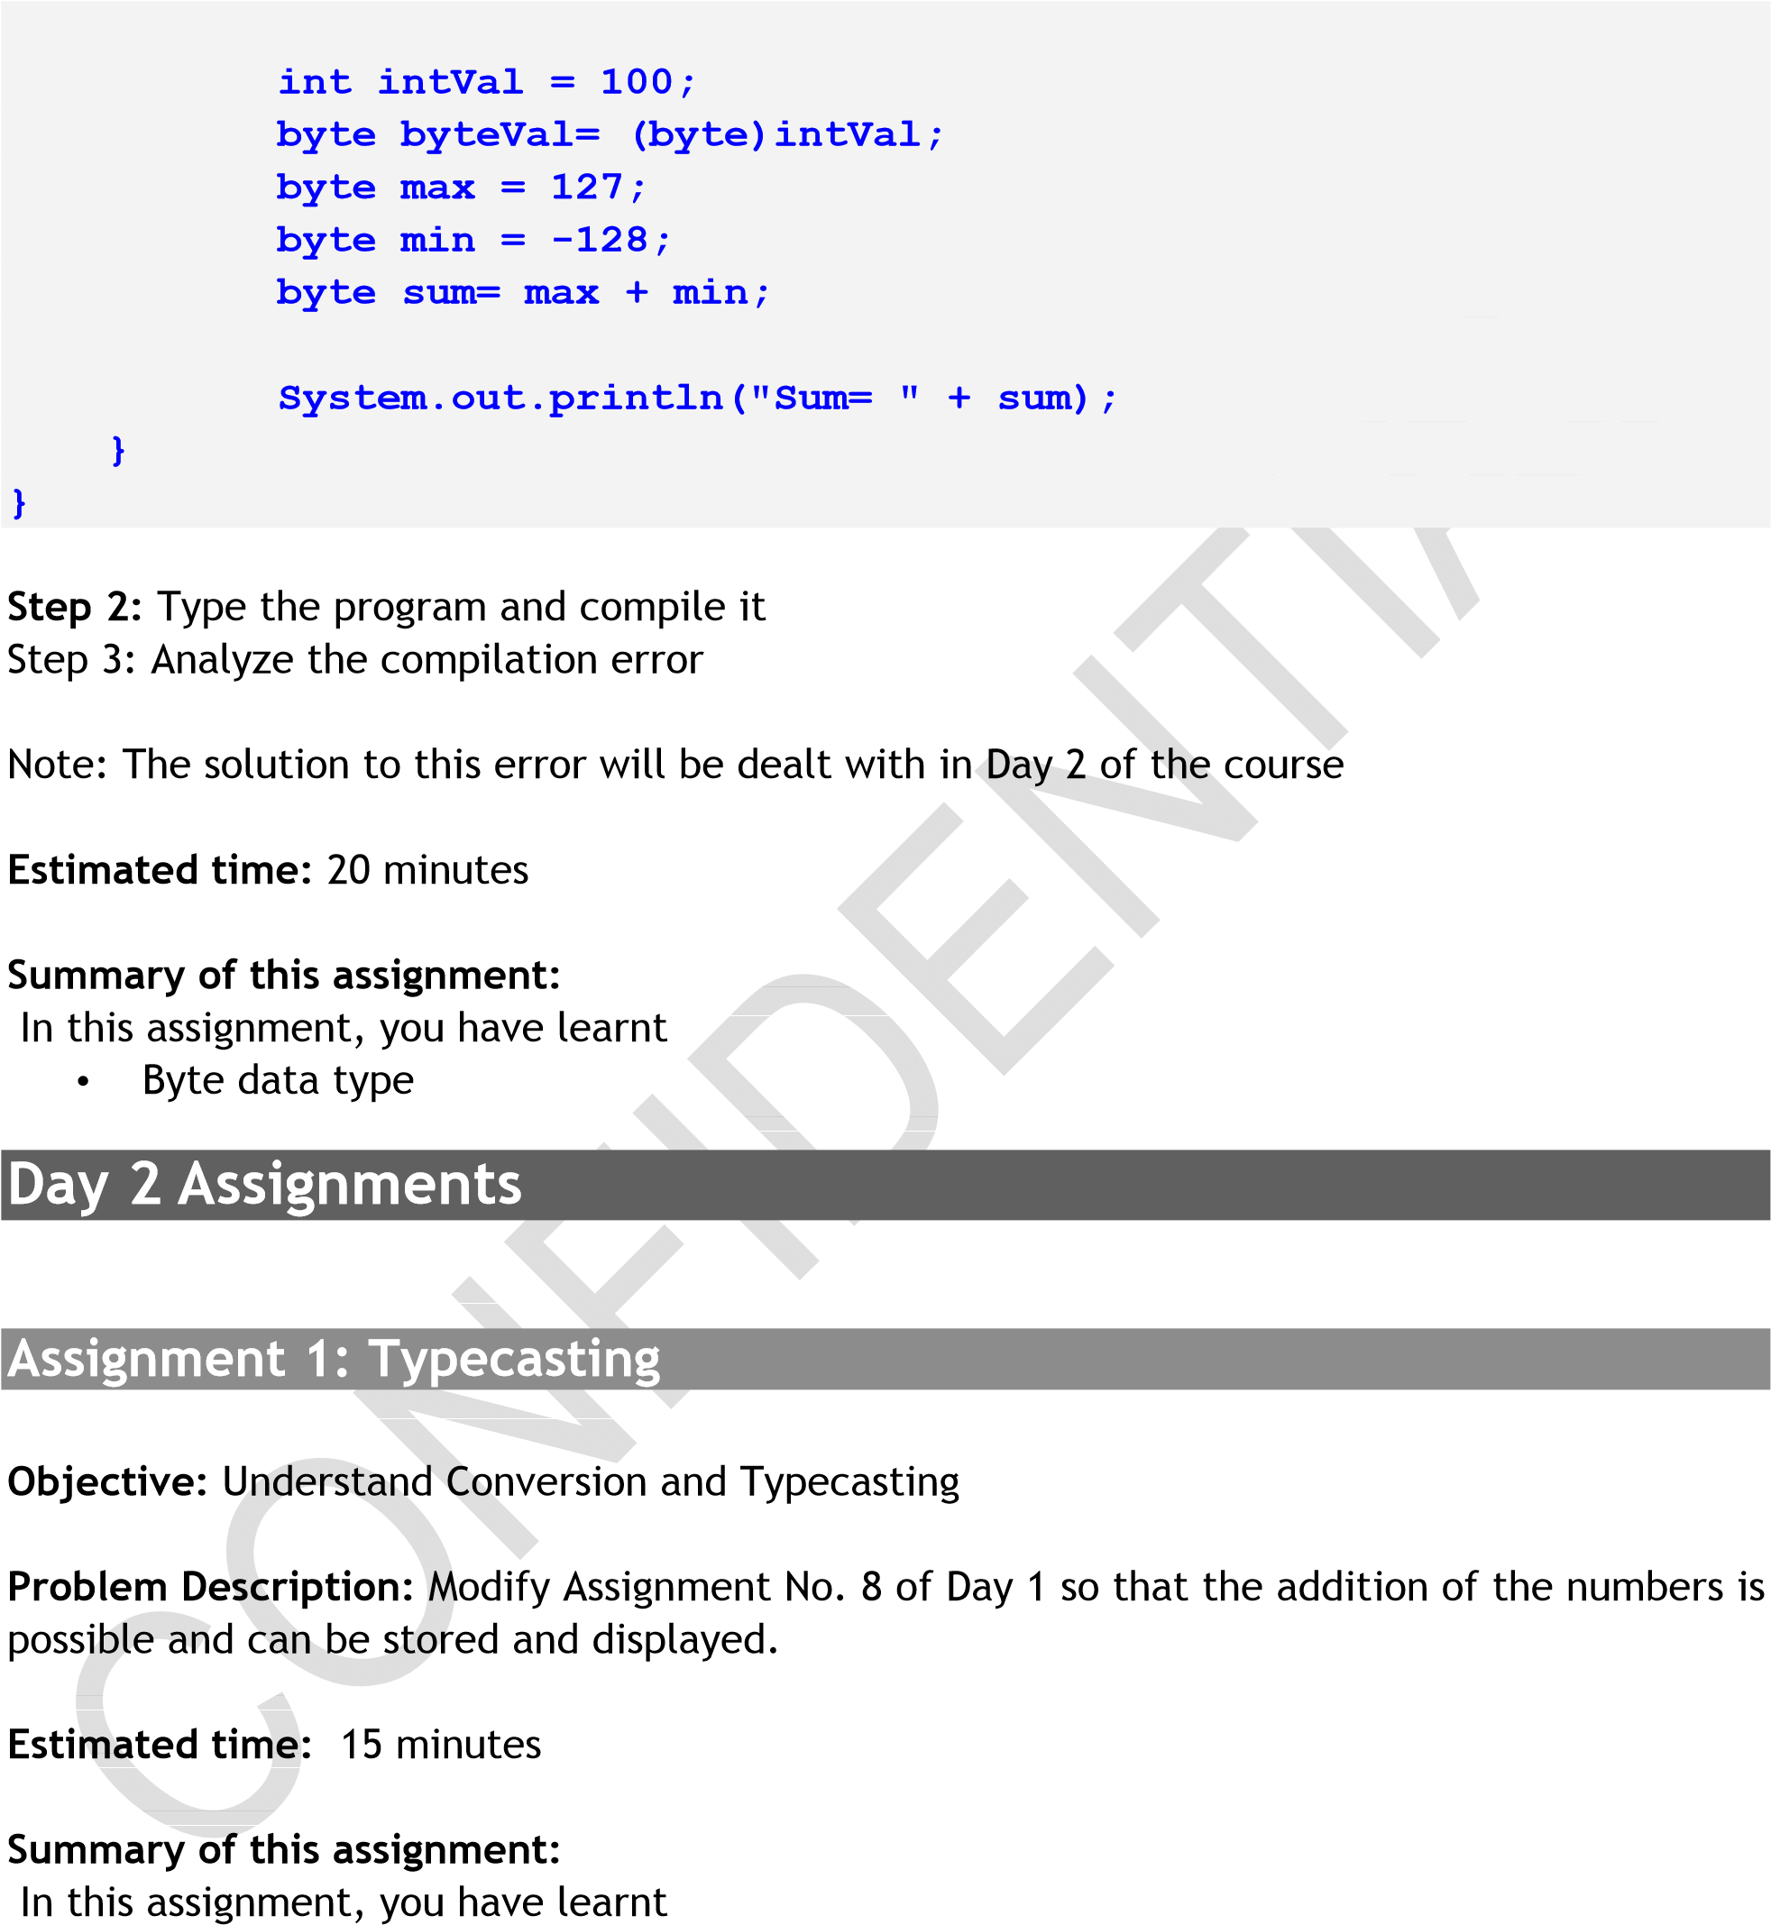

• Typecasting Data types

Assignment 2: Control Statement

Objective: Understand control statements

Problem Description: To implement control flow statements break and continue

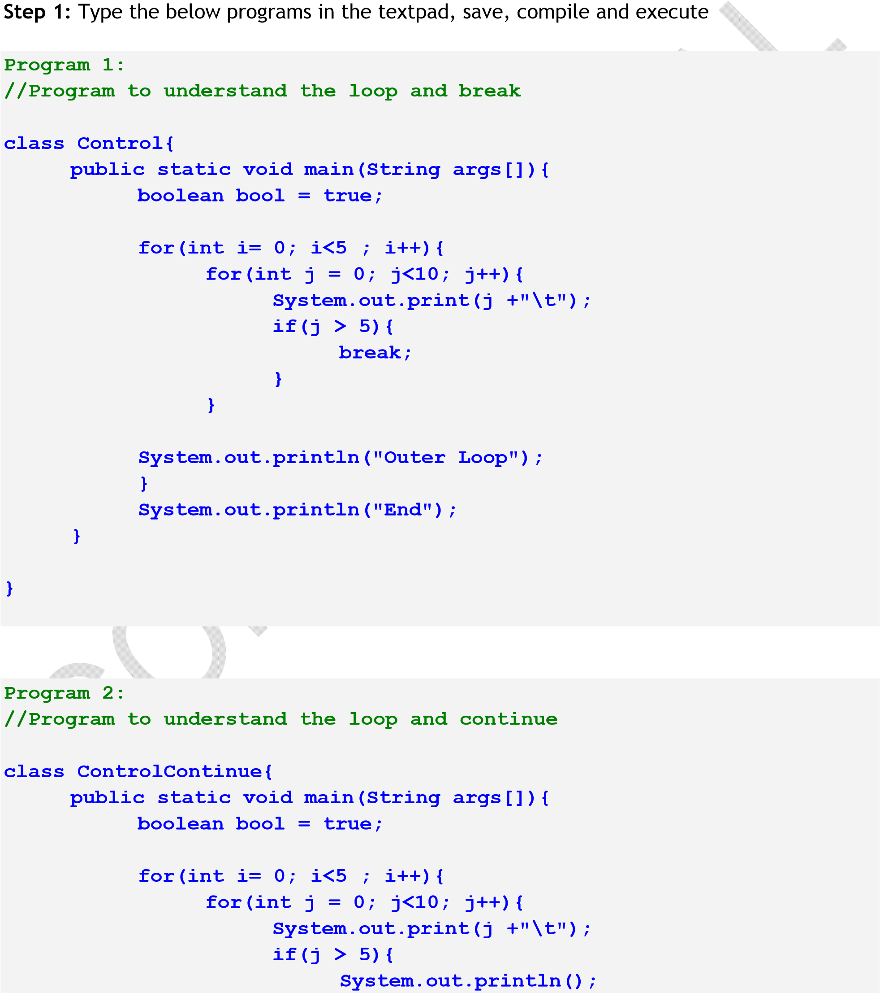

|  |  |  |  |  |  |
| --- | --- | --- | --- | --- | --- |
|  |  |  |  |  | **continue;** |

**}**

|  |  |  |  |
| --- | --- | --- | --- |
|  |  |  | **}** |

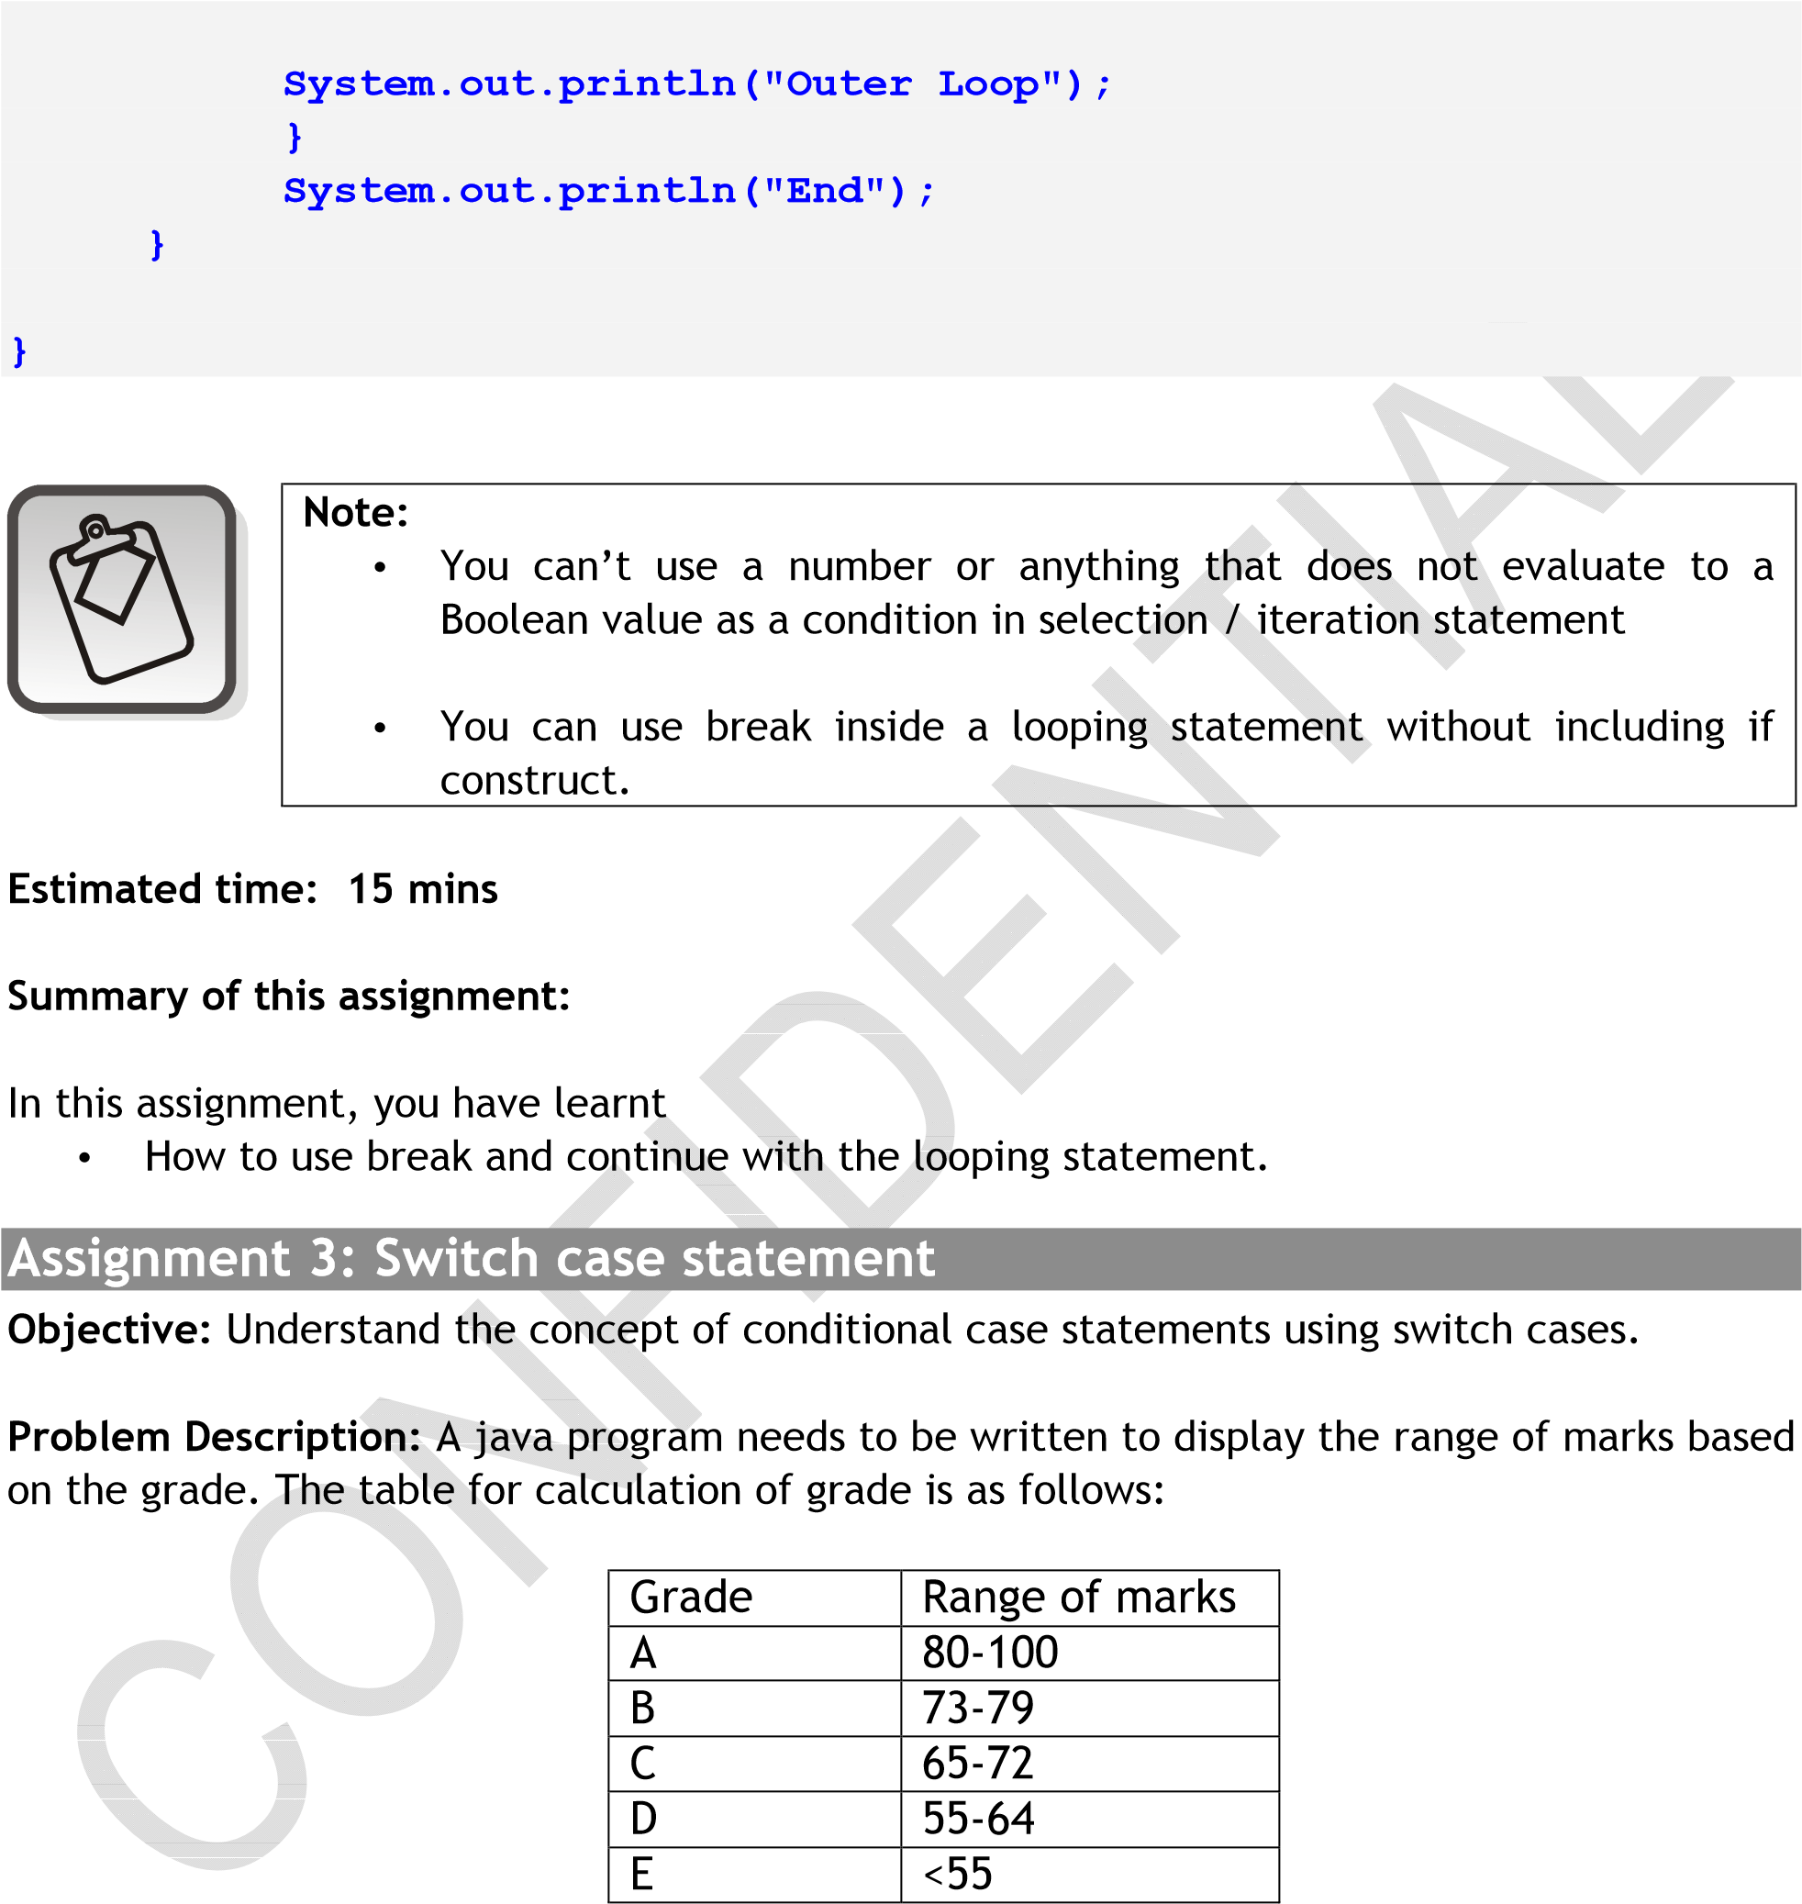

Step 1: Create a class called SwitchCase with the main method

Step 2: Create a character variable for storing the grade with a default value of B

Step 3: Write the java code to implement the calculation of grades as given in the table. If any other grade is provided , the program must display a message “Grade does not exist”,for valid grades it must display the range of marks as given in the table.

Step 4: Change the values of the grade variable and test the working of the program for all the grades.

Estimated time: 20 minutes

Summary of this assignment:

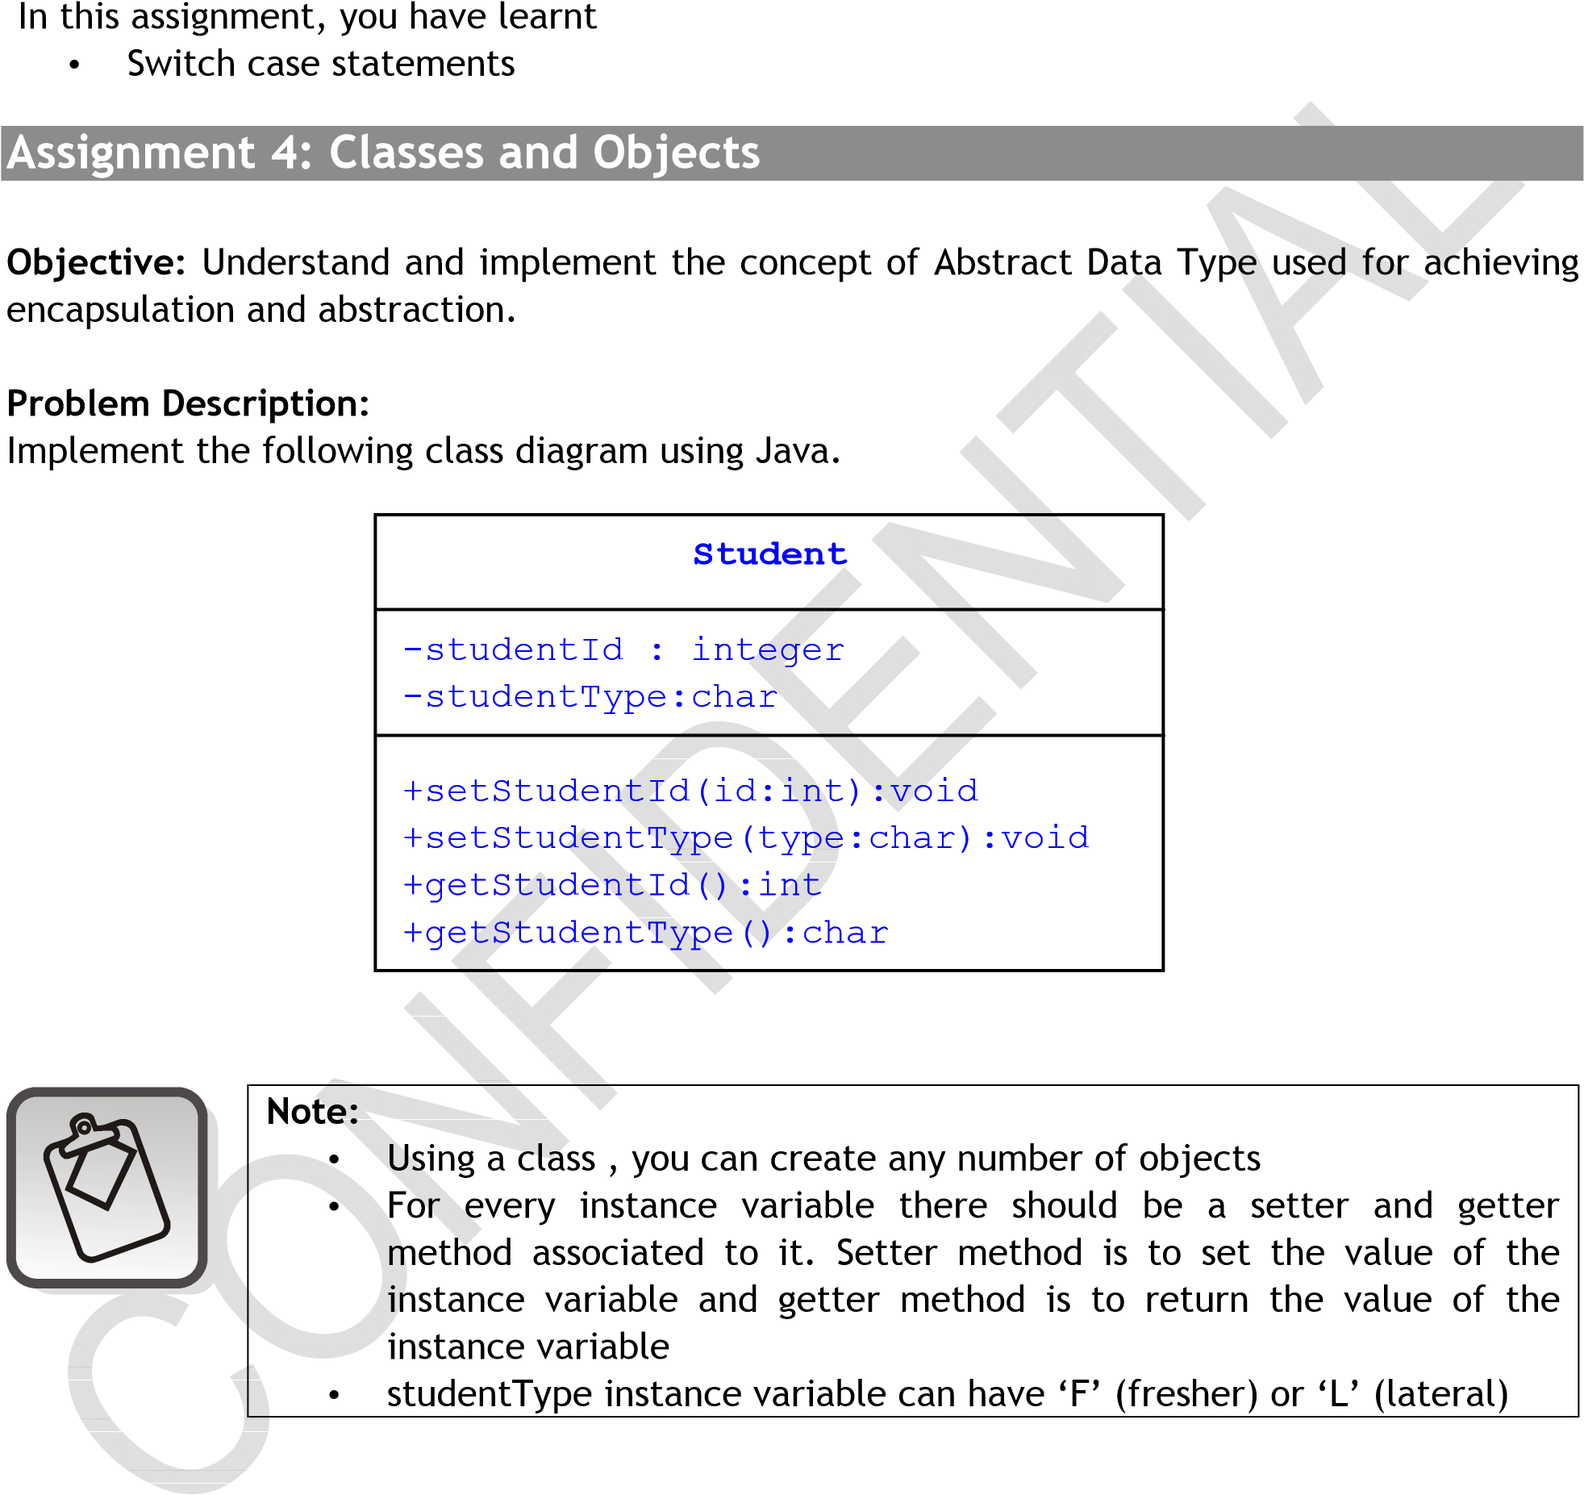

Step 1: Define a class “Student” and save it in Student.java

Step 2: Define all the member methods of Student Class

Step 3: Define a class “CourseManagement” with main method and save it in

CourseManagement.java

1. In the main method, assign the student details in the corresponding temporary variables.
2. Create a reference variable with the name student and instantiate the same
3. Invoke the corresponding setter methods to set the instance variable with the given values stored in temporary variables.
4. Using getter methods, display the student details.

Step 4: Compile the program, fix the errors if any

Step 5: Execute the program and verify the output

Estimated time: 30 mins

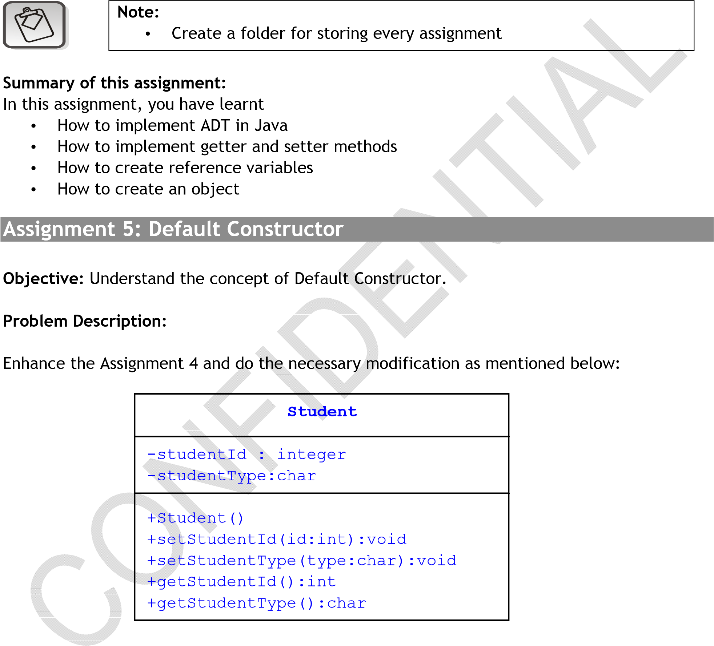

Step 1: Define constructor in Student class

Student (): initialize the instance variables with 10 and ‘F’ (indicated fresher) respectively

Step 2: Define a main method

* 1. In the main method, create a reference variable with the name student.
  2. Create an object of type Student and assign it to reference variable named student.
  3. Using getter methods, display the student details.

Step 3: Compile the program, fix the errors if any

Step 4: Execute the program and verify the output

Estimated time: 15 mins

Summary of this assignment:

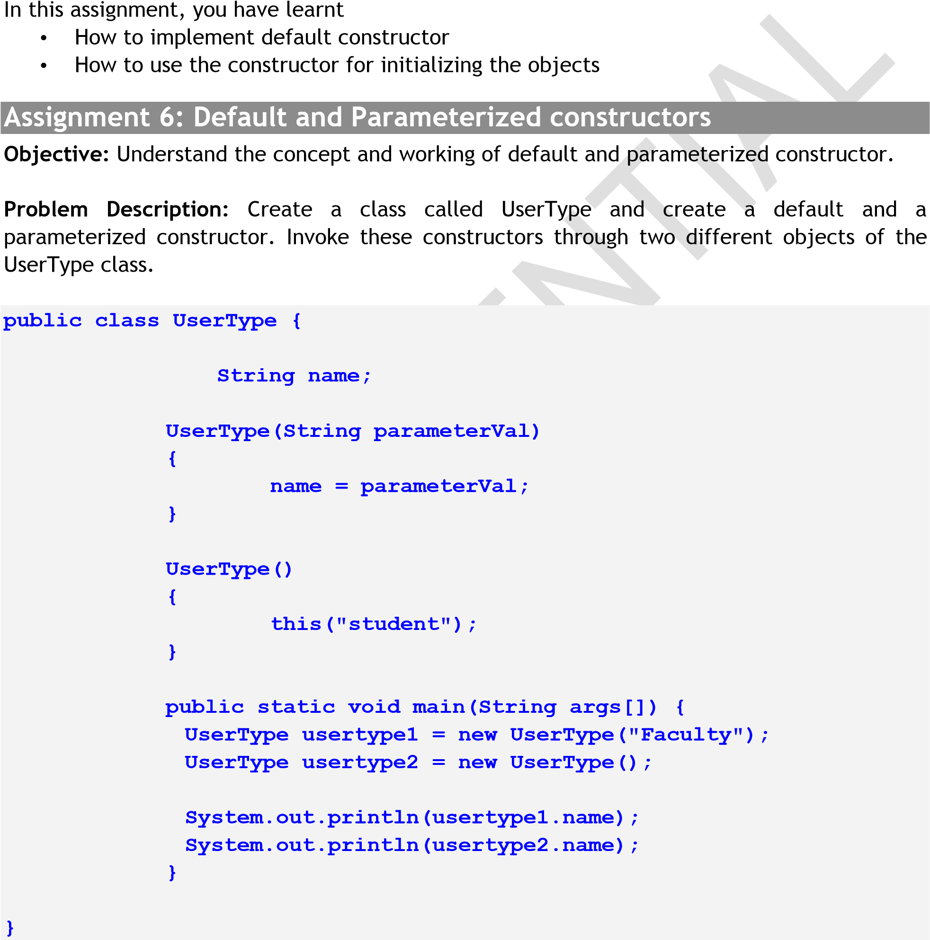

Estimated time: 15 minutes

Summary of this assignment:

In this assignment, you have learnt about

* Default and
* Parameterized constructors

Assignment 7: Pass By Value and reference

Objective: Understand passing of primitive and abstract data types .

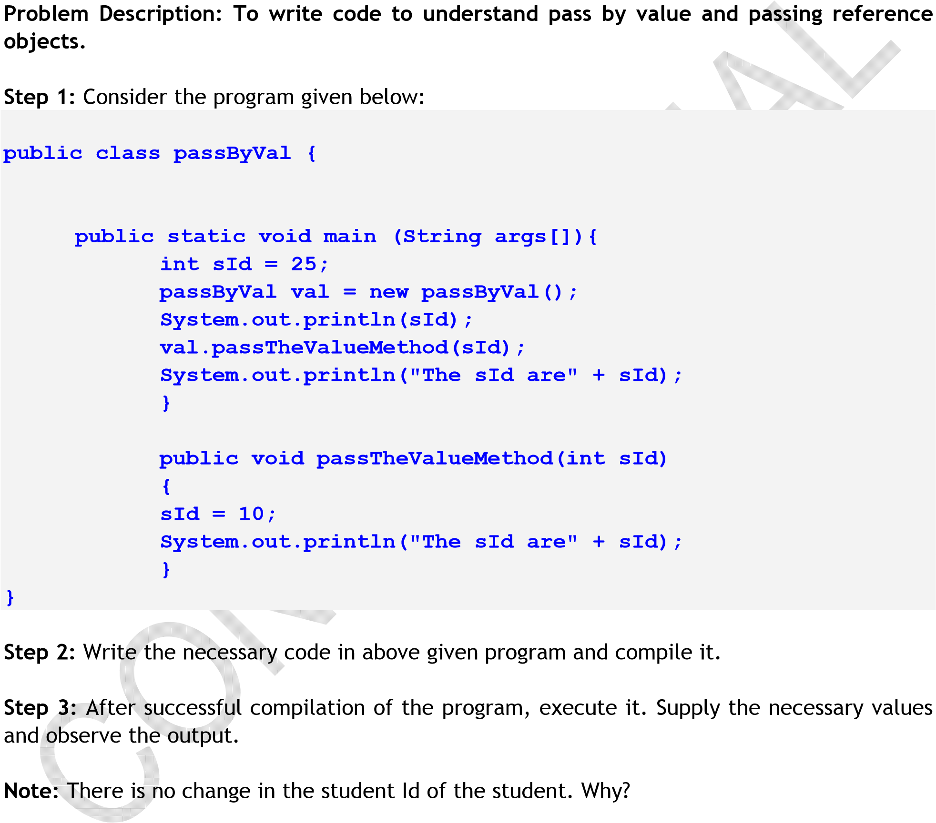

Step 5: Enhance this code by passing the object of Student class(created in earlier assignment) to the method passTheValueMethod().Change the value of Student Id and display the Student Id of the student.

Note: There is a change in the Student Id. Why?

Estimated time: 20 minutes

Summary of this assignment:

In this assignment, you have learnt

* Pass by value and Pass by reference

Assignment 8: Coding Standards

Objective: Understand and implement coding standards

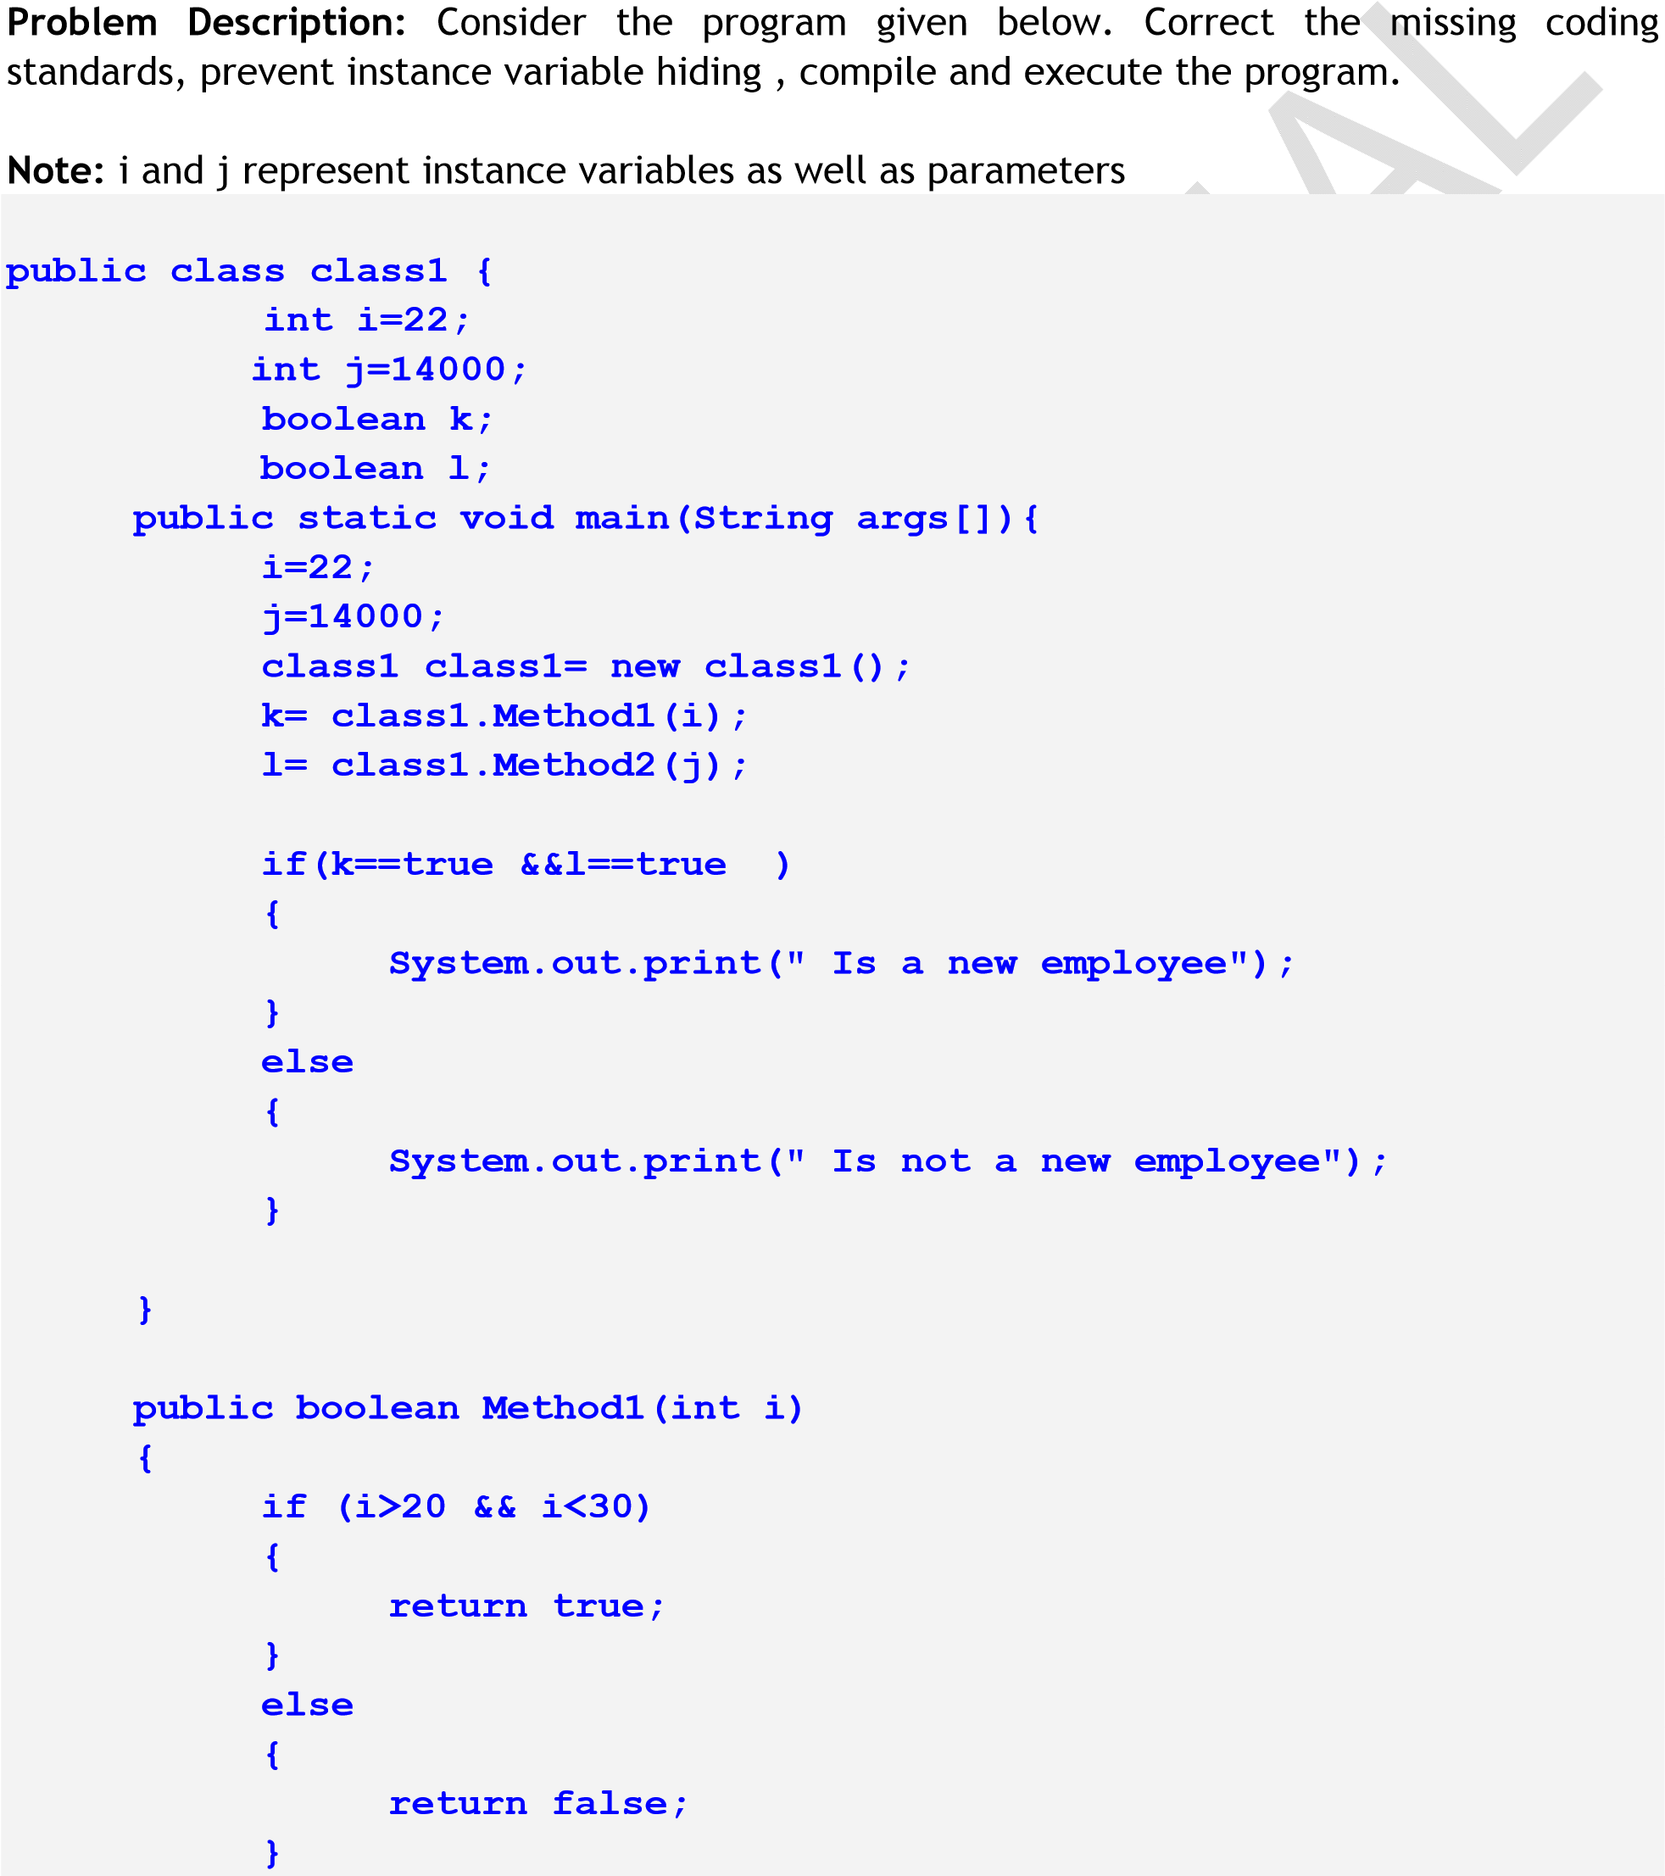

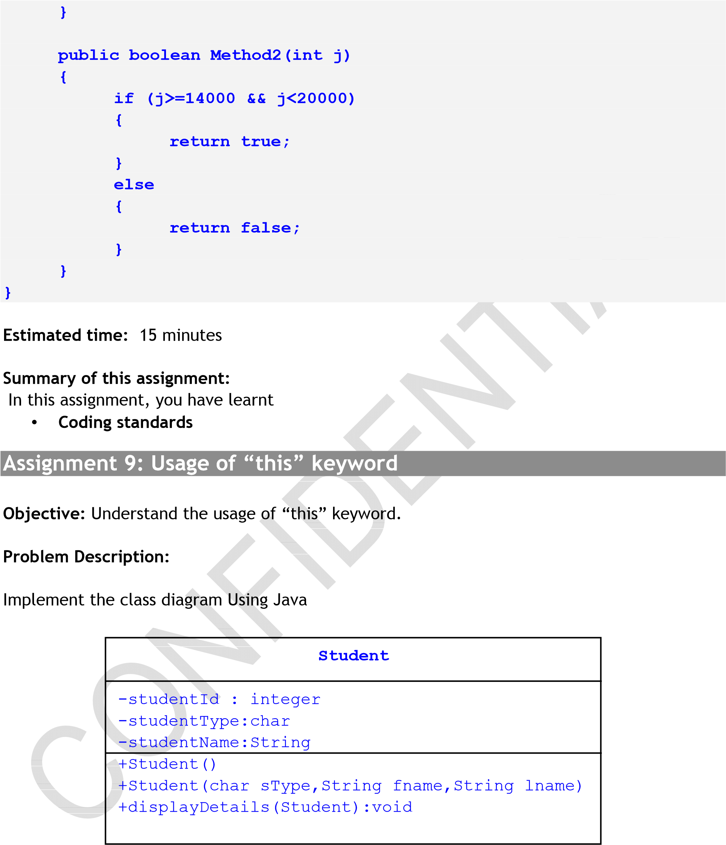

Step 1: Define a class Student , • Define two constructors o Default constructor: Used to increment the value of studentId for each objects of Student class. studentId should start from 550.

* + Parameterized constructor: Constructor with three arguments

StudentType(H/D),firstName and lastName

studentName=firstName+lastName o displayDetails (Student obj):Should accept the object as an argument and display the details like studentId, studentType, studentName of that object

Step 2: Define a main method , • In the main method o Create an object of Student(‘D’,”Bony”,”Thomas”) and assign it to reference variable studentOne;

* + Call the displayDetails() method and display the details of studentOne o Create an object of Student(‘H’,”Dinil”,”Bose”) and assign it to reference variable studentTwo; o Call the displayDetails() method and display the details of studentTwo

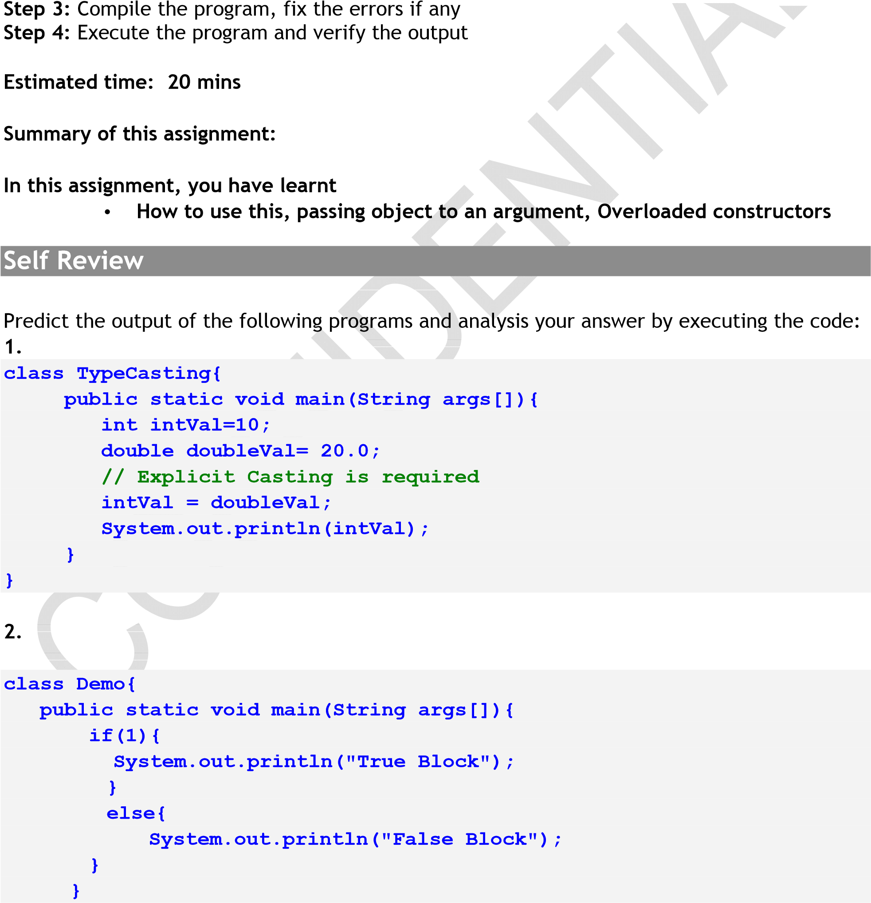

|  |  |
| --- | --- |
| **}**    **Note :** You can only the Boolean type in the conditional statement 0 won’t be interpreted as false and nonzero (>0) won’t be interpreted as true. | |
|  |  |

3.

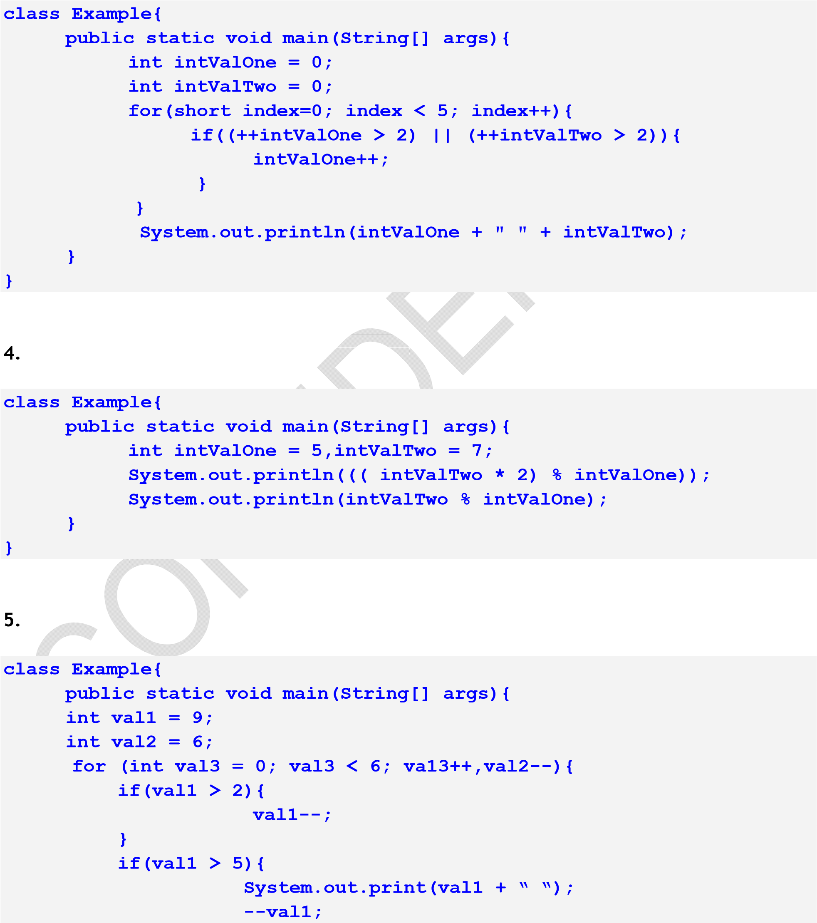

|  |
| --- |
| **continue;**  **} val1--; } }**  **}** |

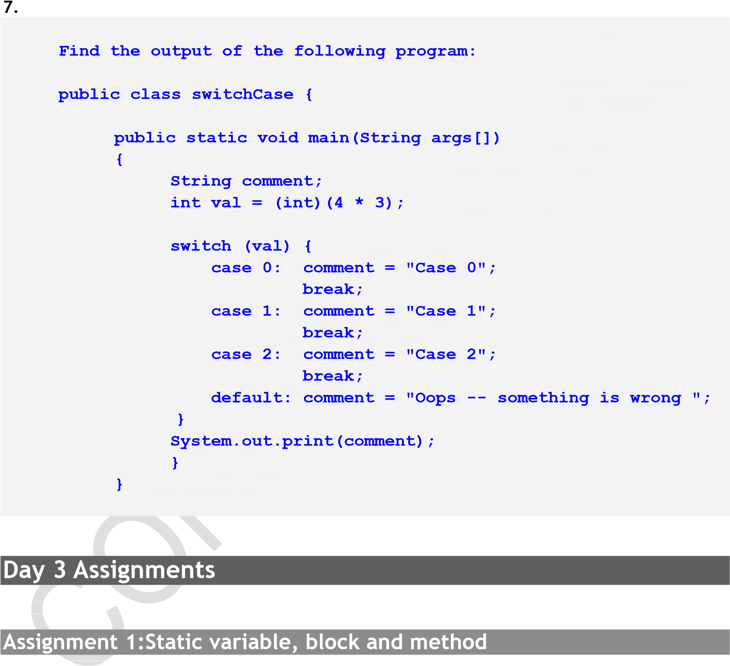

Objective: Understand the static variable, static block and static method

Problem Description:

Modify the Assignment 10 of Day 2 to get the total number of student objects

Static variable and static method:

Step 1: Add static data member studentCount to store the total number of objects of type Student

Step 2: Add static member method getStudentCount () to return the value studentCount.

Step 3: In default constructor Student(), increment the studentCount by 1 and assign to studentId

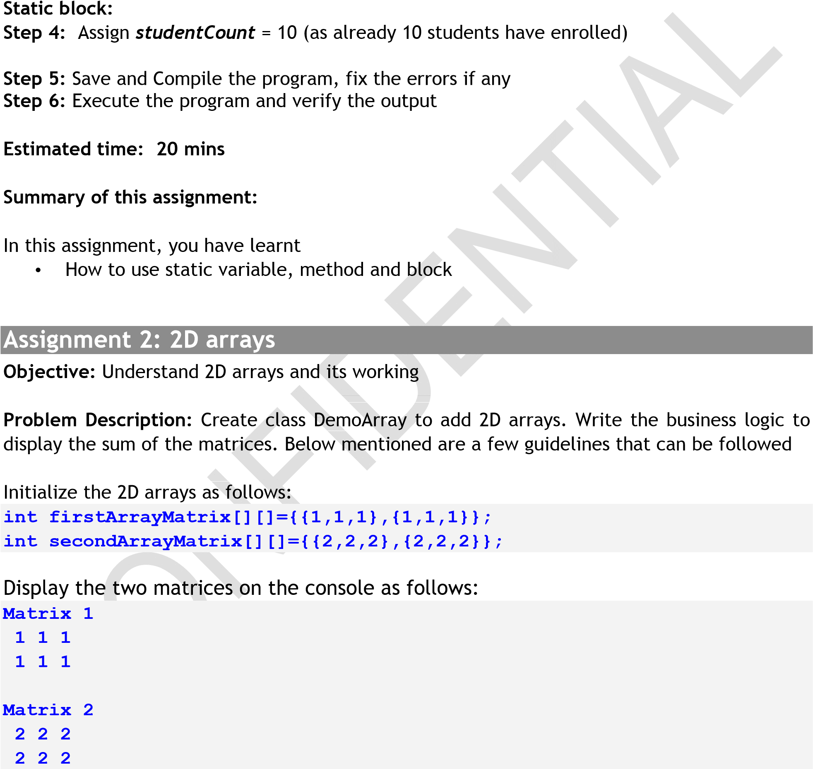

Display the sum of the matrices:

**Sum of the Matrices**

**3 3 3**

**3 3 3**

Estimated time: 20 minutes

Summary of this assignment:

In this assignment, you have learnt

• Implementation of 2d arrays

|  |  |  |
| --- | --- | --- |
|  | **Student** |  |
| -studentId : integer  -studentType:char  -**studentName:String** |
| +Student()  +**Student(id,type,firstName,lastName)** |
| ER/CORP/C | +setStudentId(id:int):void  RS/ LA1026 CONFIDENTIAL Version No. 1.2 2  +setStudentType(type:char):void  **+setStudentName(firstName:String,lastName:String)**  +getStudentId():int | 5 of 68 |

Assignment 3: Multidimensional Array(Jagged Array)

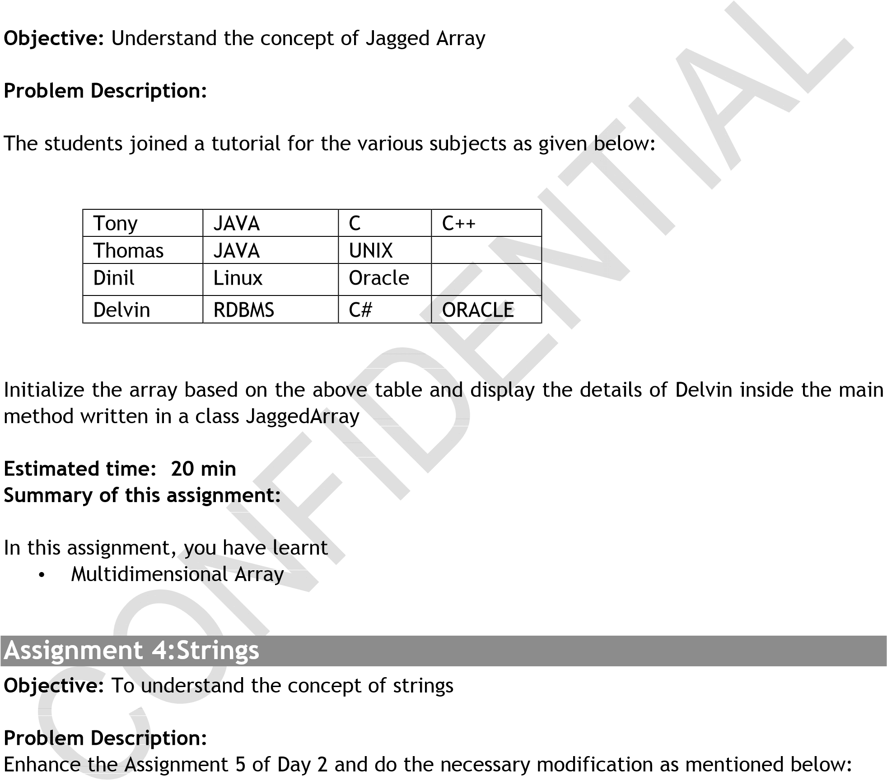

Step 1: Define constructors in Student class

Student (): Initialize the instance variables with 10 and ‘F’ (indicated fresher) respectively

Student(id,type,firstName,lastName):Initialize the instance variables studentId and studentType with id and type respectively. Initialize the instance variable

studentName with firstName + lastName. (+ denote concatenation)

Step 2: Define the setStudentName(firstName:String,lastN~~ame:St~~ring) ~~as b~~elow:

setStudentName(String firstNa~~me,String lastN~~ame){

studentName = firstName+lastName;

}

Step 3: Define a main method

1. In the main method, create a reference variable student of type Student.
2. Create an object of type Student and assign it to reference variable named student.
   * 1. I~~nvoke the~~ corresponding setter methods to set the instance variable with the given values stored in temporary variables.
     2. Using getter methods, display the student details.
3. Create an object of type Student (id, type, firstName, lastName) and assign it to reference variable named student.

i. Using getter methods, display the student details

Step 4: Compile the program, fix the errors if any

Step 5: Exe~~cute the prog~~ram and verify the output

Estimated time: 25 mins

Note:

* + You can refer javadoc to know various methods present in String class

Summary of this assignment:

In this assignment, you have learnt

* + How to use strings

Assignment 5: Java Doc Exploratory assignment

Objective: To explore and understand the Java Doc. Create a program with the help of java doc. (hint use String)

Problem Description: Create classes called which does the following:

1. Takes User name as input

1. 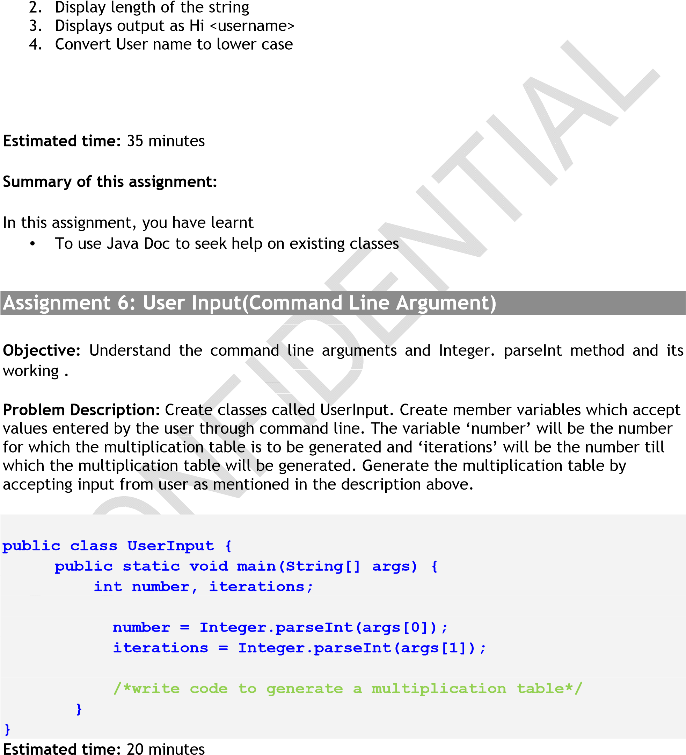Convert User name to upper case
2. Check whether the name is starting with ‘a’
3. Replace the User name as SEED

Summary of this assignment:

In this assignment, you have learnt

* Taking input from user as arguments

Assignment 7:Command Line Argument

Objective: Understand command line arguments

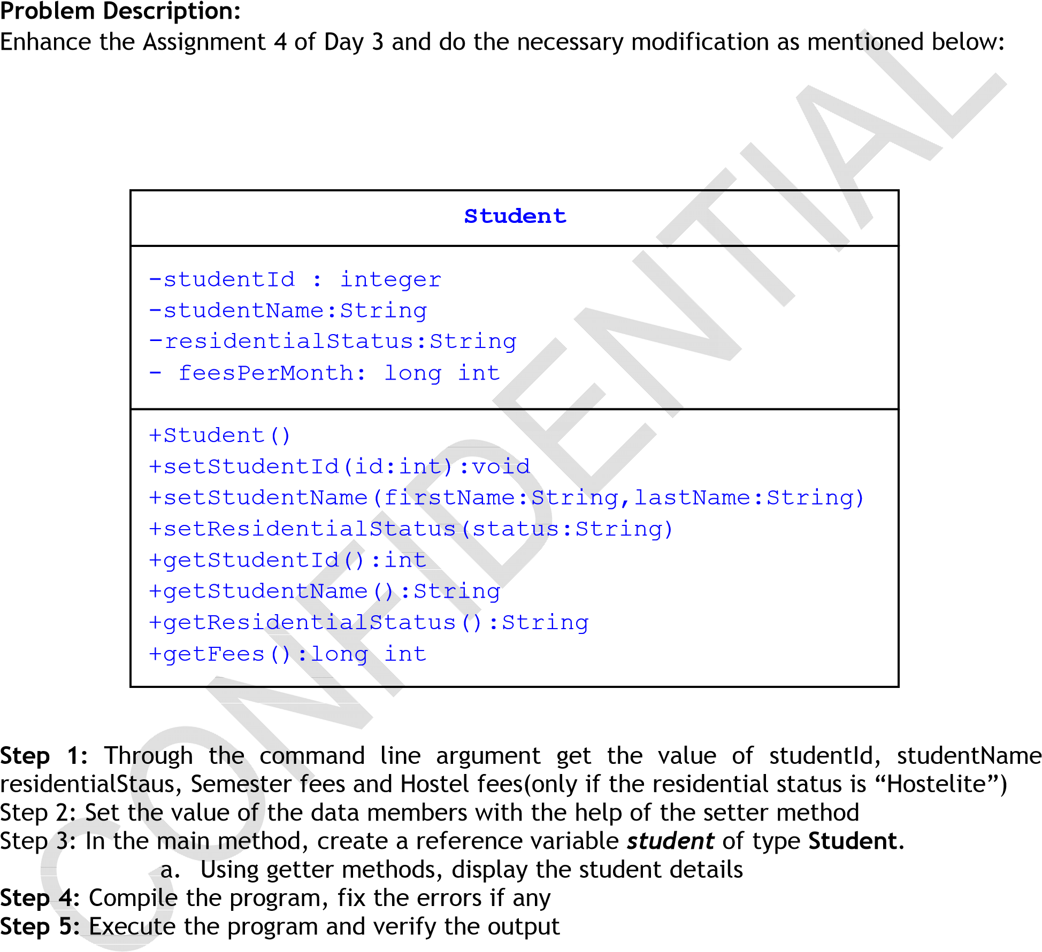

Estimated time: 20 mins

Summary of this assignment:

In this assignment, you have learnt

* How to implement command line argument and parseInt()method

Assignment 8:Overloaded Methods

Objective: Understand method overloading

Problem Description:

Enhance the Assignment 7 and do the necessary modification as mentioned below:

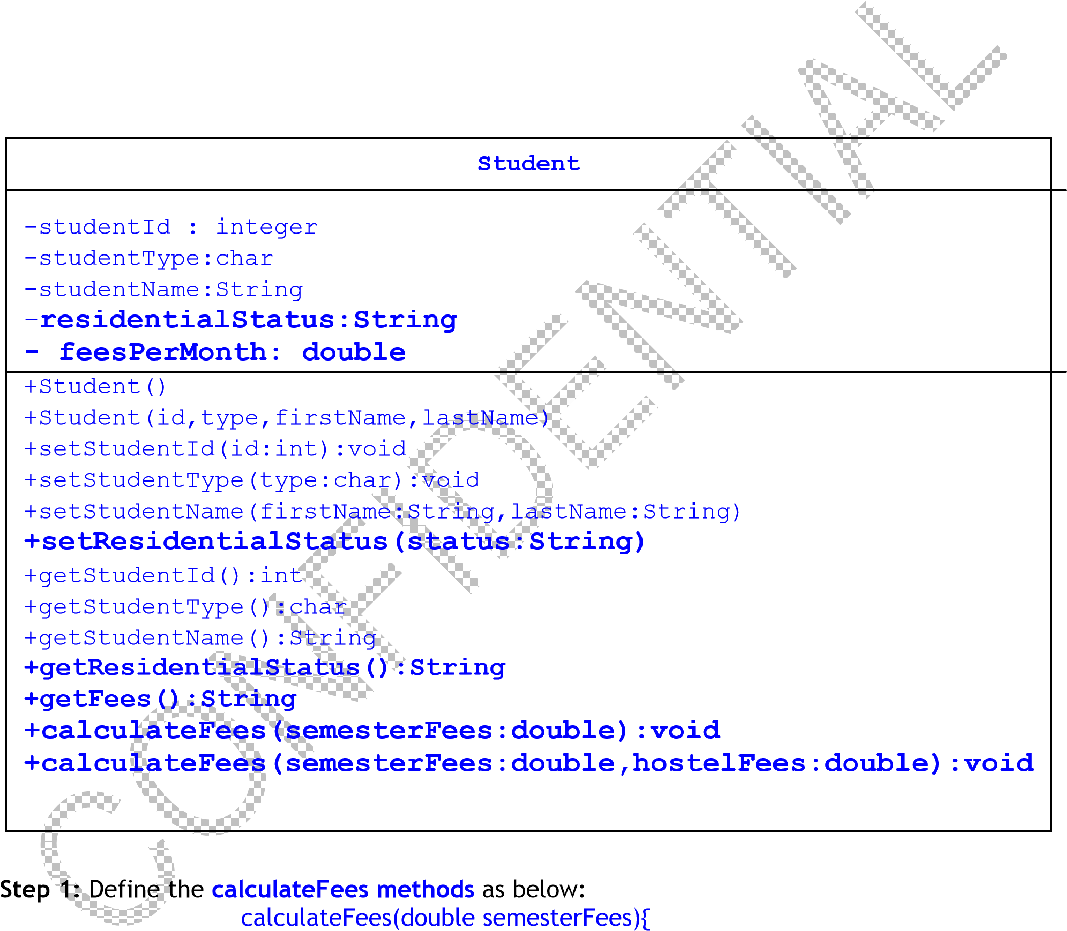

feesPerMonth = semesterFees / 6.0;

}

calculateFees(double semesterFees,double hosterlFees){

feesPerMonth = semesterFees / 6.0;

feesPerMonth = feesPerMonth+ hostelFees;

}

Step 2: Define a main method

1. In the main method, create a reference variable student of type Student.
2. Create an object of type Student (id, type, firstName, lastName) and assign it to reference variable named student.
3. Invoke setResidentialStatus method to set the residentialStatus as “Day

Scholar” or “Hostelite”

1. Check for the residential status, if residential status is equals to “Day Scholar”,invoke calculateFees(double semesterFees) method otherwise, invoke calculateFees(double semesterFees, double hosterlFees)

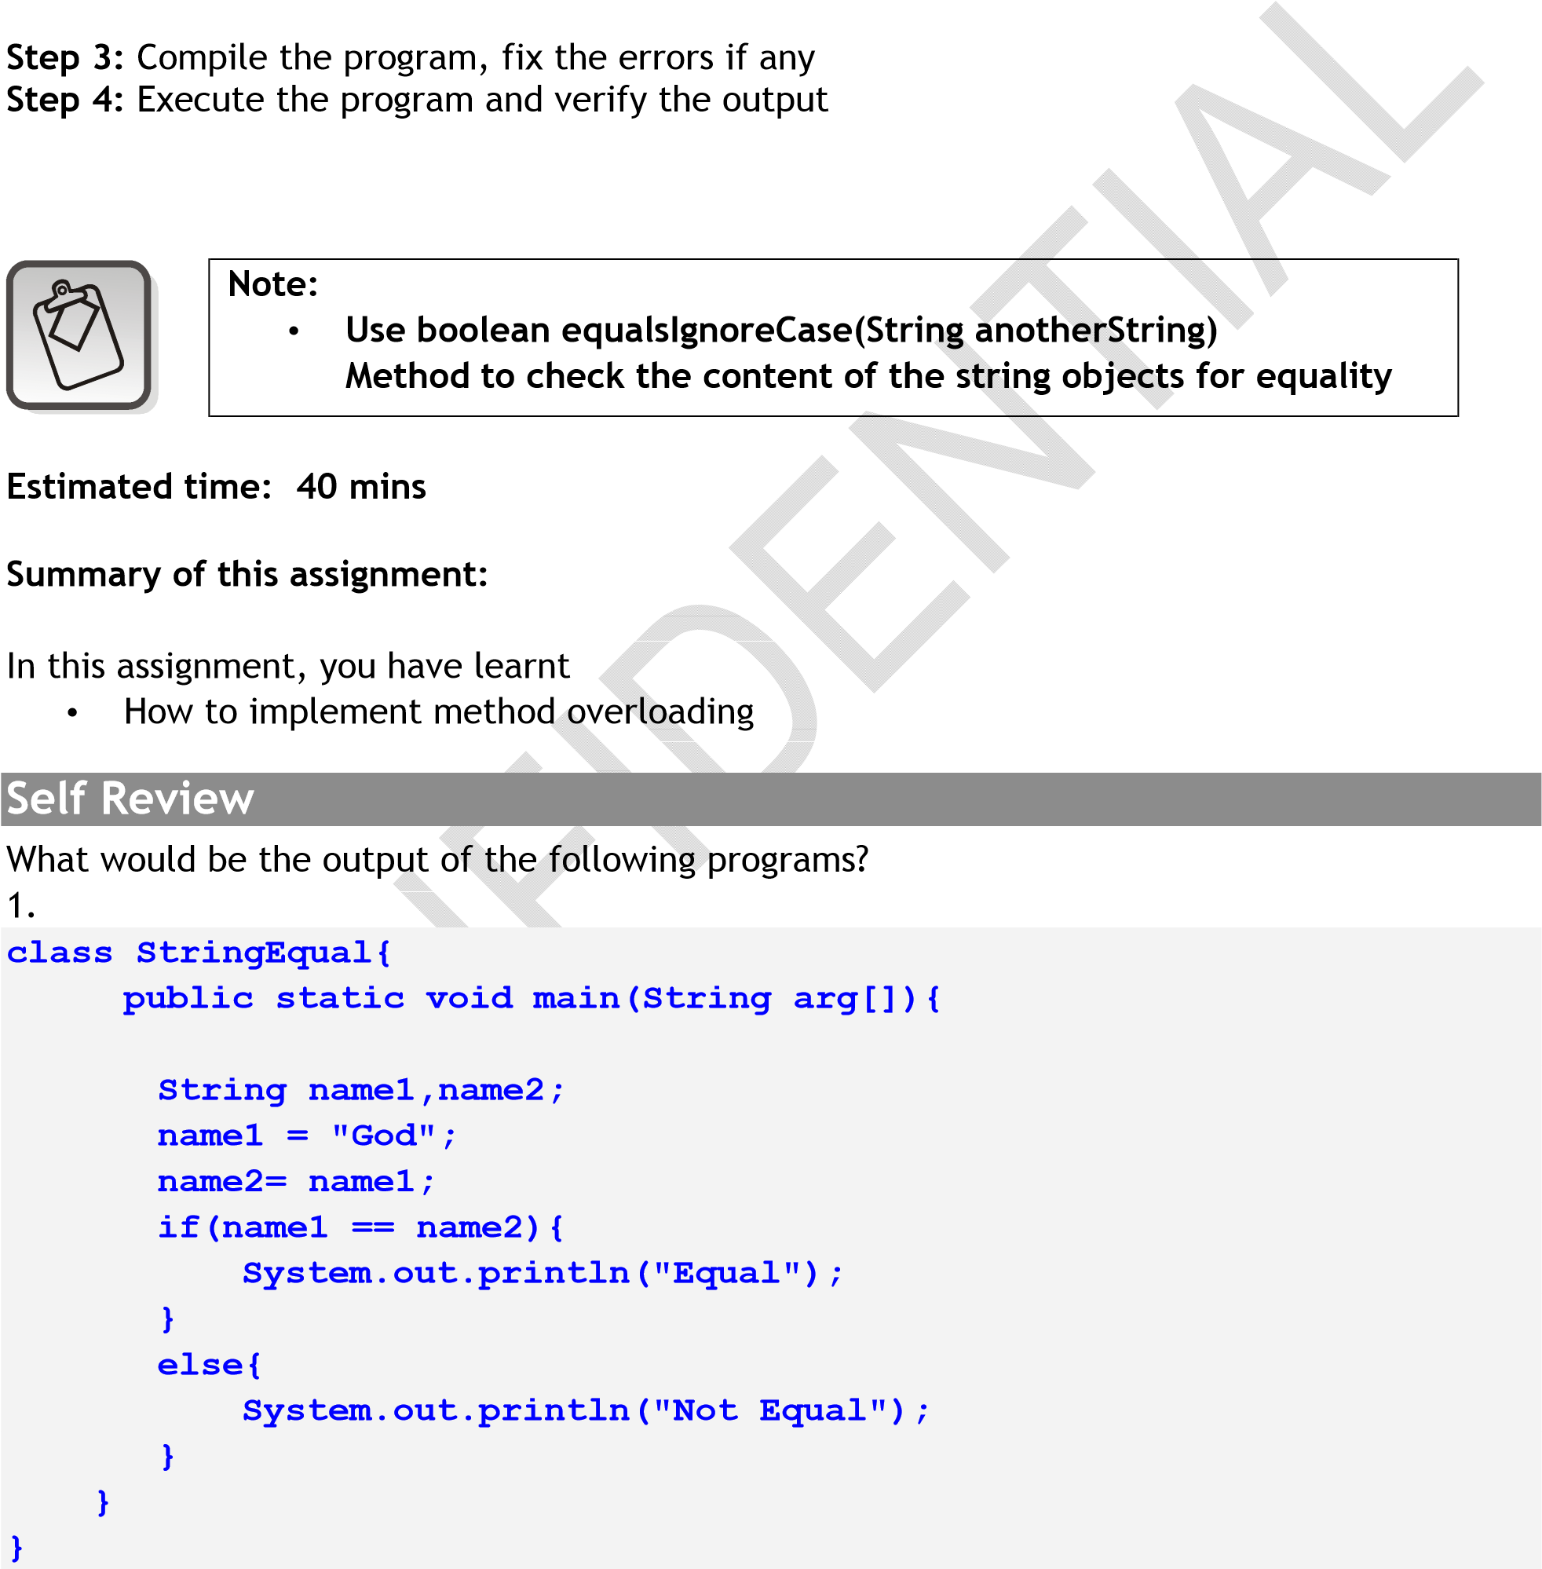e. Using getter methods, display the student details

2.

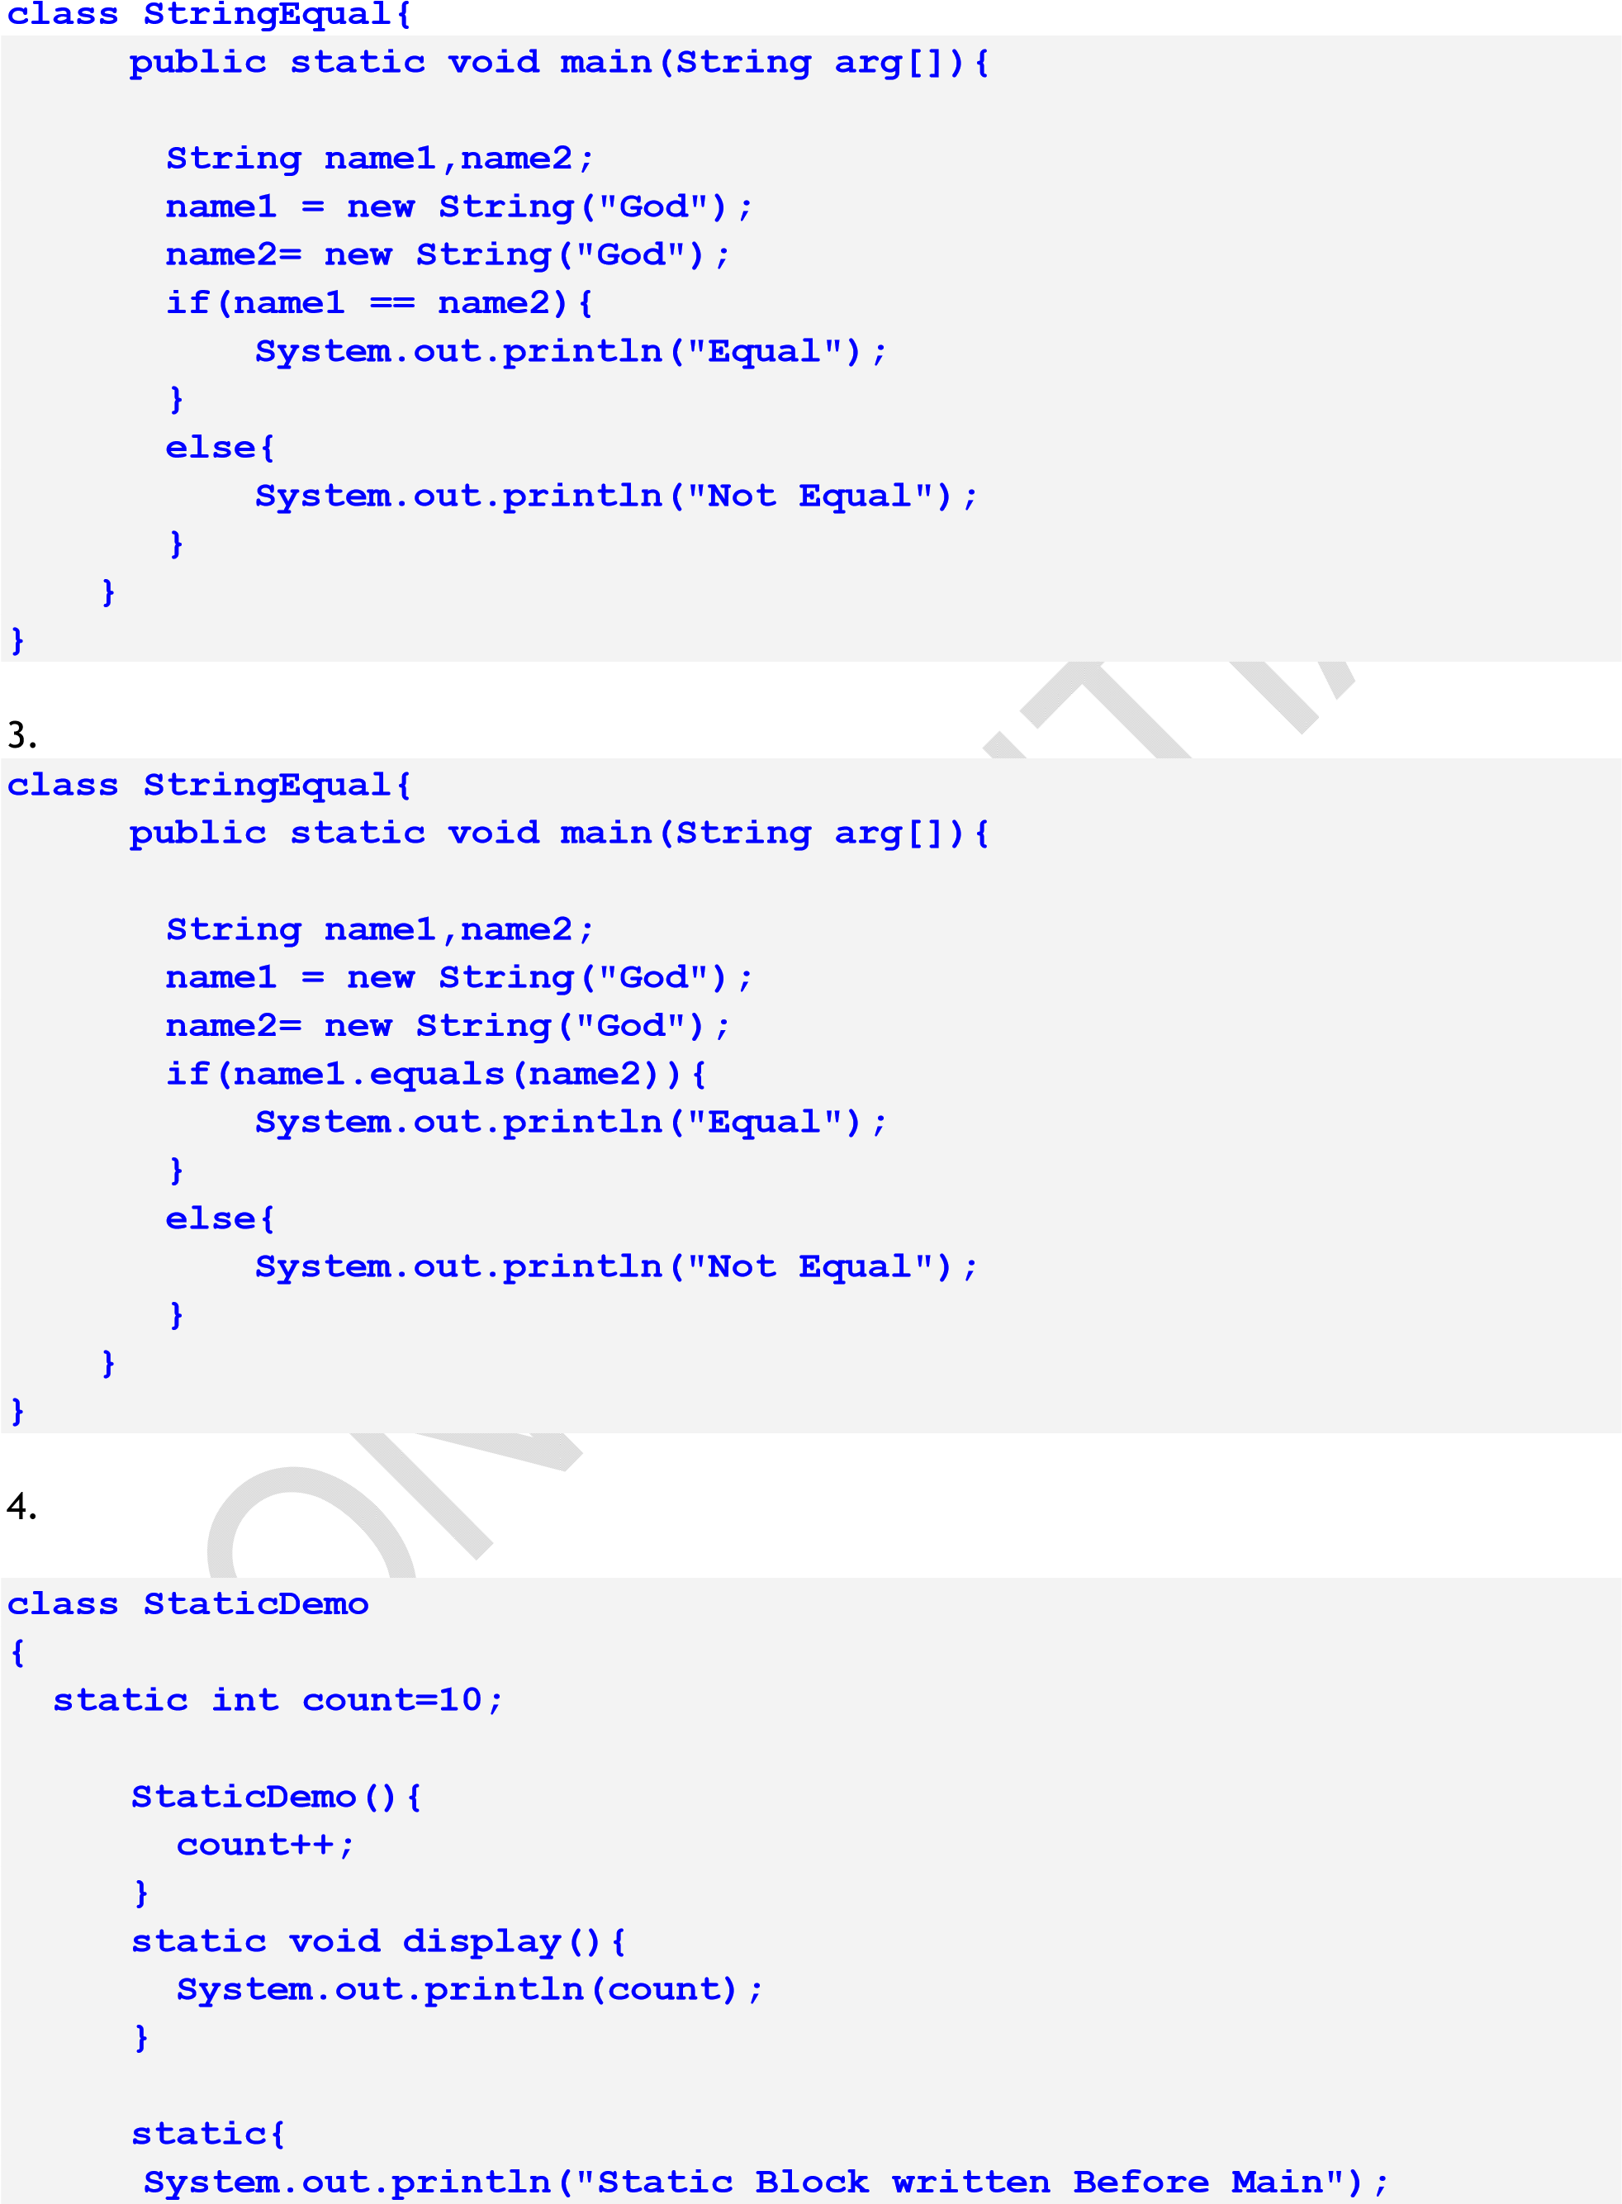

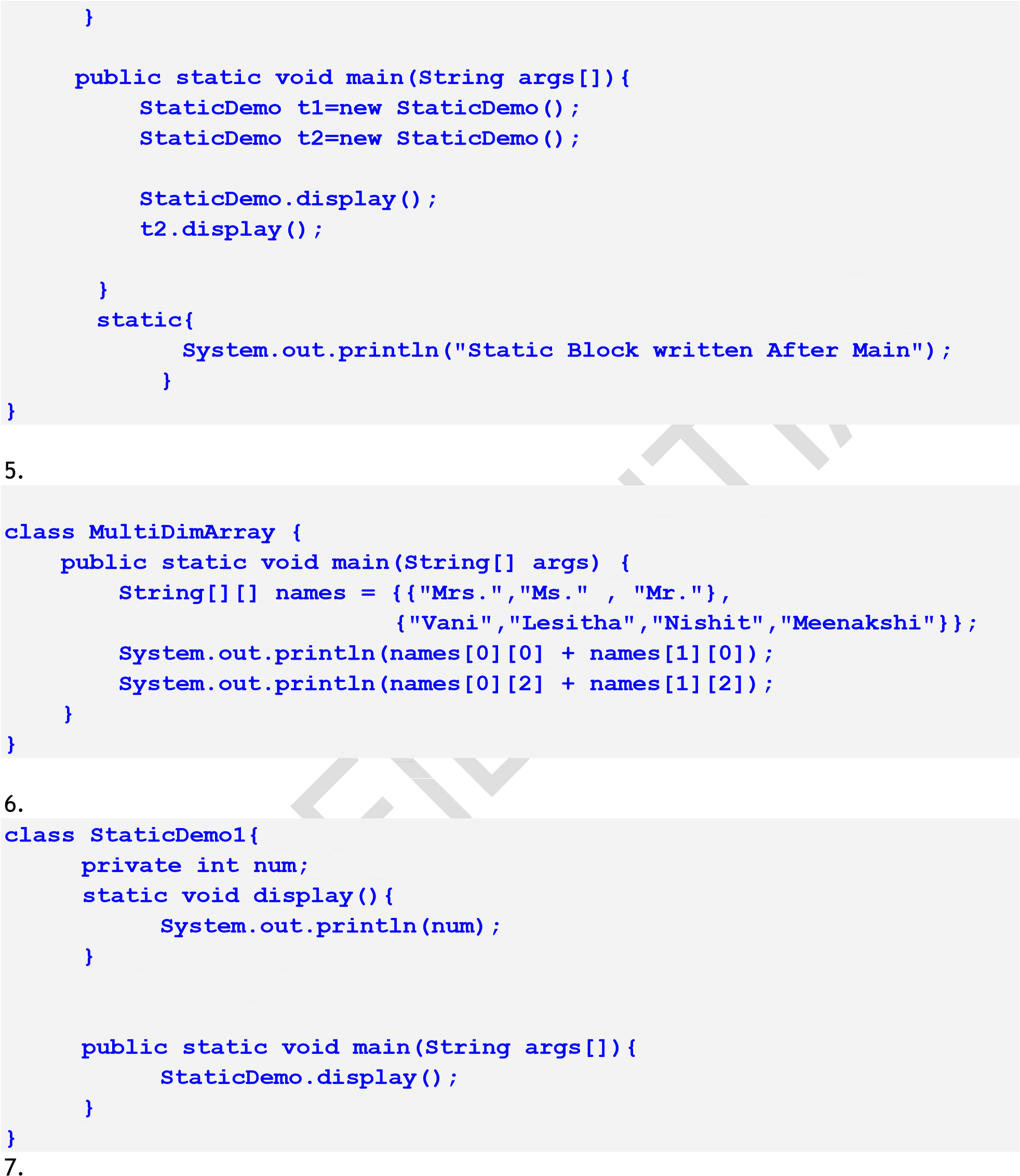

|  |
| --- |
| **What will be the output of the following:**  **public class thisSample {**  **public static void main(String[] args){ Square square =new Square(); square.display(5); int area = square.calculateArea();** |

|  |  |  |
| --- | --- | --- |
| **System.out.println("The area of the Square is : " + area);**  **}**  **} public class Square { int length;** | | |
|  | **Student** |  |
| -studentId : integer  -studentType:char  -studentName:String  -feesPerMonth: double |
| +Student()  +Student(id,type,firstName,lastName)  +setStudentId(id:integer):void  +setStudentType(type:char):void  +setStudentName(firstName:String,lastName:String)  +setFeesPerMonth(double)  +getStudentId():integer  +getStudentType():char  +getStudentName():String +getStudentType():char  +getStudentName():String  +getFeesPerMonth():double |

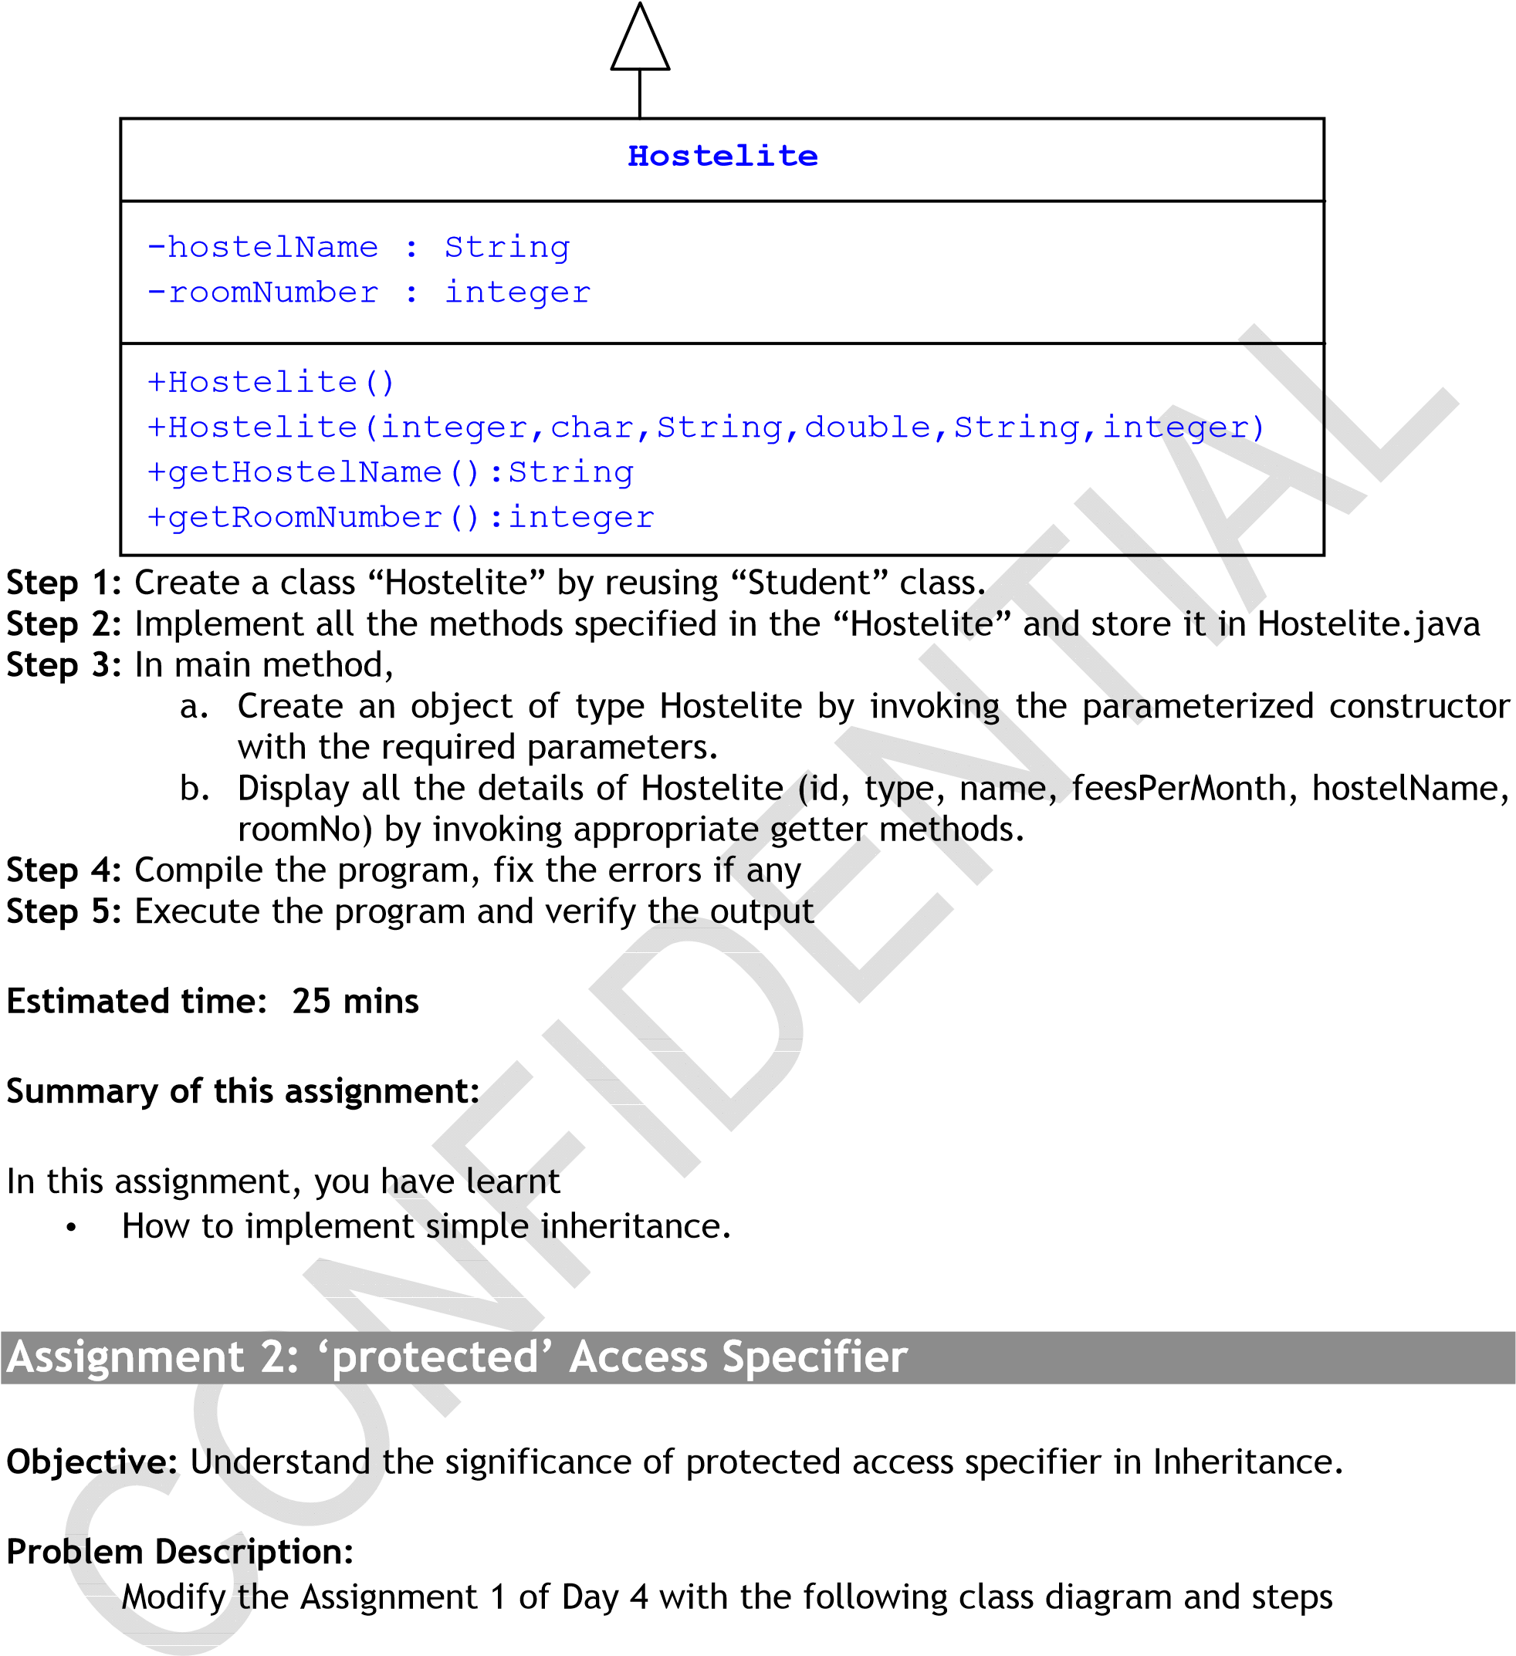

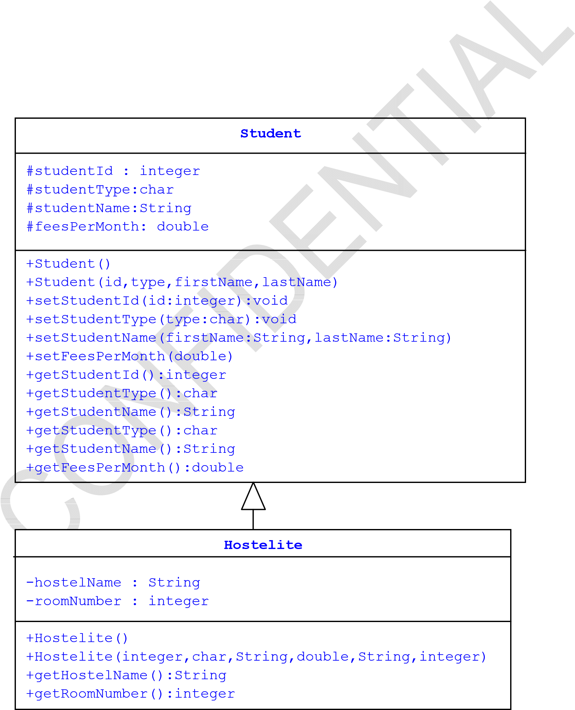

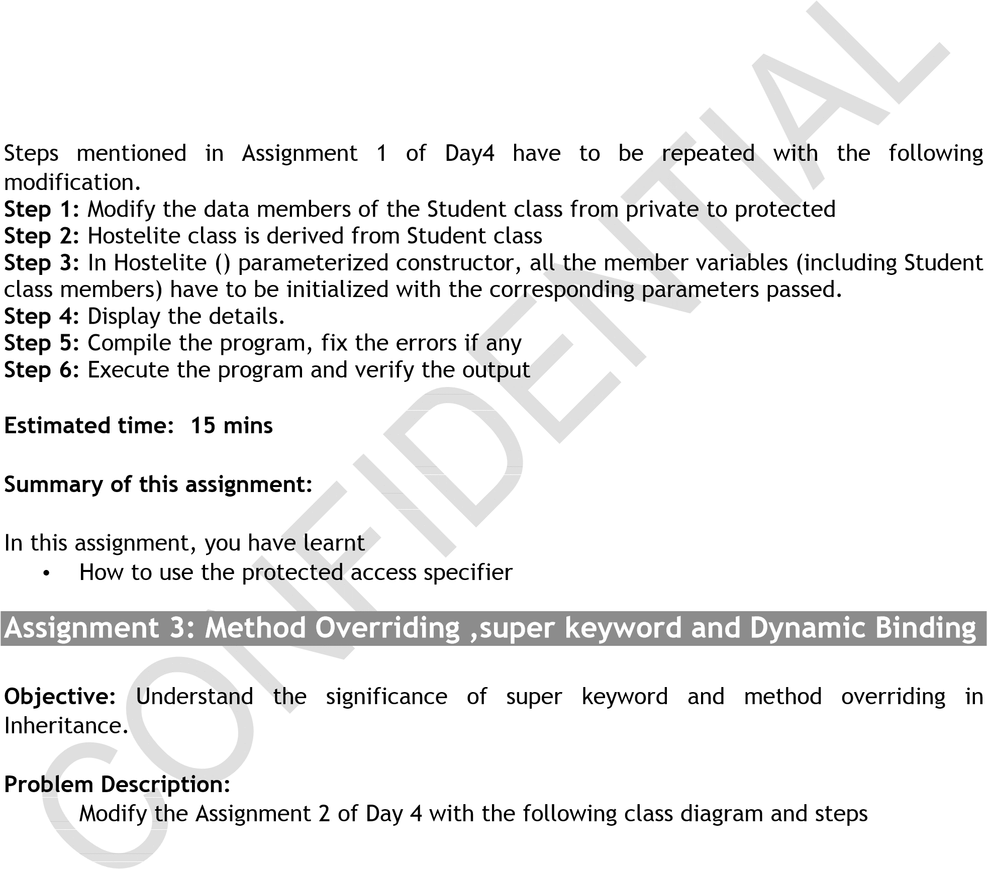

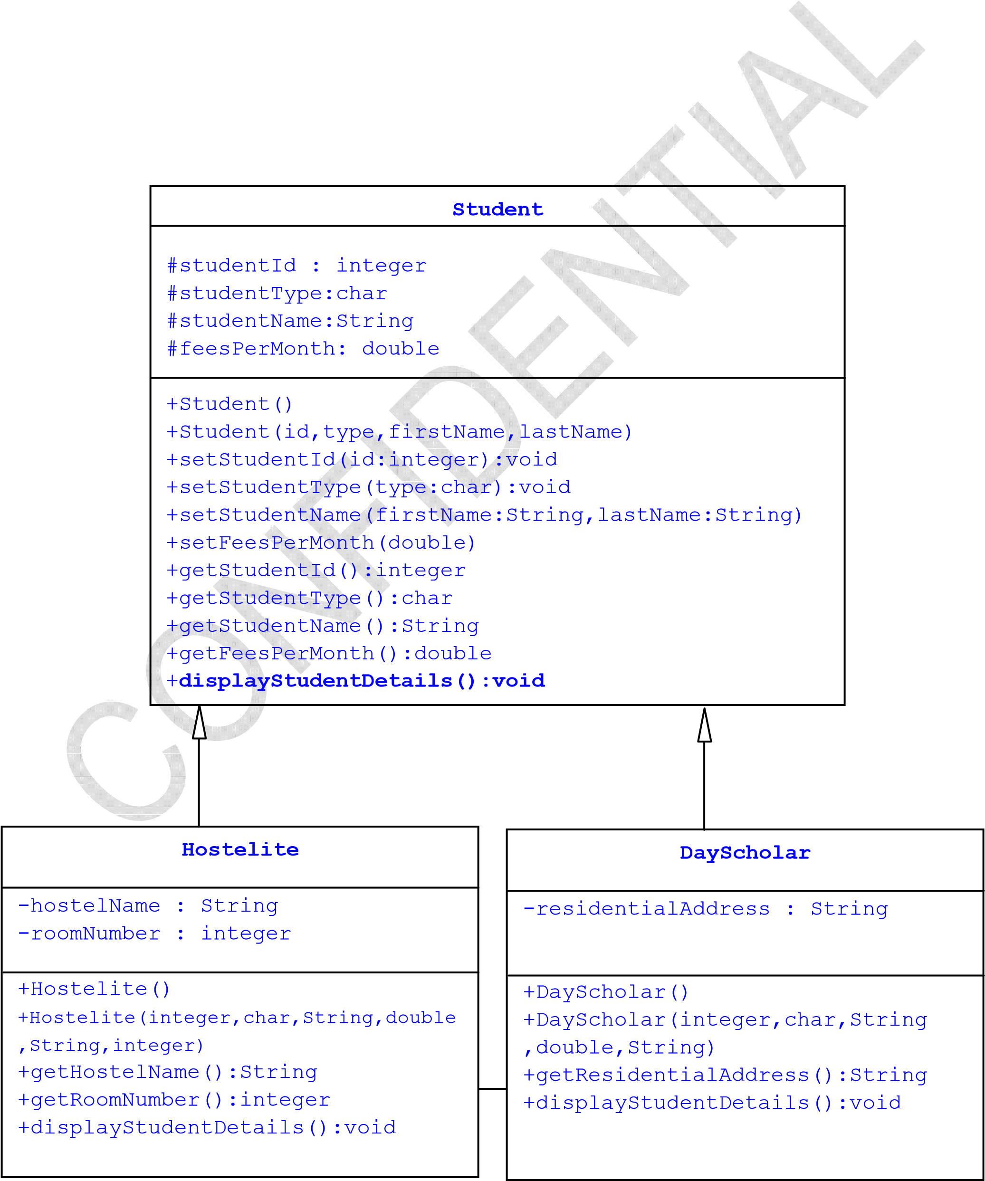

Steps mentioned in Assignment 2 of Day4 have to be repeated with the following modification.

Step 1: displayStudentDetails() method needs to be defined in Student class. This method should display the student details.

Step 2: The method displayStudentDetails() needs to be overridden in Hotelite and DayScholar classes which will display additional student informa~~tion(hostelNa~~me and roomNumber or residentialAddress).

Note:

• Use super keyword to invoke the super class displayStudentDetails()

Step 3: In main method,

1. Create reference variable of type Student
2. Read the residential status of the student(from the command line argument using String as described in earlier assignments- Hostelite or Dayscholar), if (s)he is ~~a hostelit~~e then create object of type hostelite by invoking the parameterized constructor and assign it to reference variable named student otherwise, create object of type dayscholar by invoking the corresponding parameterized constructor and assign it to reference
3. Invoke the corresponding displayDetails method and display the complete student details

Step 4: Compile the program, fix the errors if any

Step 5: Execute the program and verify the output

Estimated time: 35mins

Assignment 4: super keyword

Objective: Understand the significance of super keyword

Problem Description:

Analyze the problem and Debug the code

**Problem 1:**

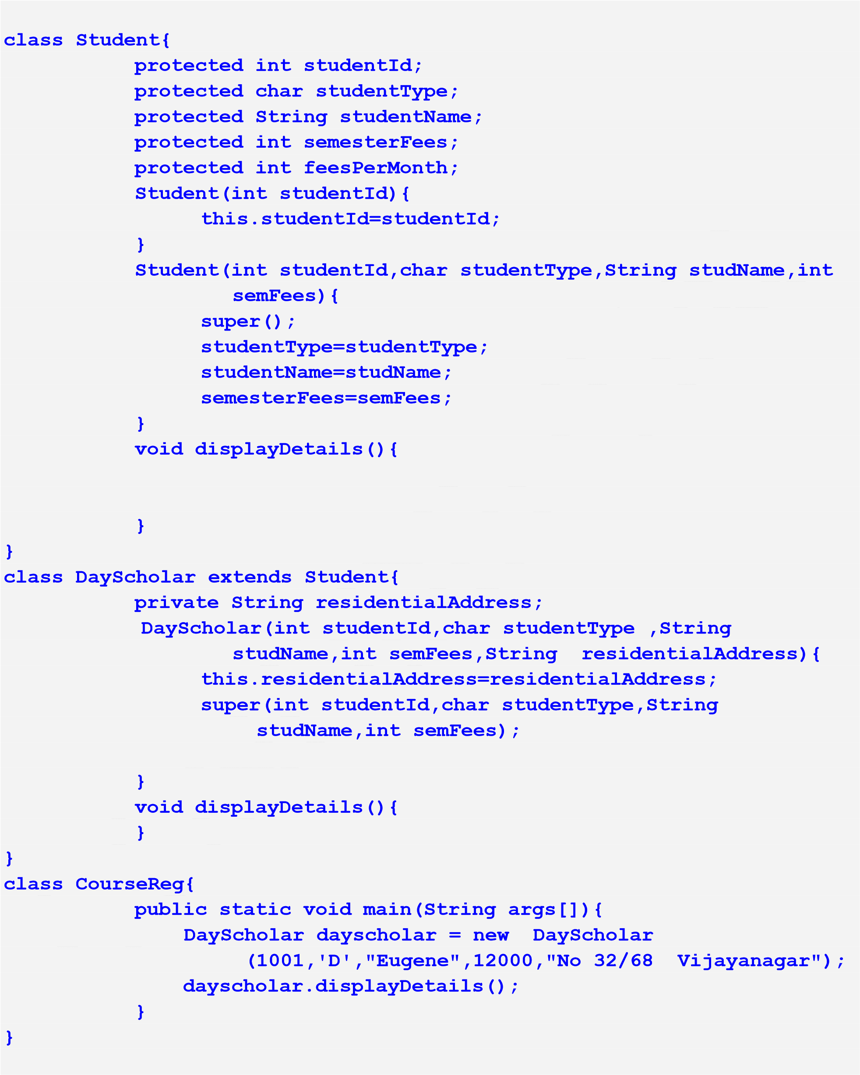

After fixing the errors, perform the following:

Step 1: In main method,

* 1. Create object of type Dayscholar by invoking the corresponding constructor and assign it to reference variable dayscholar
  2. Both the constructor of the Student class need to be invoked
  3. Fill the displayDetails() of the both the class
  4. dayscholar.displayDetails() should invoke both derived and base class displayDetails()

Step 2: Compile the program, fix the errors if any

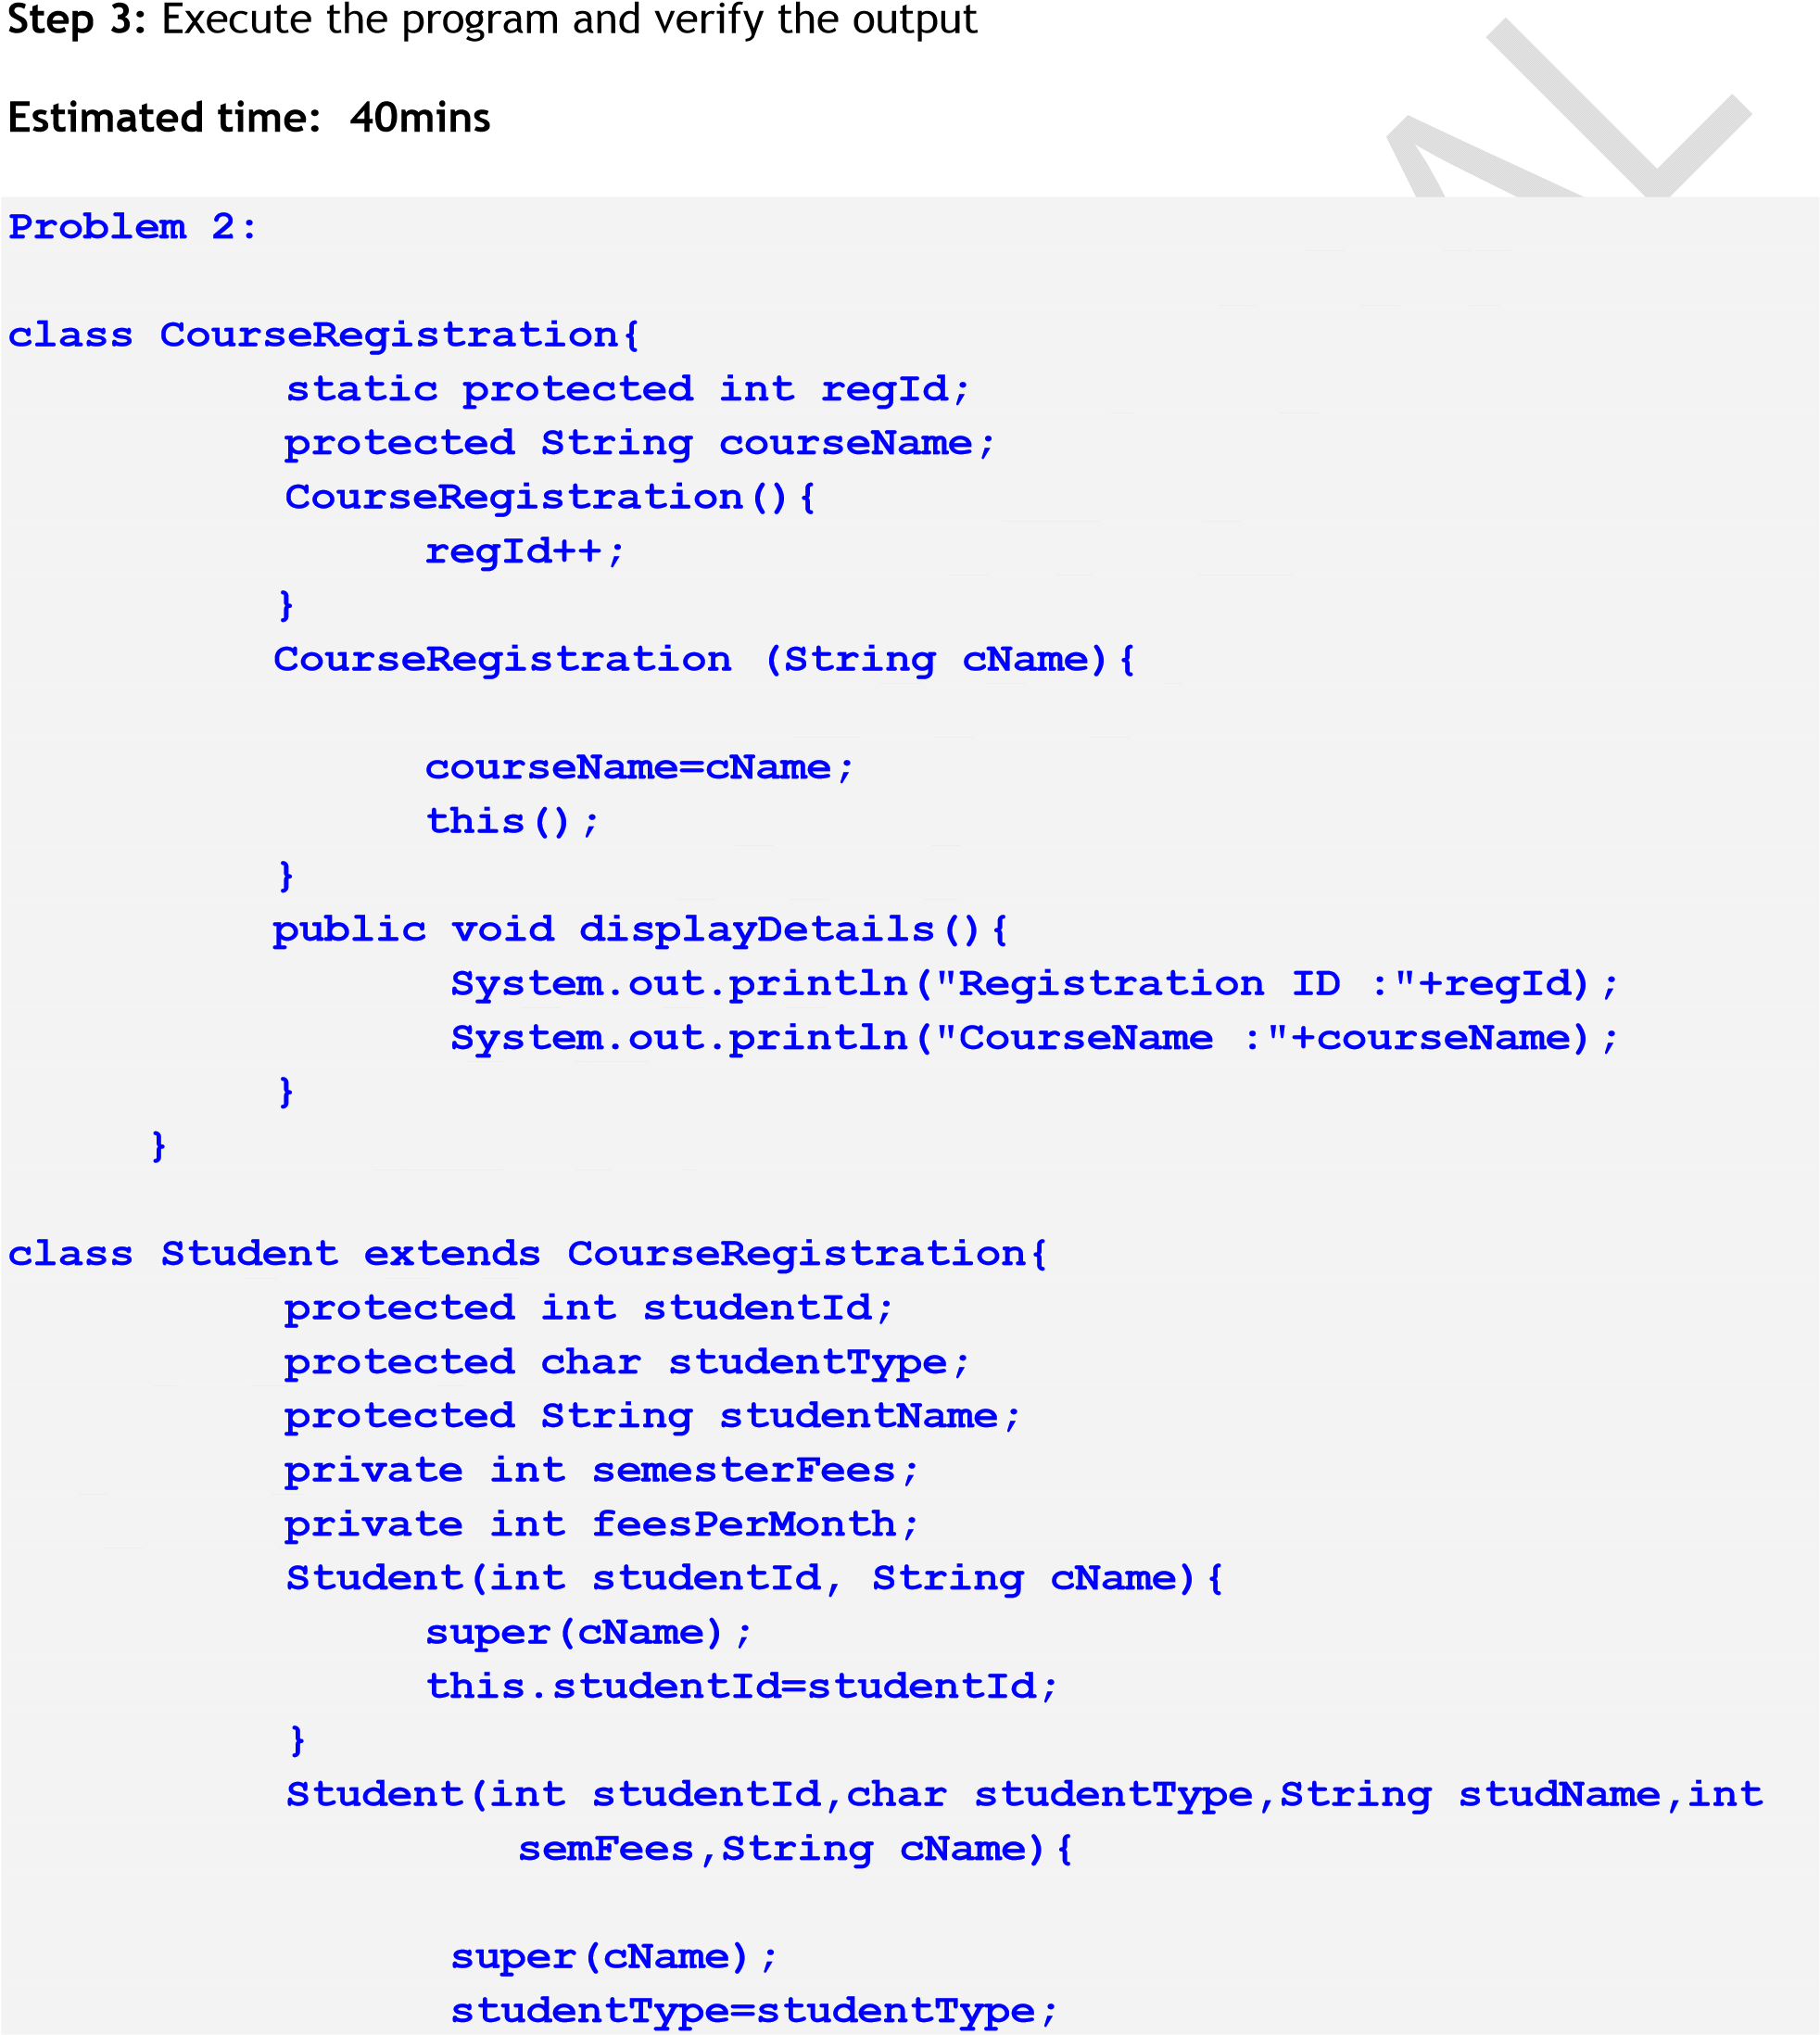

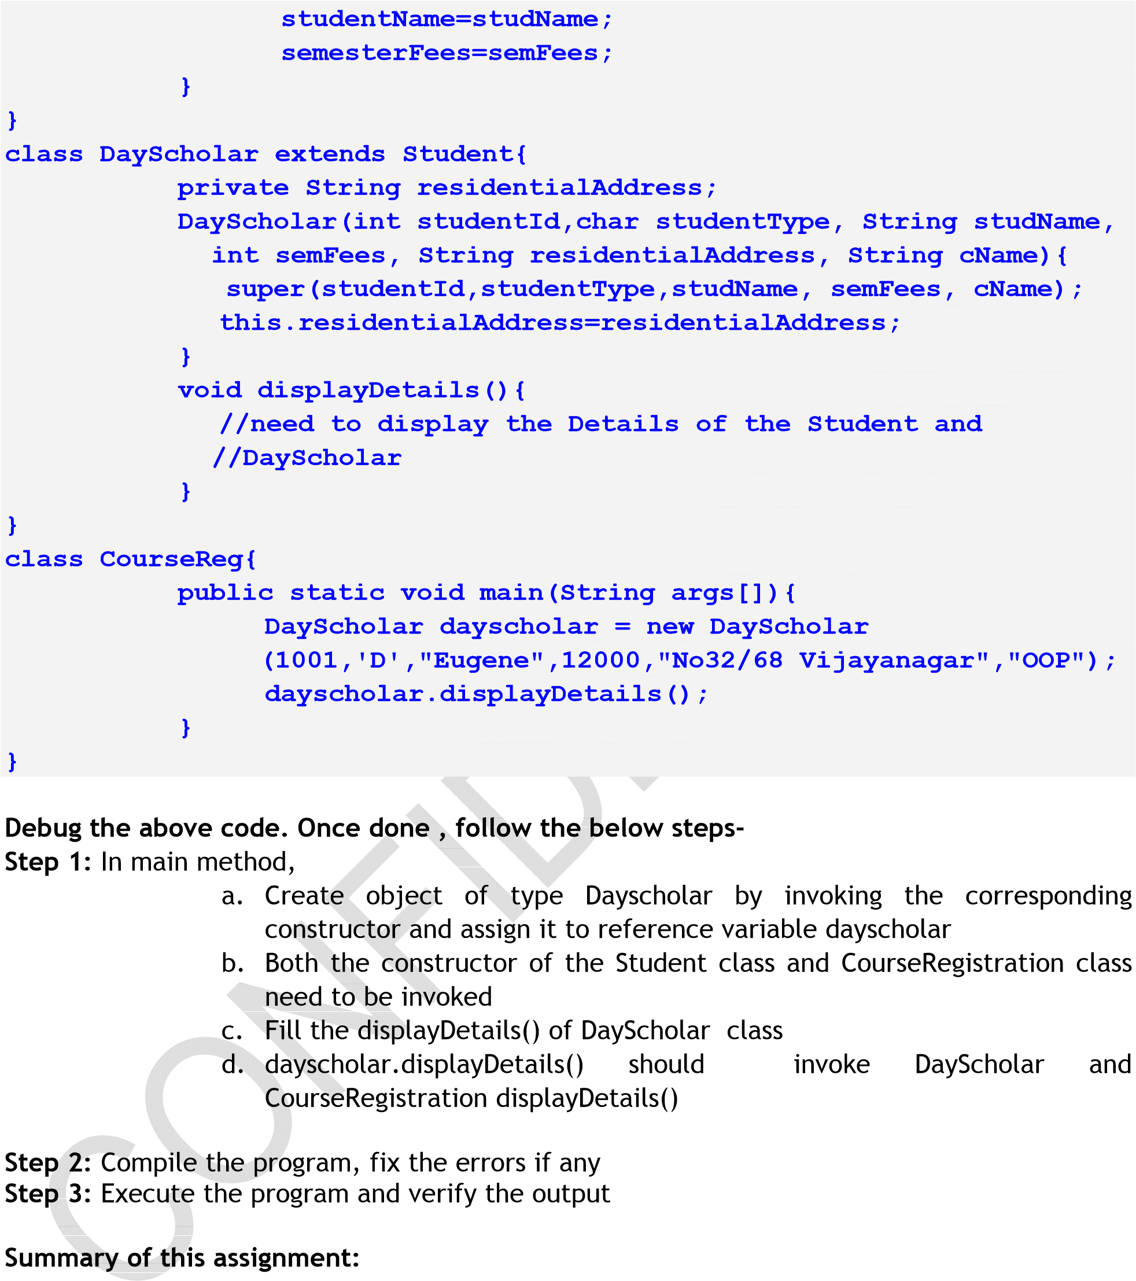

In this assignment, you have learnt

* Uses of super keyword

Estimated time: 25 mins

Assignment 5: Constructor Invocation

Objective: Understand the order of constructor invocation

Problem Description:

Implement the following class diagram using Java.

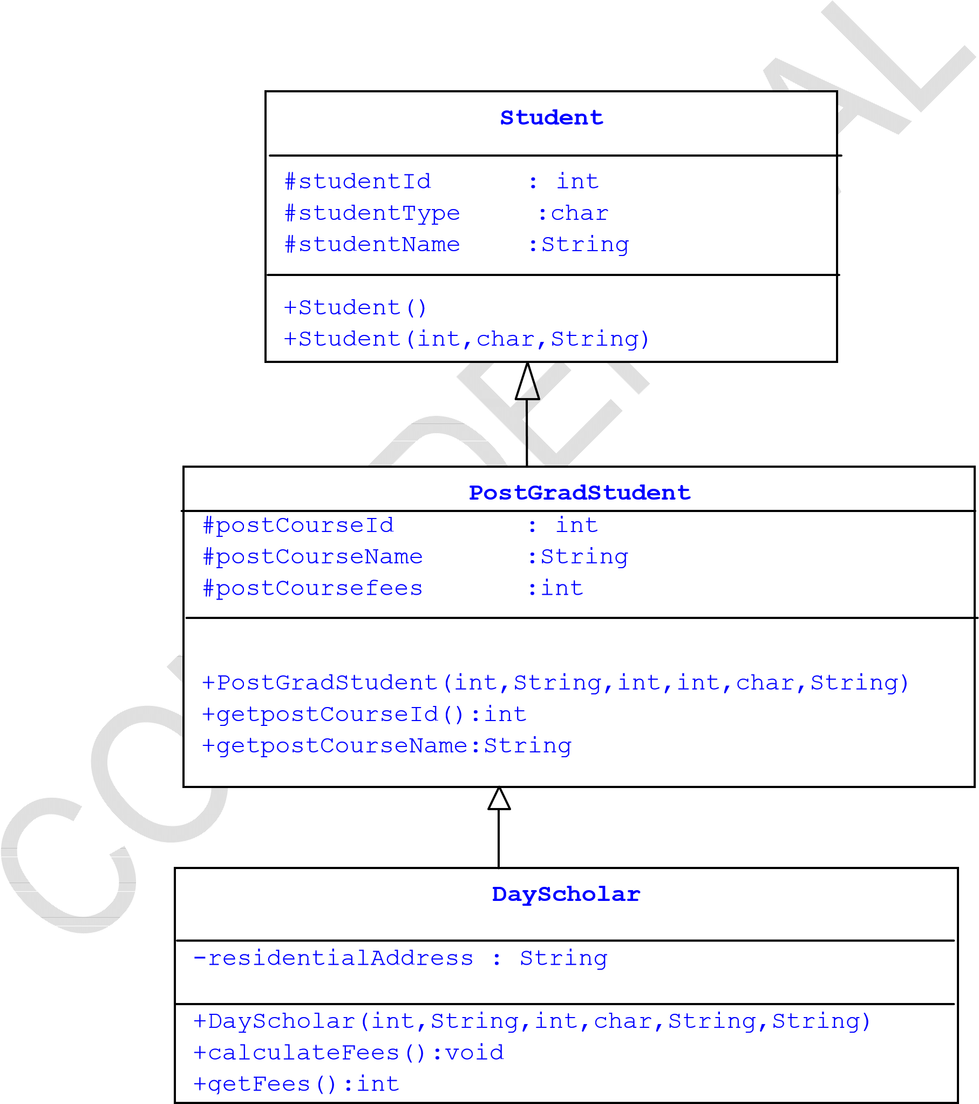

Step 1:In the Student class

* Define constructor o Student(): Used to increment the value of studentId each and every time object is created. Hint : Use a static variable

o Student(sid,sType,sName): Used to initialize the instance variables studentId,studentType,studentName and to invoke the constructor Student()

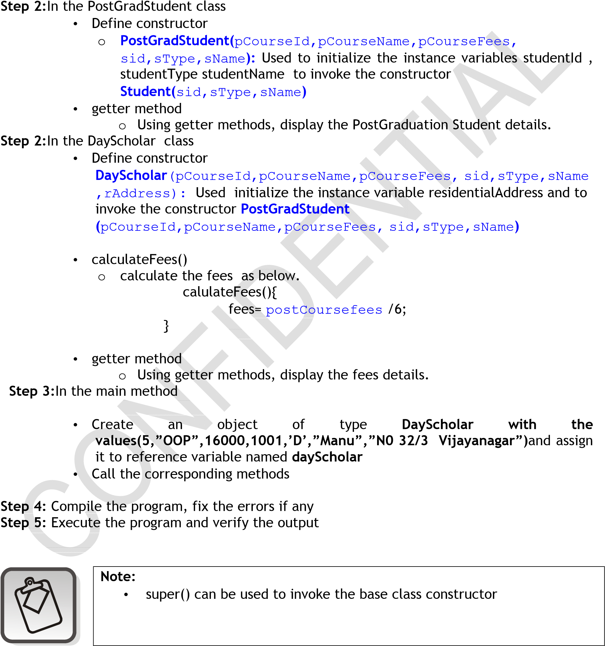the

Estimated time: 25 mins

Summary of this assignment:

In this assignment, you have learnt

* How to implement constructors
* Constructor invocation

Assignment 6 : Dynamic Polymorphism

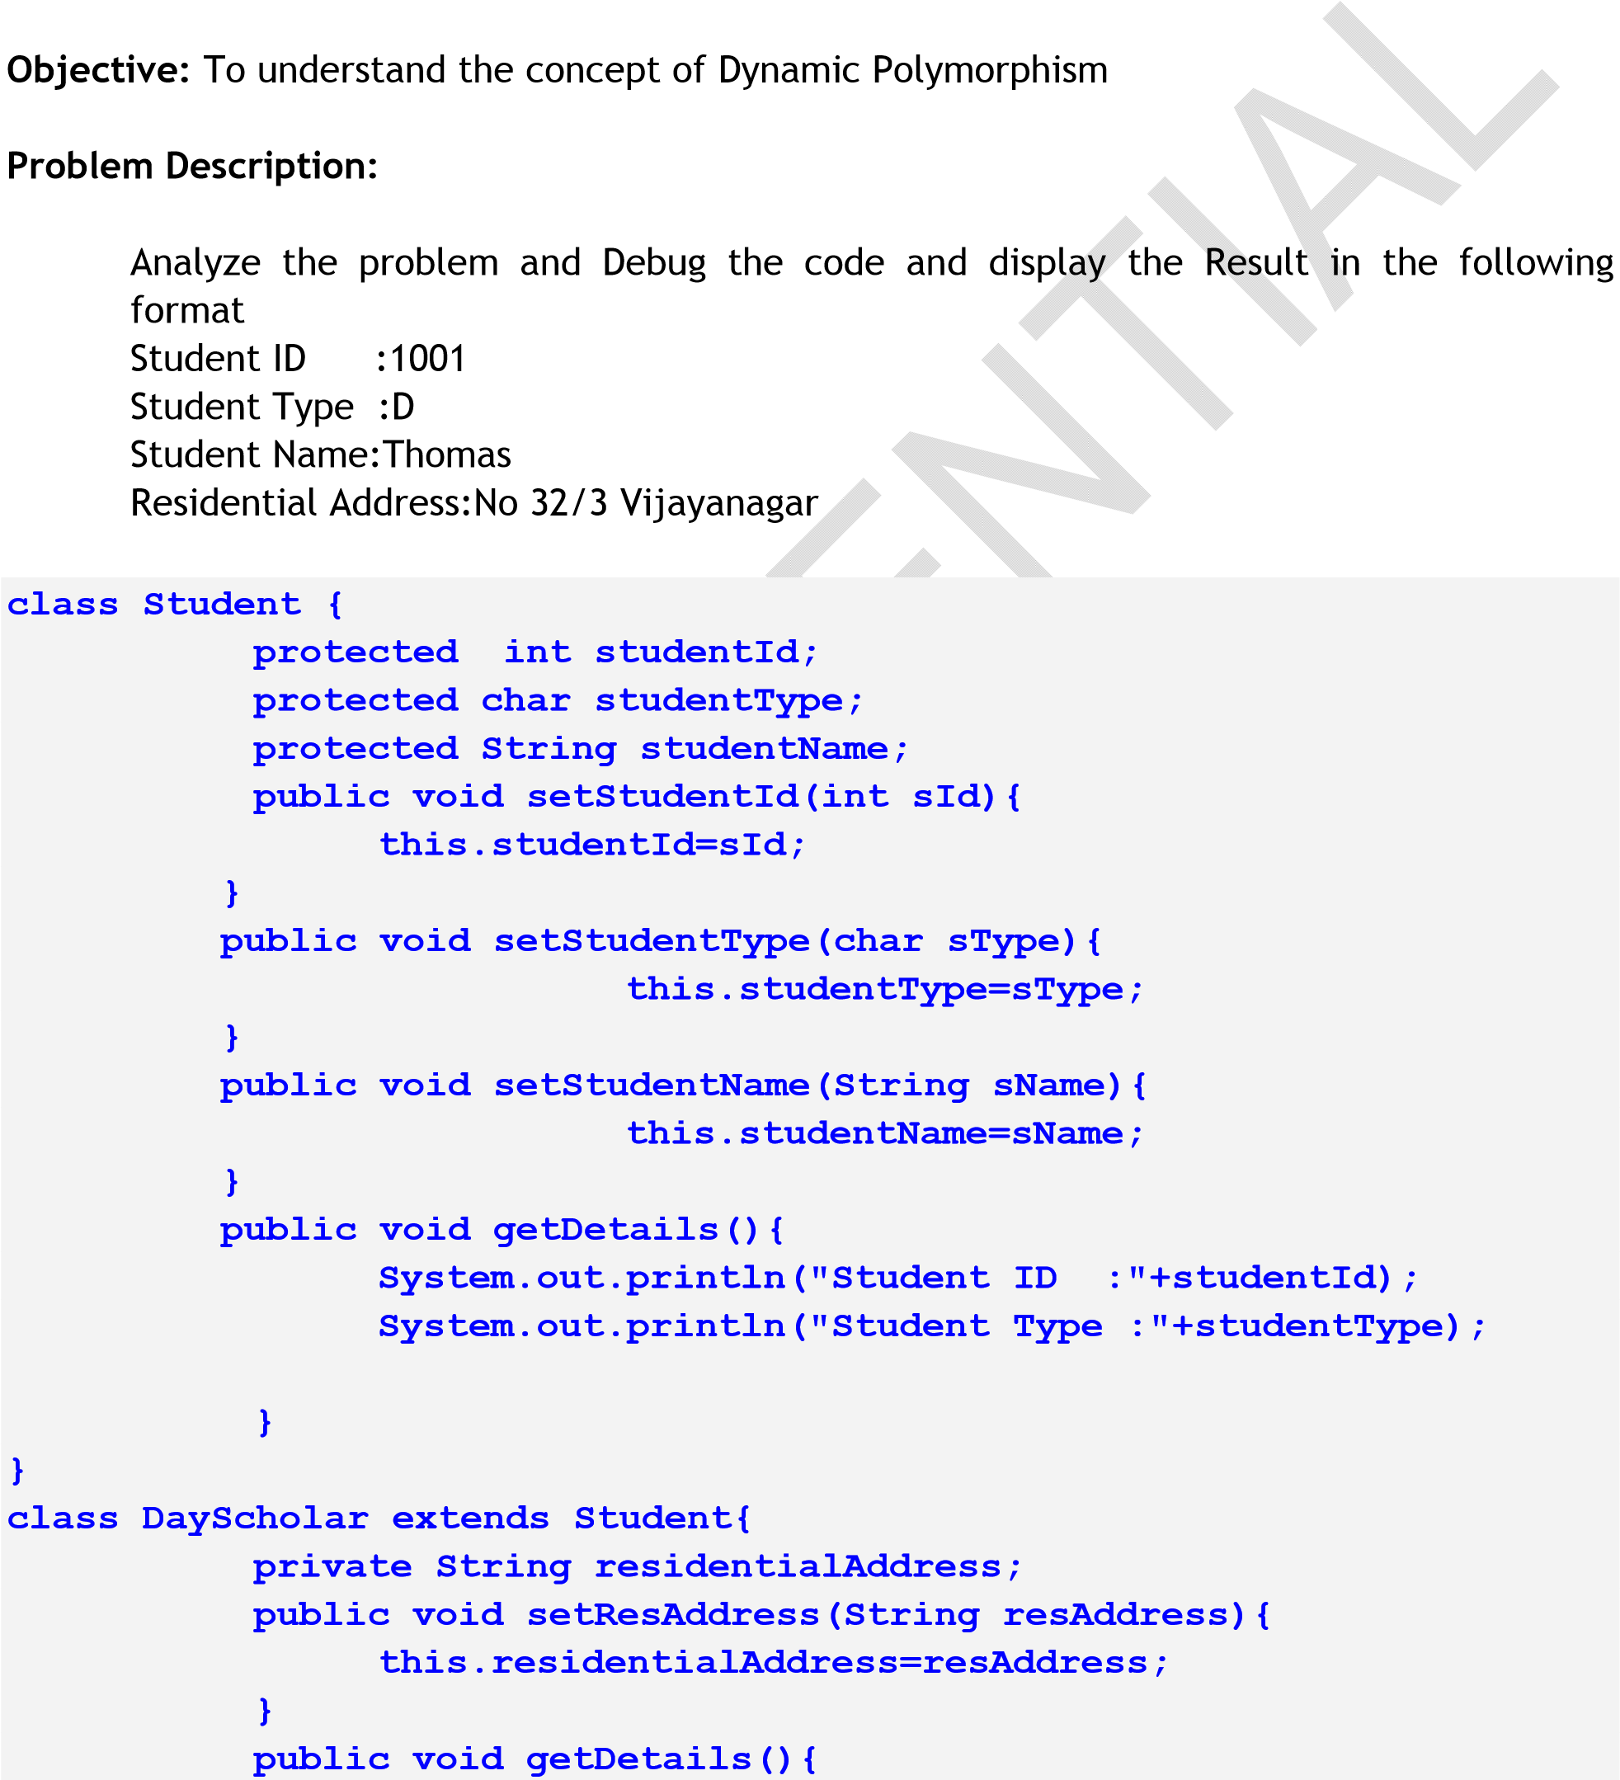

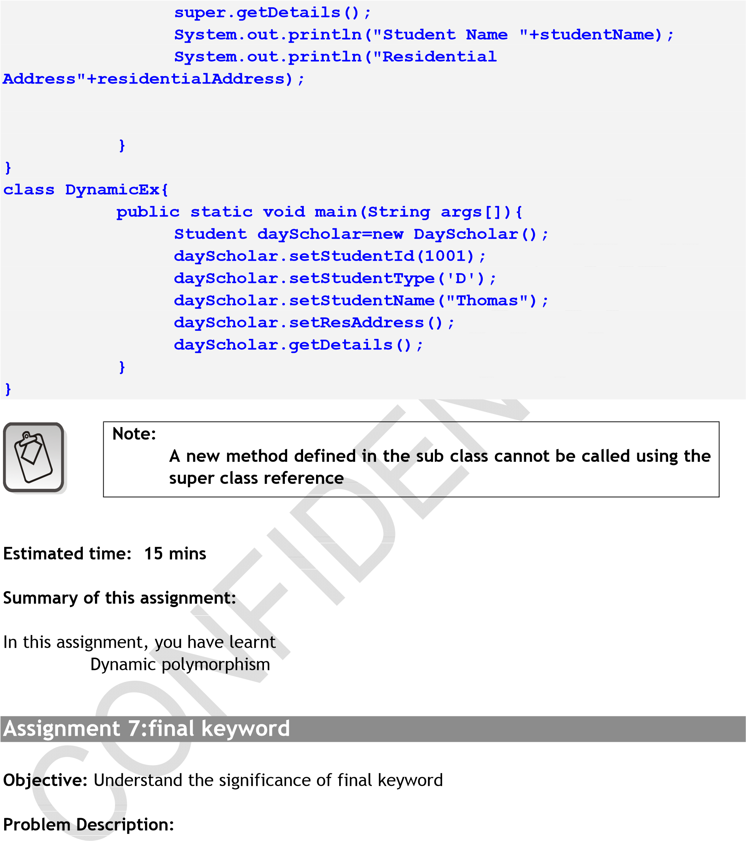

Reuse Assignment 6 of Day 4 to achieve the following:

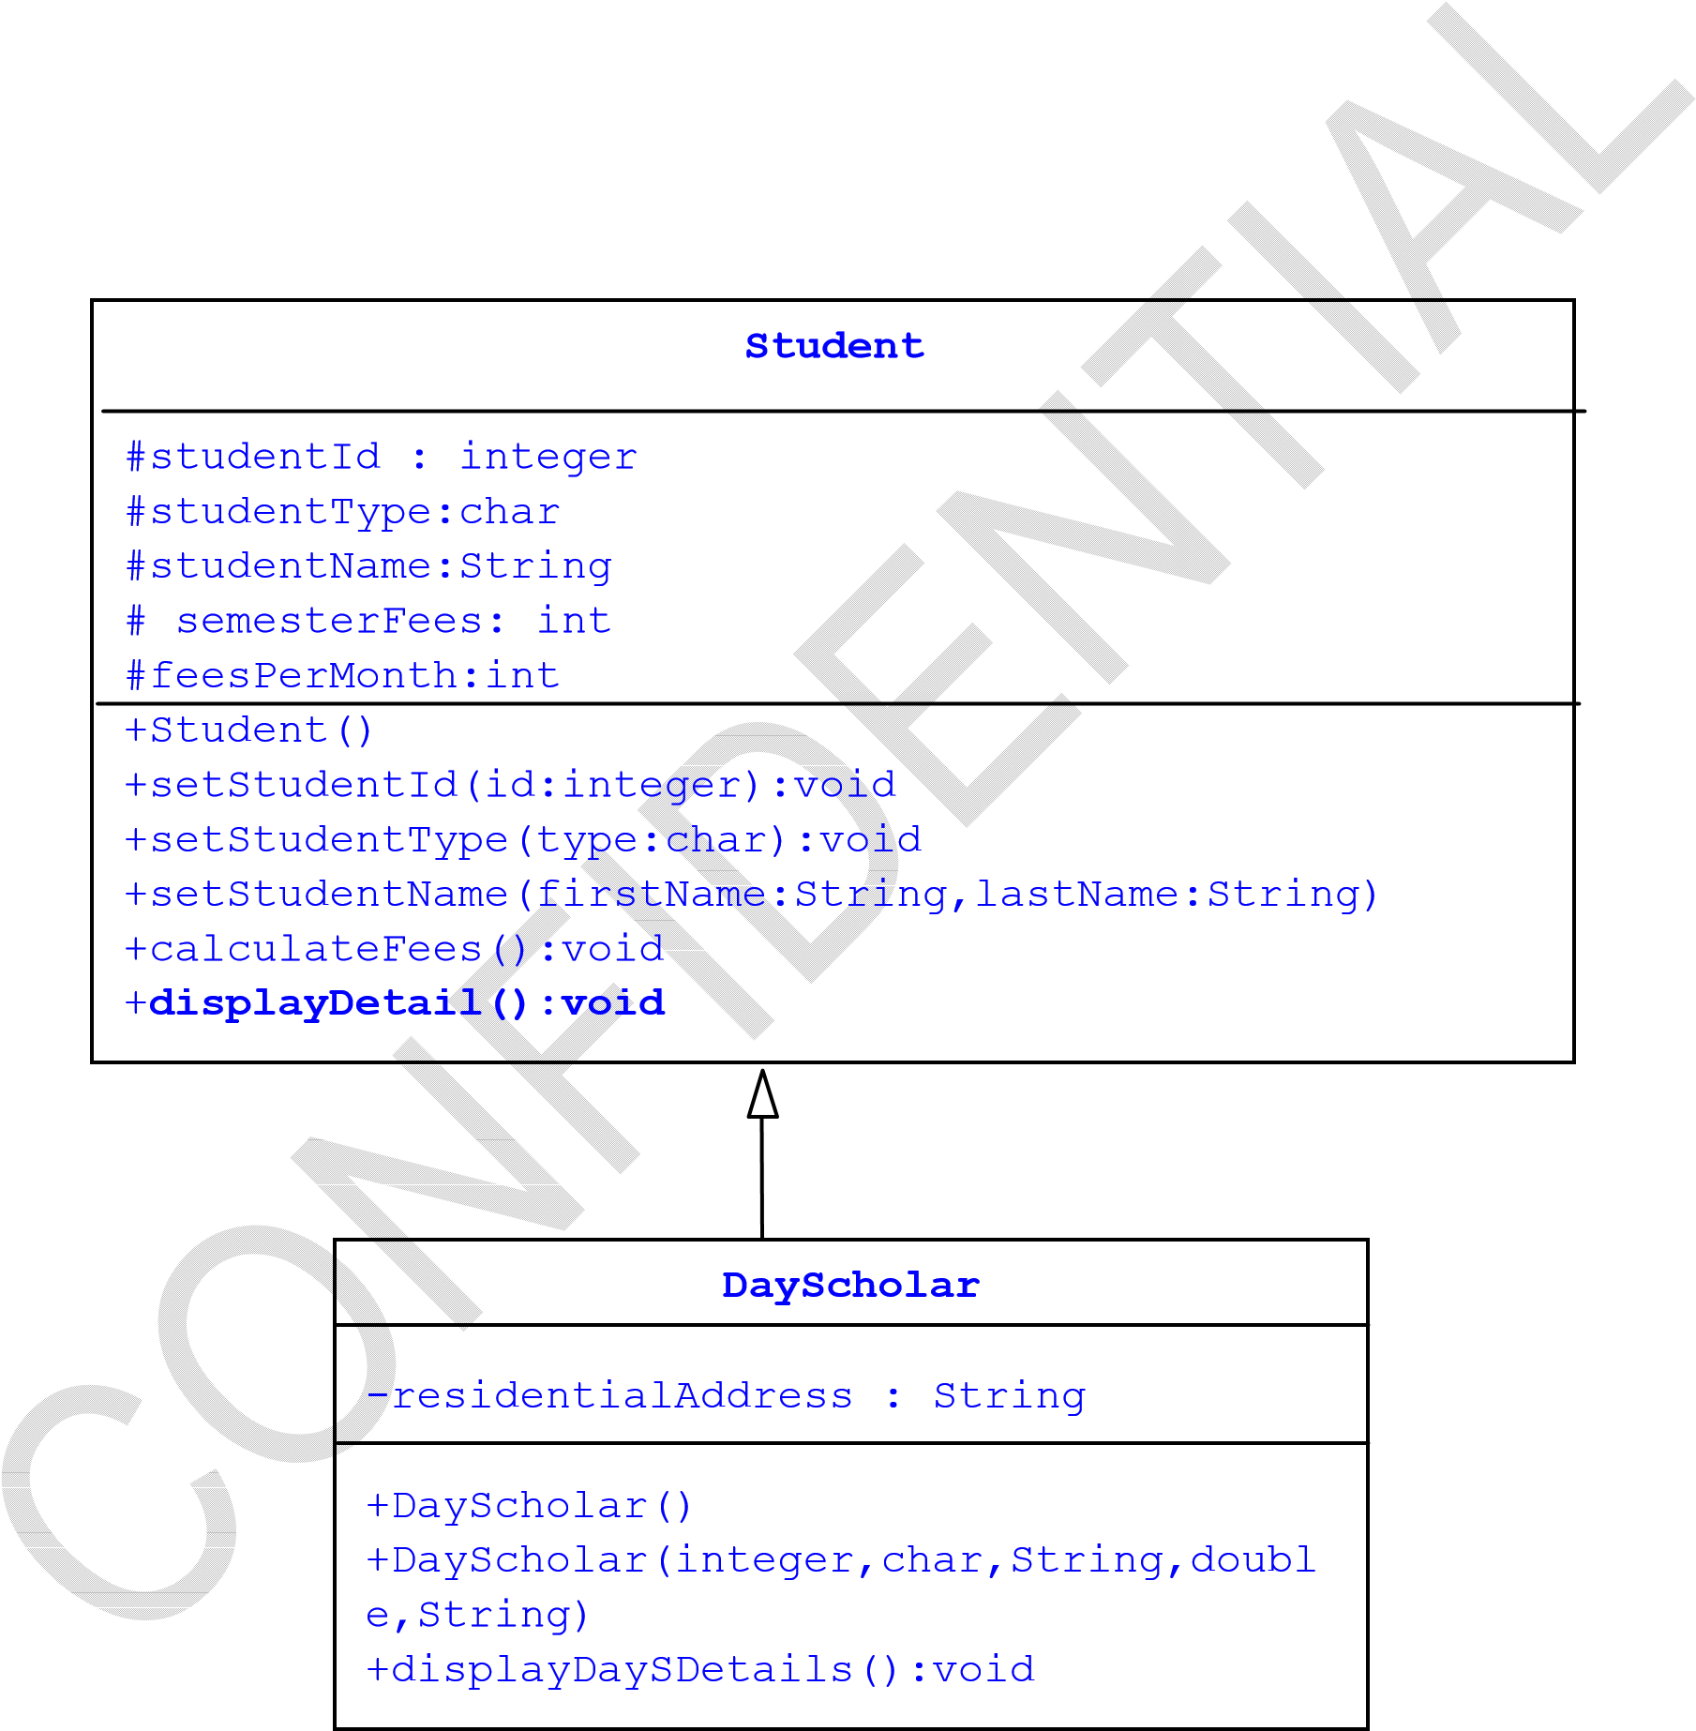

Step 1: Make the Student class as specified in the class diagram

Step 2: Data member semesterFees should be fixed as 12000

Step 3:displayDetail() should not be used in any of its derived classes to display the details Step 4:calculateFees() method should be given as below : void calculateFees(){

feesPerMonth = semesterFees / 6.0;

}

Step5:Make the class DayScholar in such a way that no other class should derive from DayScholar

Step 6: Code the displayDaySDetails() to display the details of DayScholar

Step 7: In main method,

1. Create object of type DayScholar by invoking the corresponding constructor and assign it to reference variable dayscholar
2. Set the value of all the data members with the help of setter method
3. Invoke the calculateFees method
4. Invoke the corresponding method to display the det~~ails of DaySch~~olar and Student

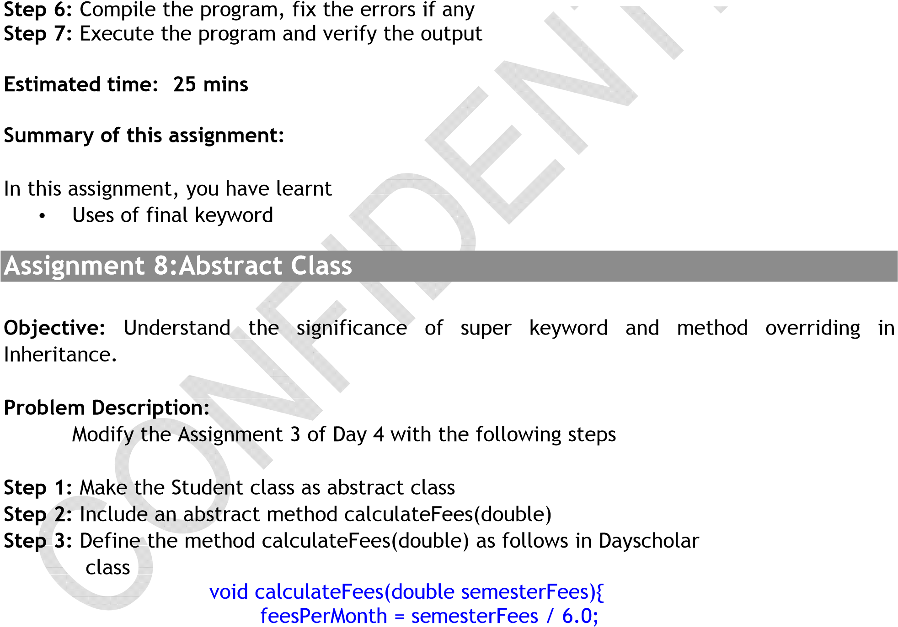

}

Step 4: Define the method calculateFees(double) as follows in Hostelite class void calculateFees(double semesterFee){

feesPerMonth = semesterFees / 6.0; // Add hostel fees Rs.1200

feesPerMonth = feesPerMonth+ 1200;

}

Step 5: In main method,

1. Create reference variable of type Student
2. Read the residential status of the student(from the command line argument using String as described in earlier assignments- Hostelite or Dayscholar), if (s)he is a hostelite then create object of type hostelite by invoking the parameterized constructor and assign it to reference variable named student otherwise, create object of type dayscholar by invoking the corresponding parameterized constructor and assign it to reference

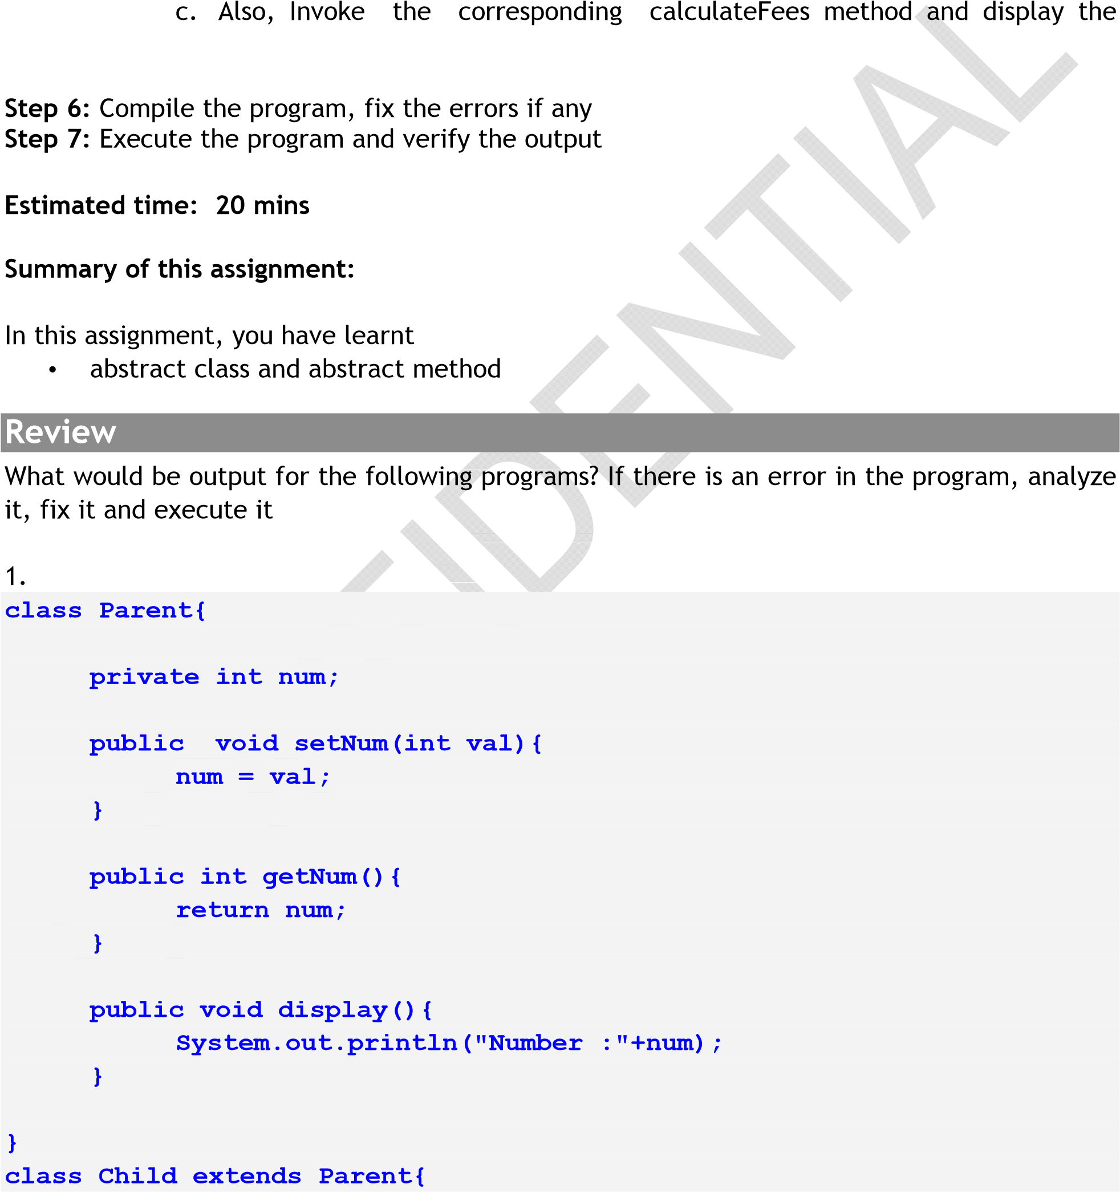complete student details

**private int val; public void setVal(int num){**

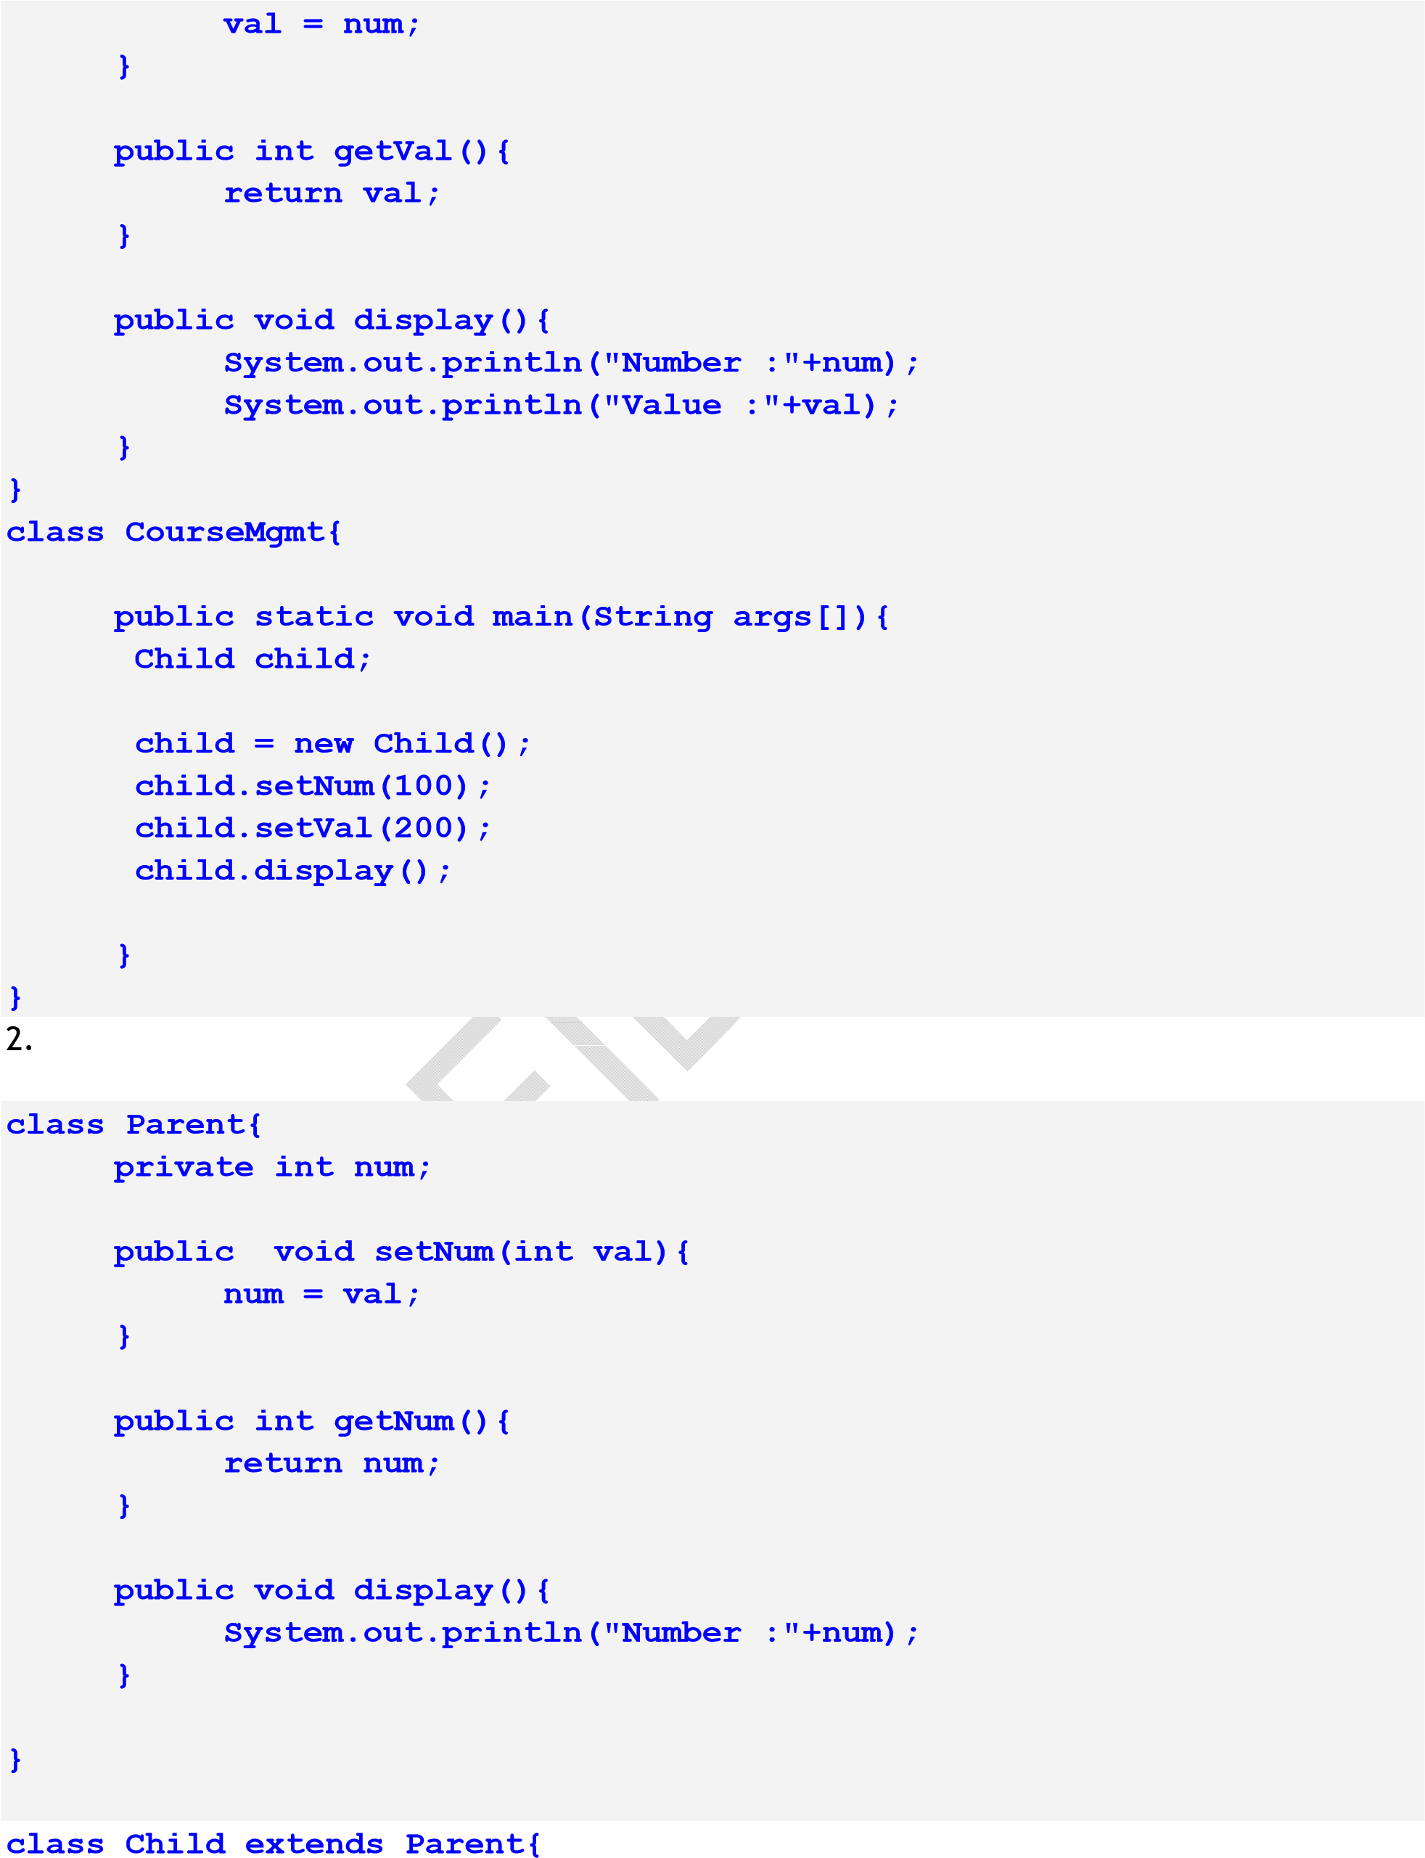

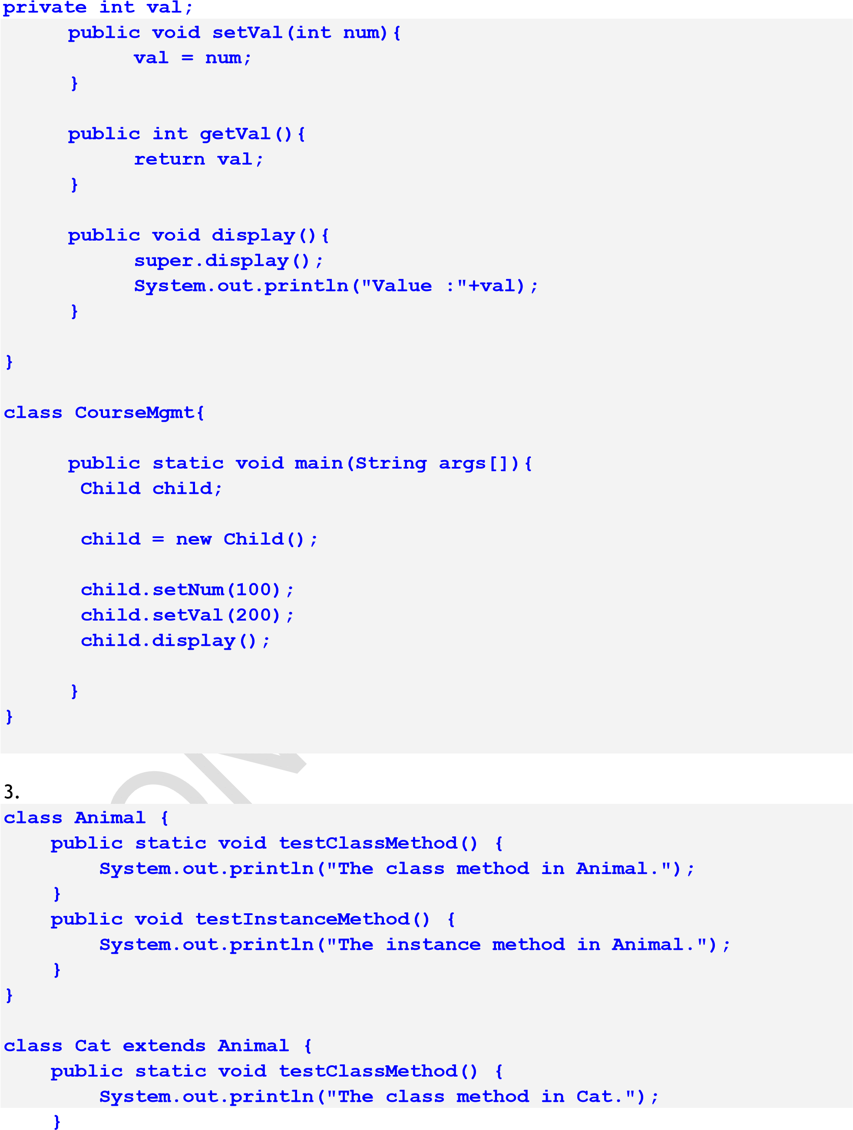

**public void testInstanceMethod() { System.out.println("The instance method in Cat.");**

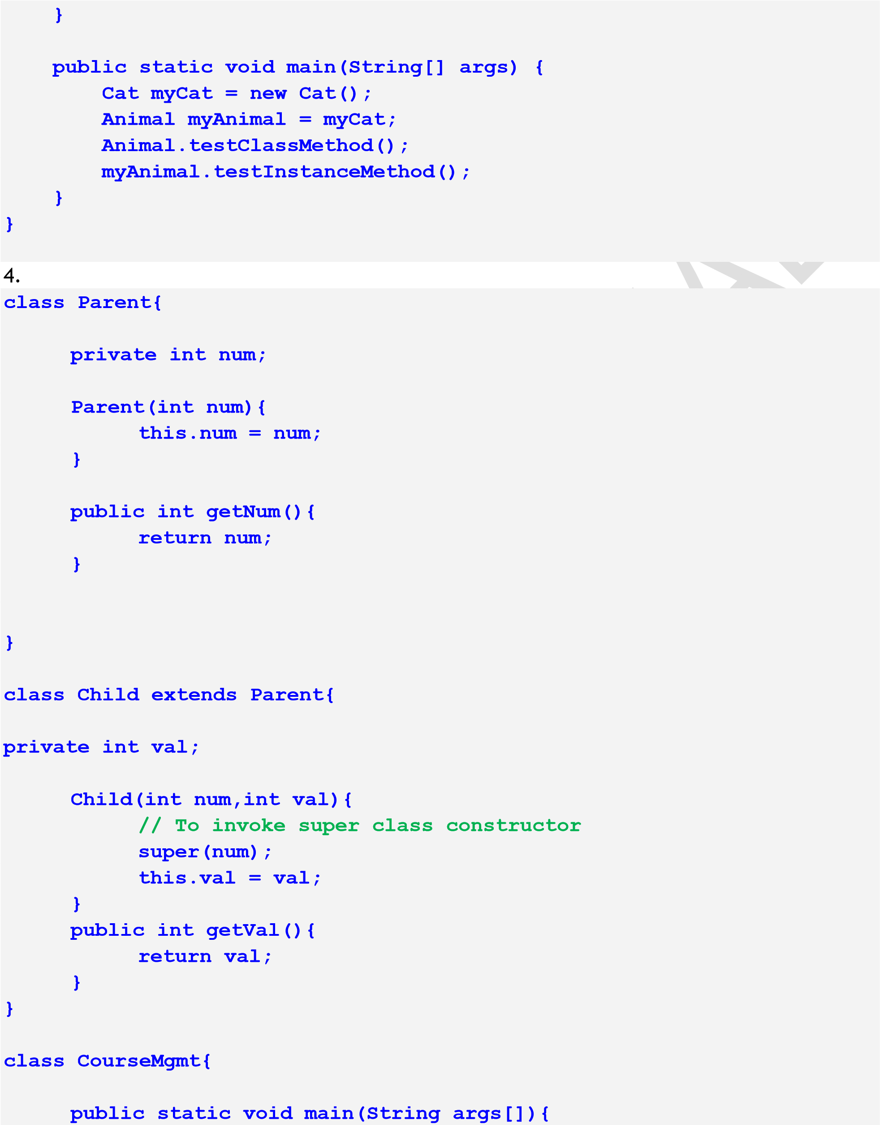

**Child child;**

**child = new Child(100,200);**

|  |  |
| --- | --- |
| **}** | **System.out.println("Parent: Num:" + child.getNum()); System.out.println("Child: Val:" + child.getVal());**  **}** |

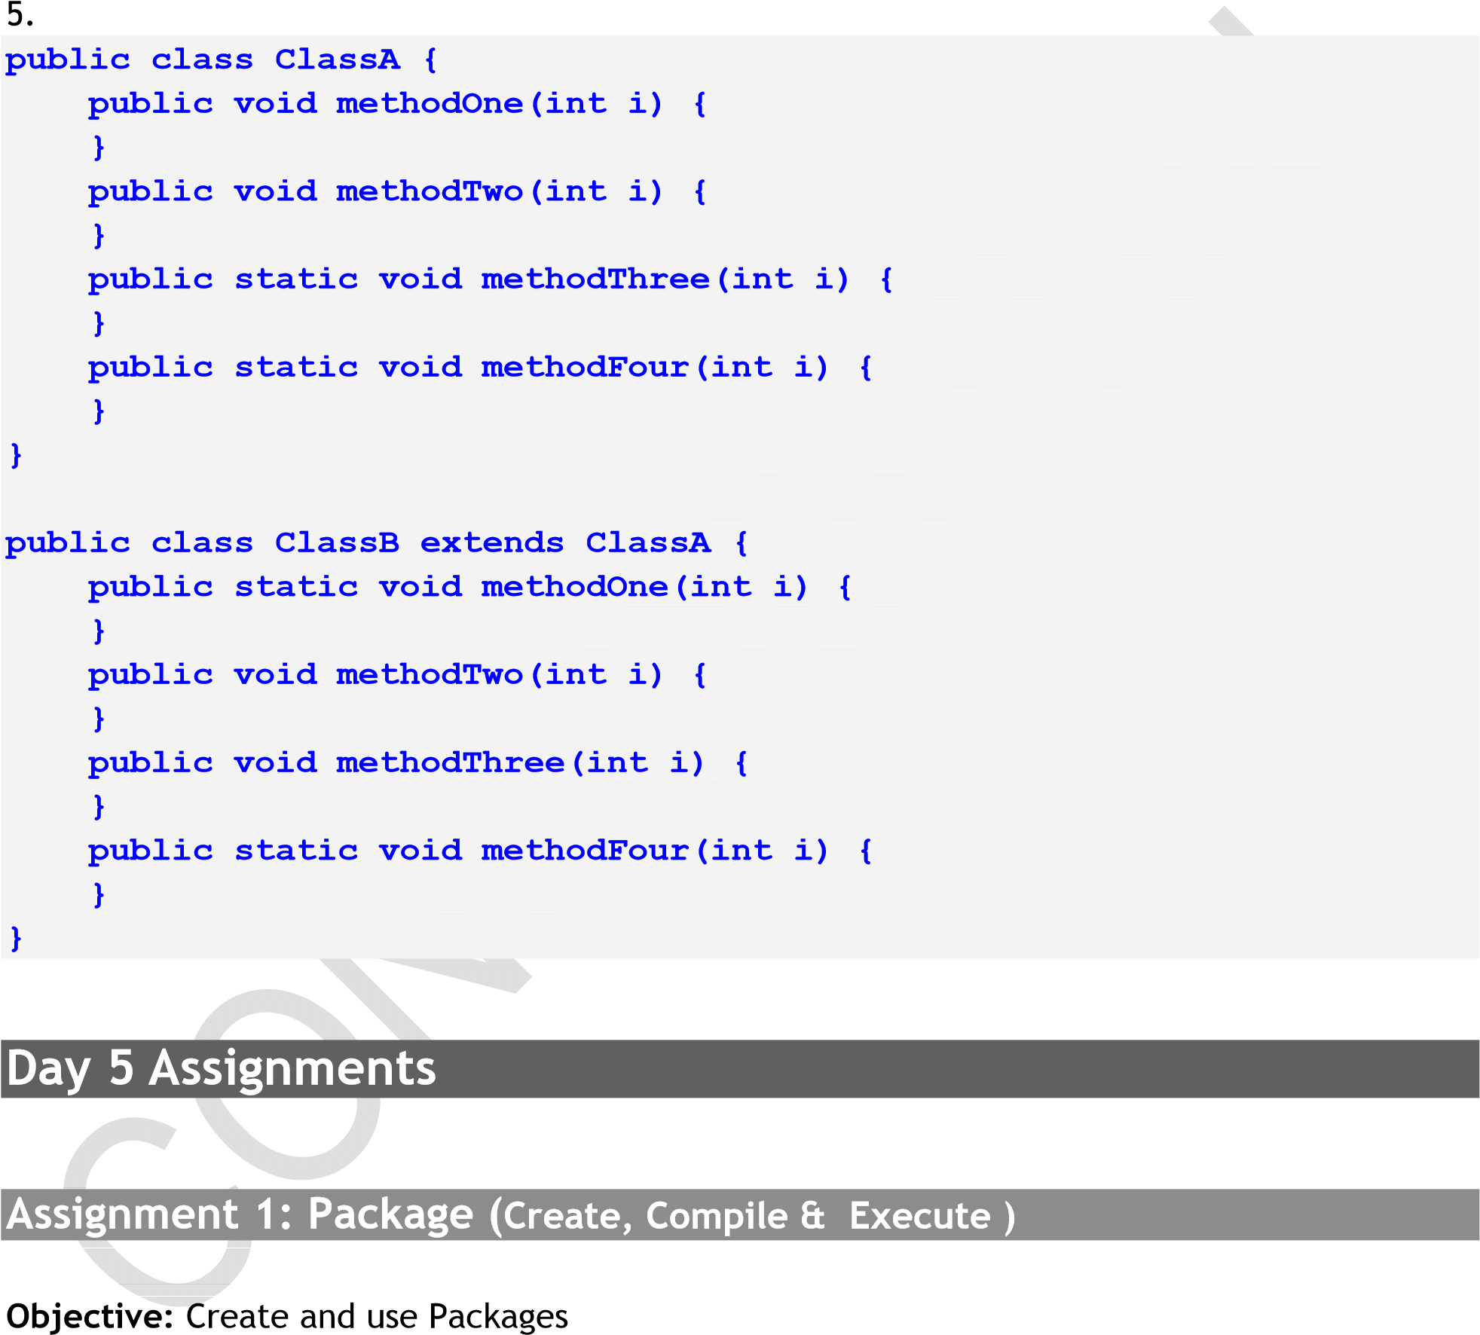

Problem Description: To display student details using package program

Step1: Write the following program in a textpad

**package courseregistration;**

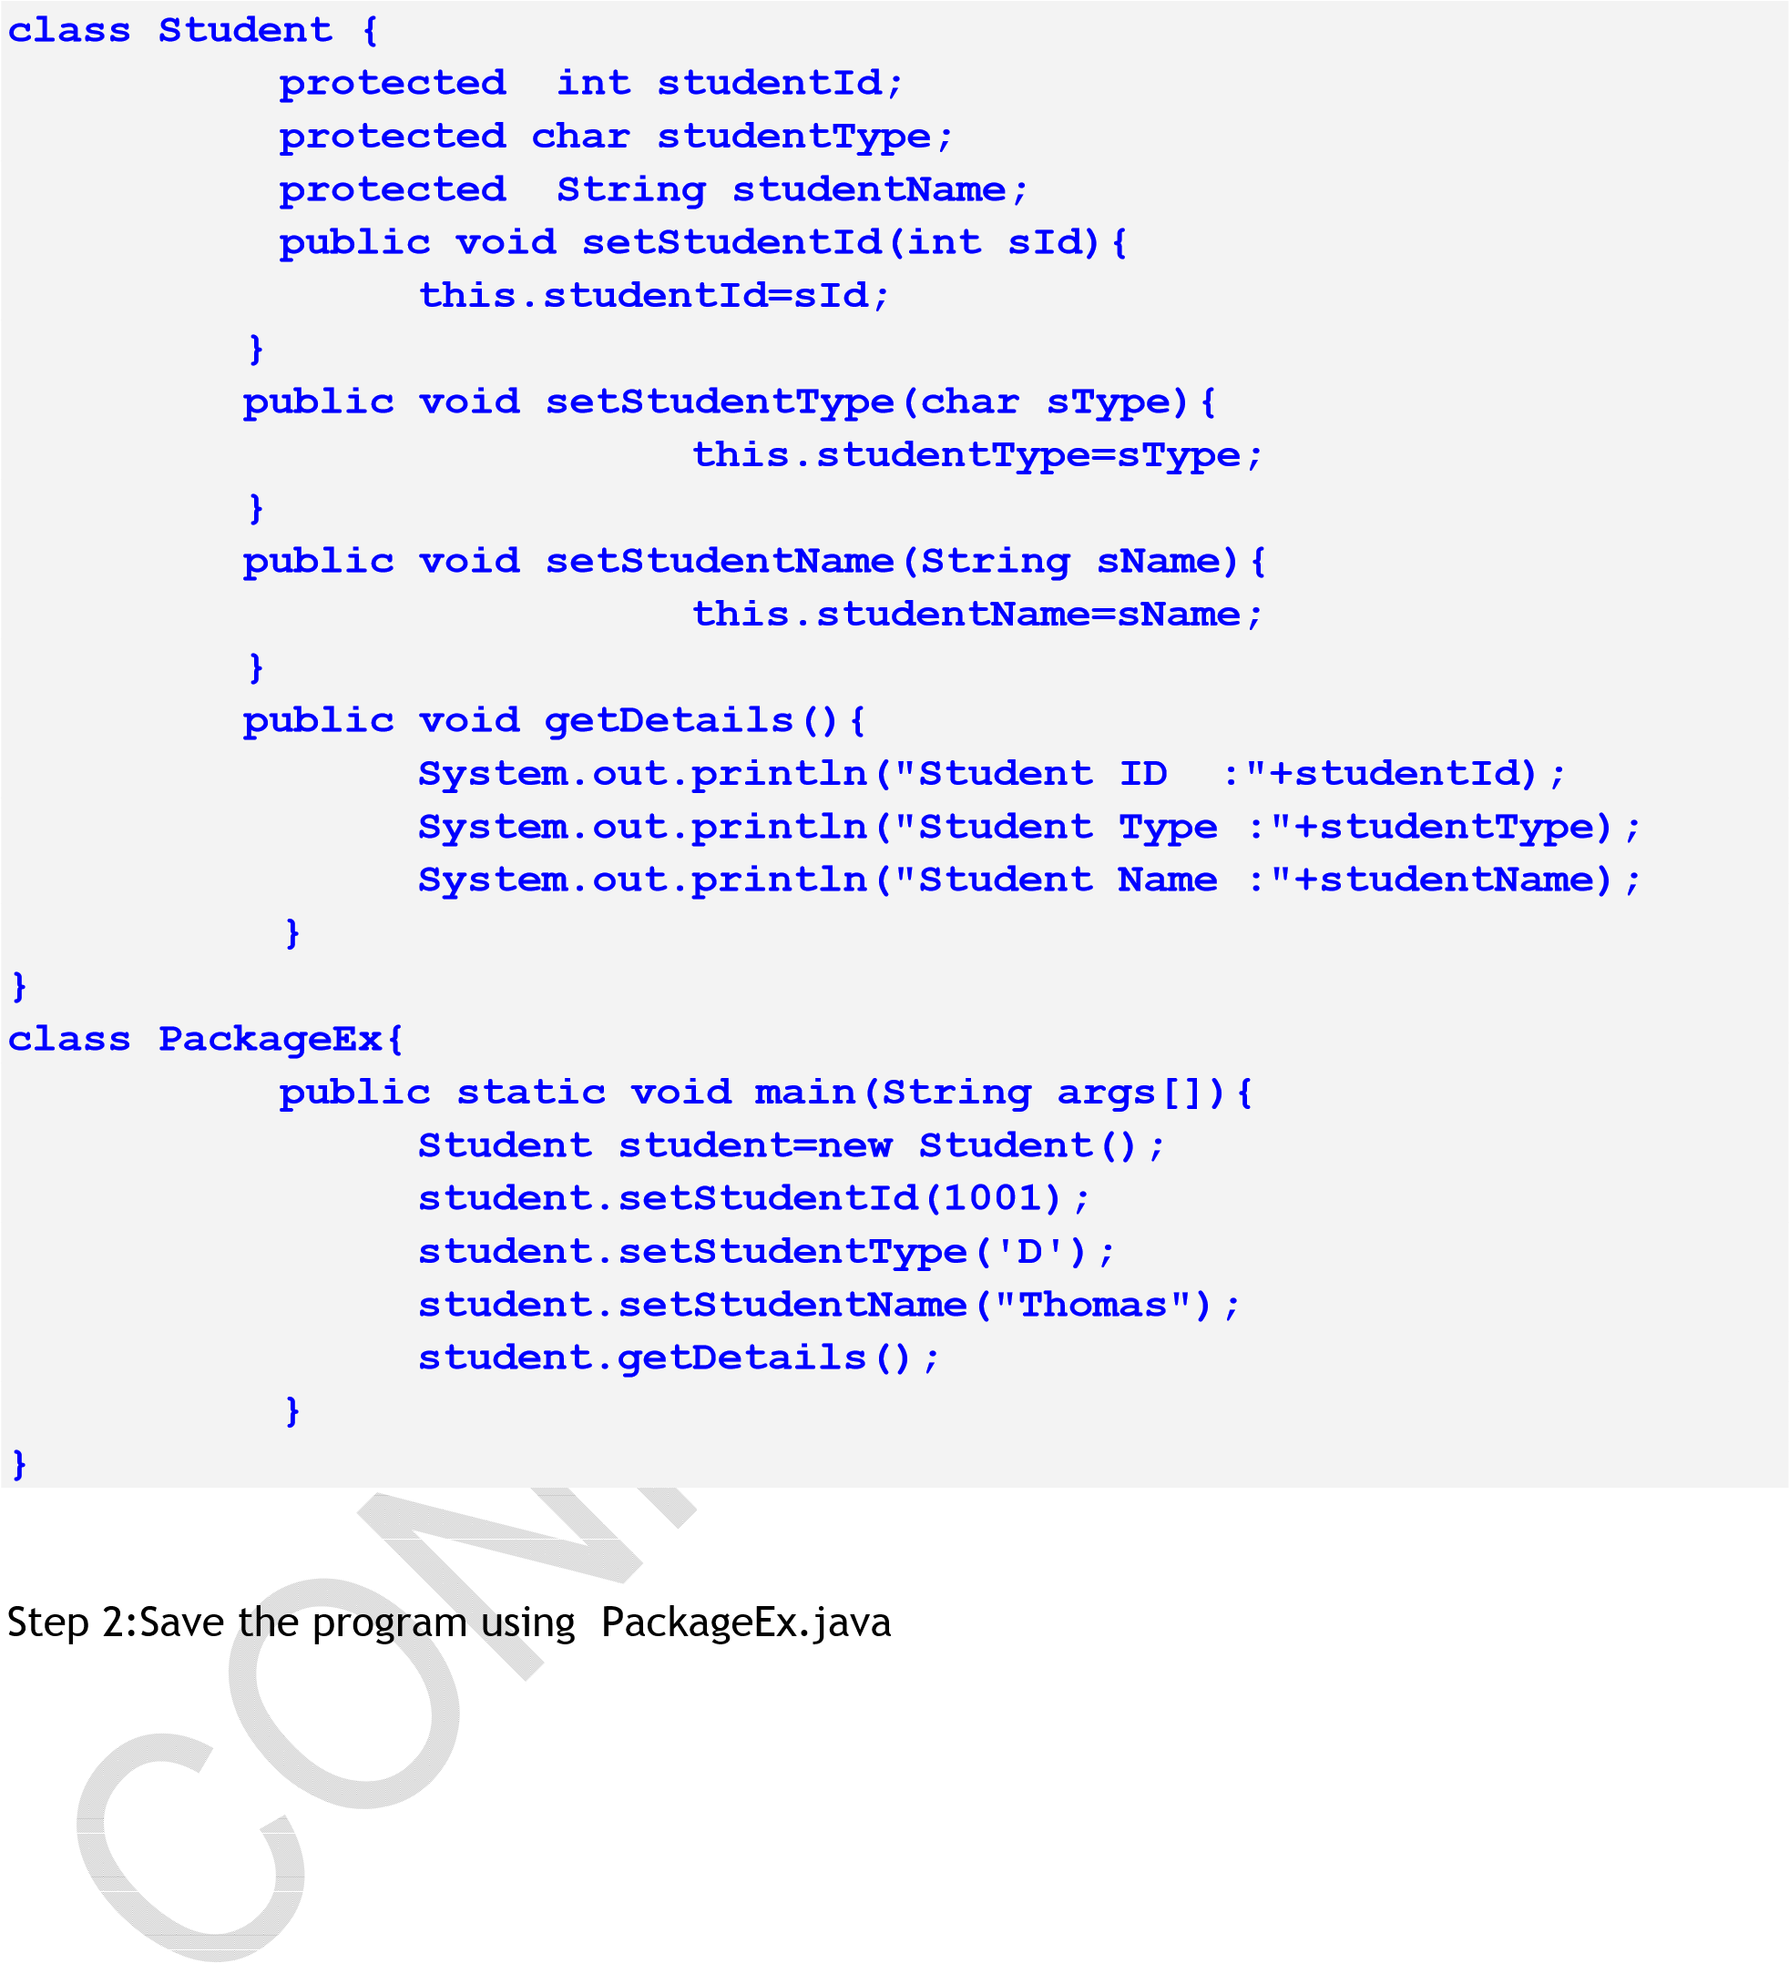

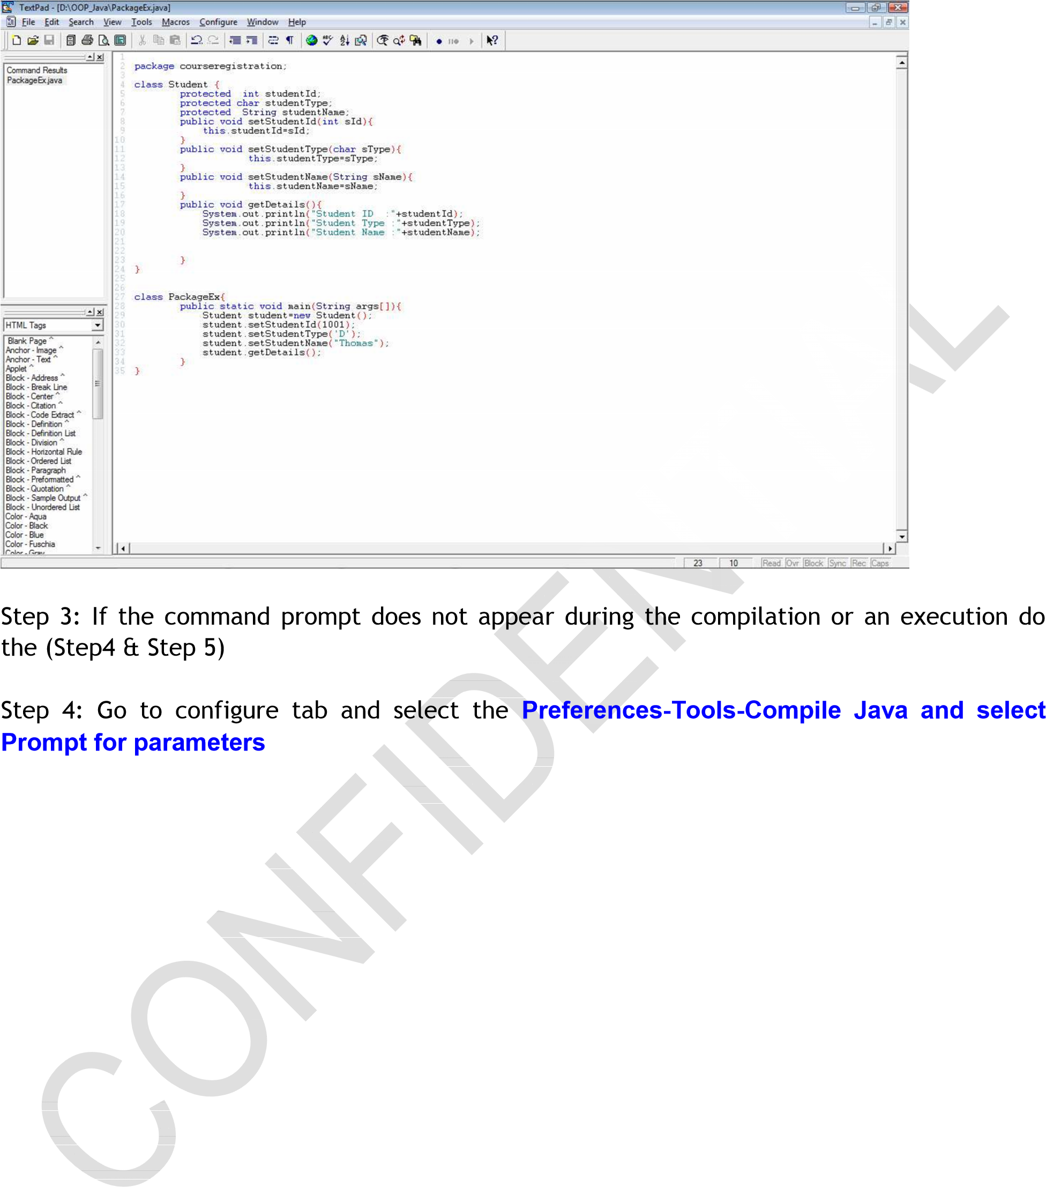

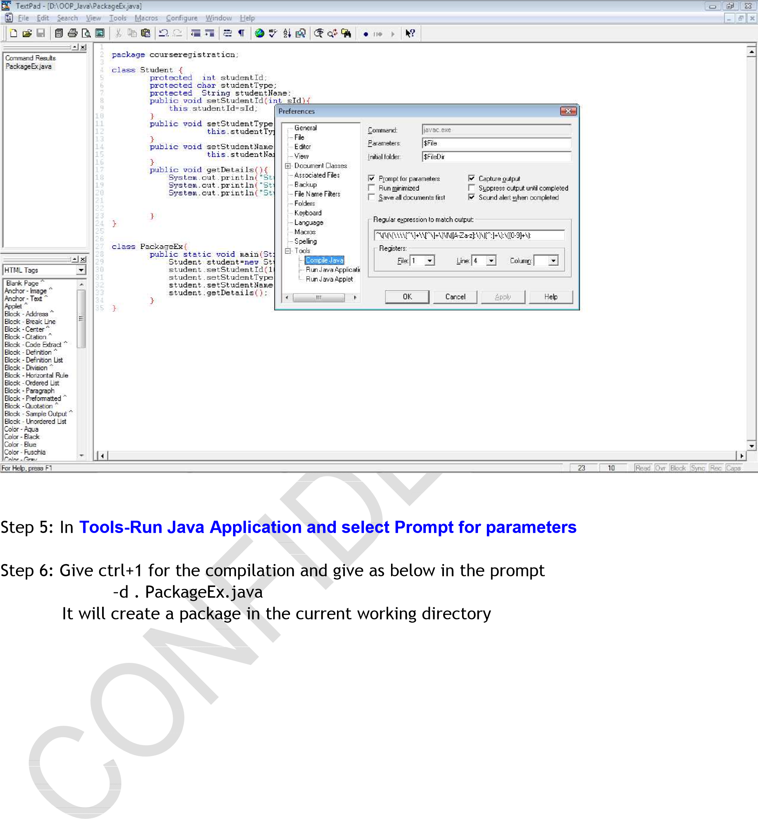

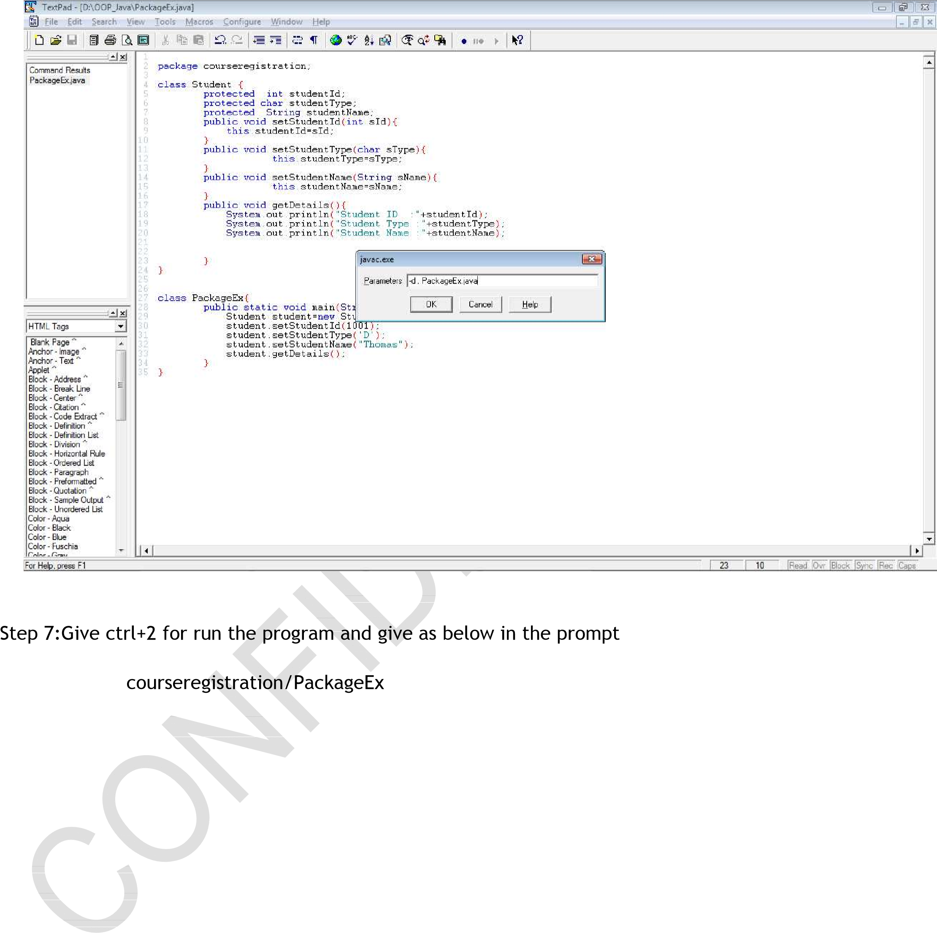

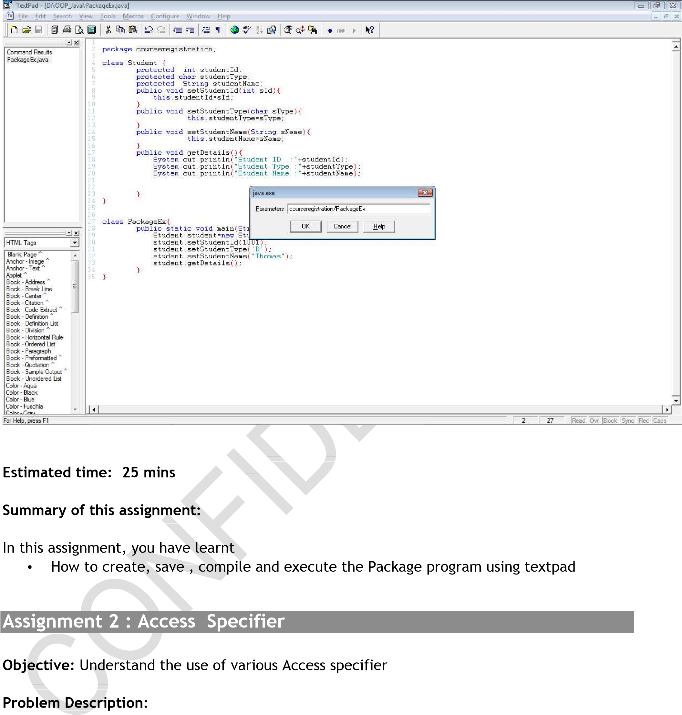

Analyze the problem, Debug the code and display the result in the following format

Student Id:1001 Student Type:D

Student Name:Dinil

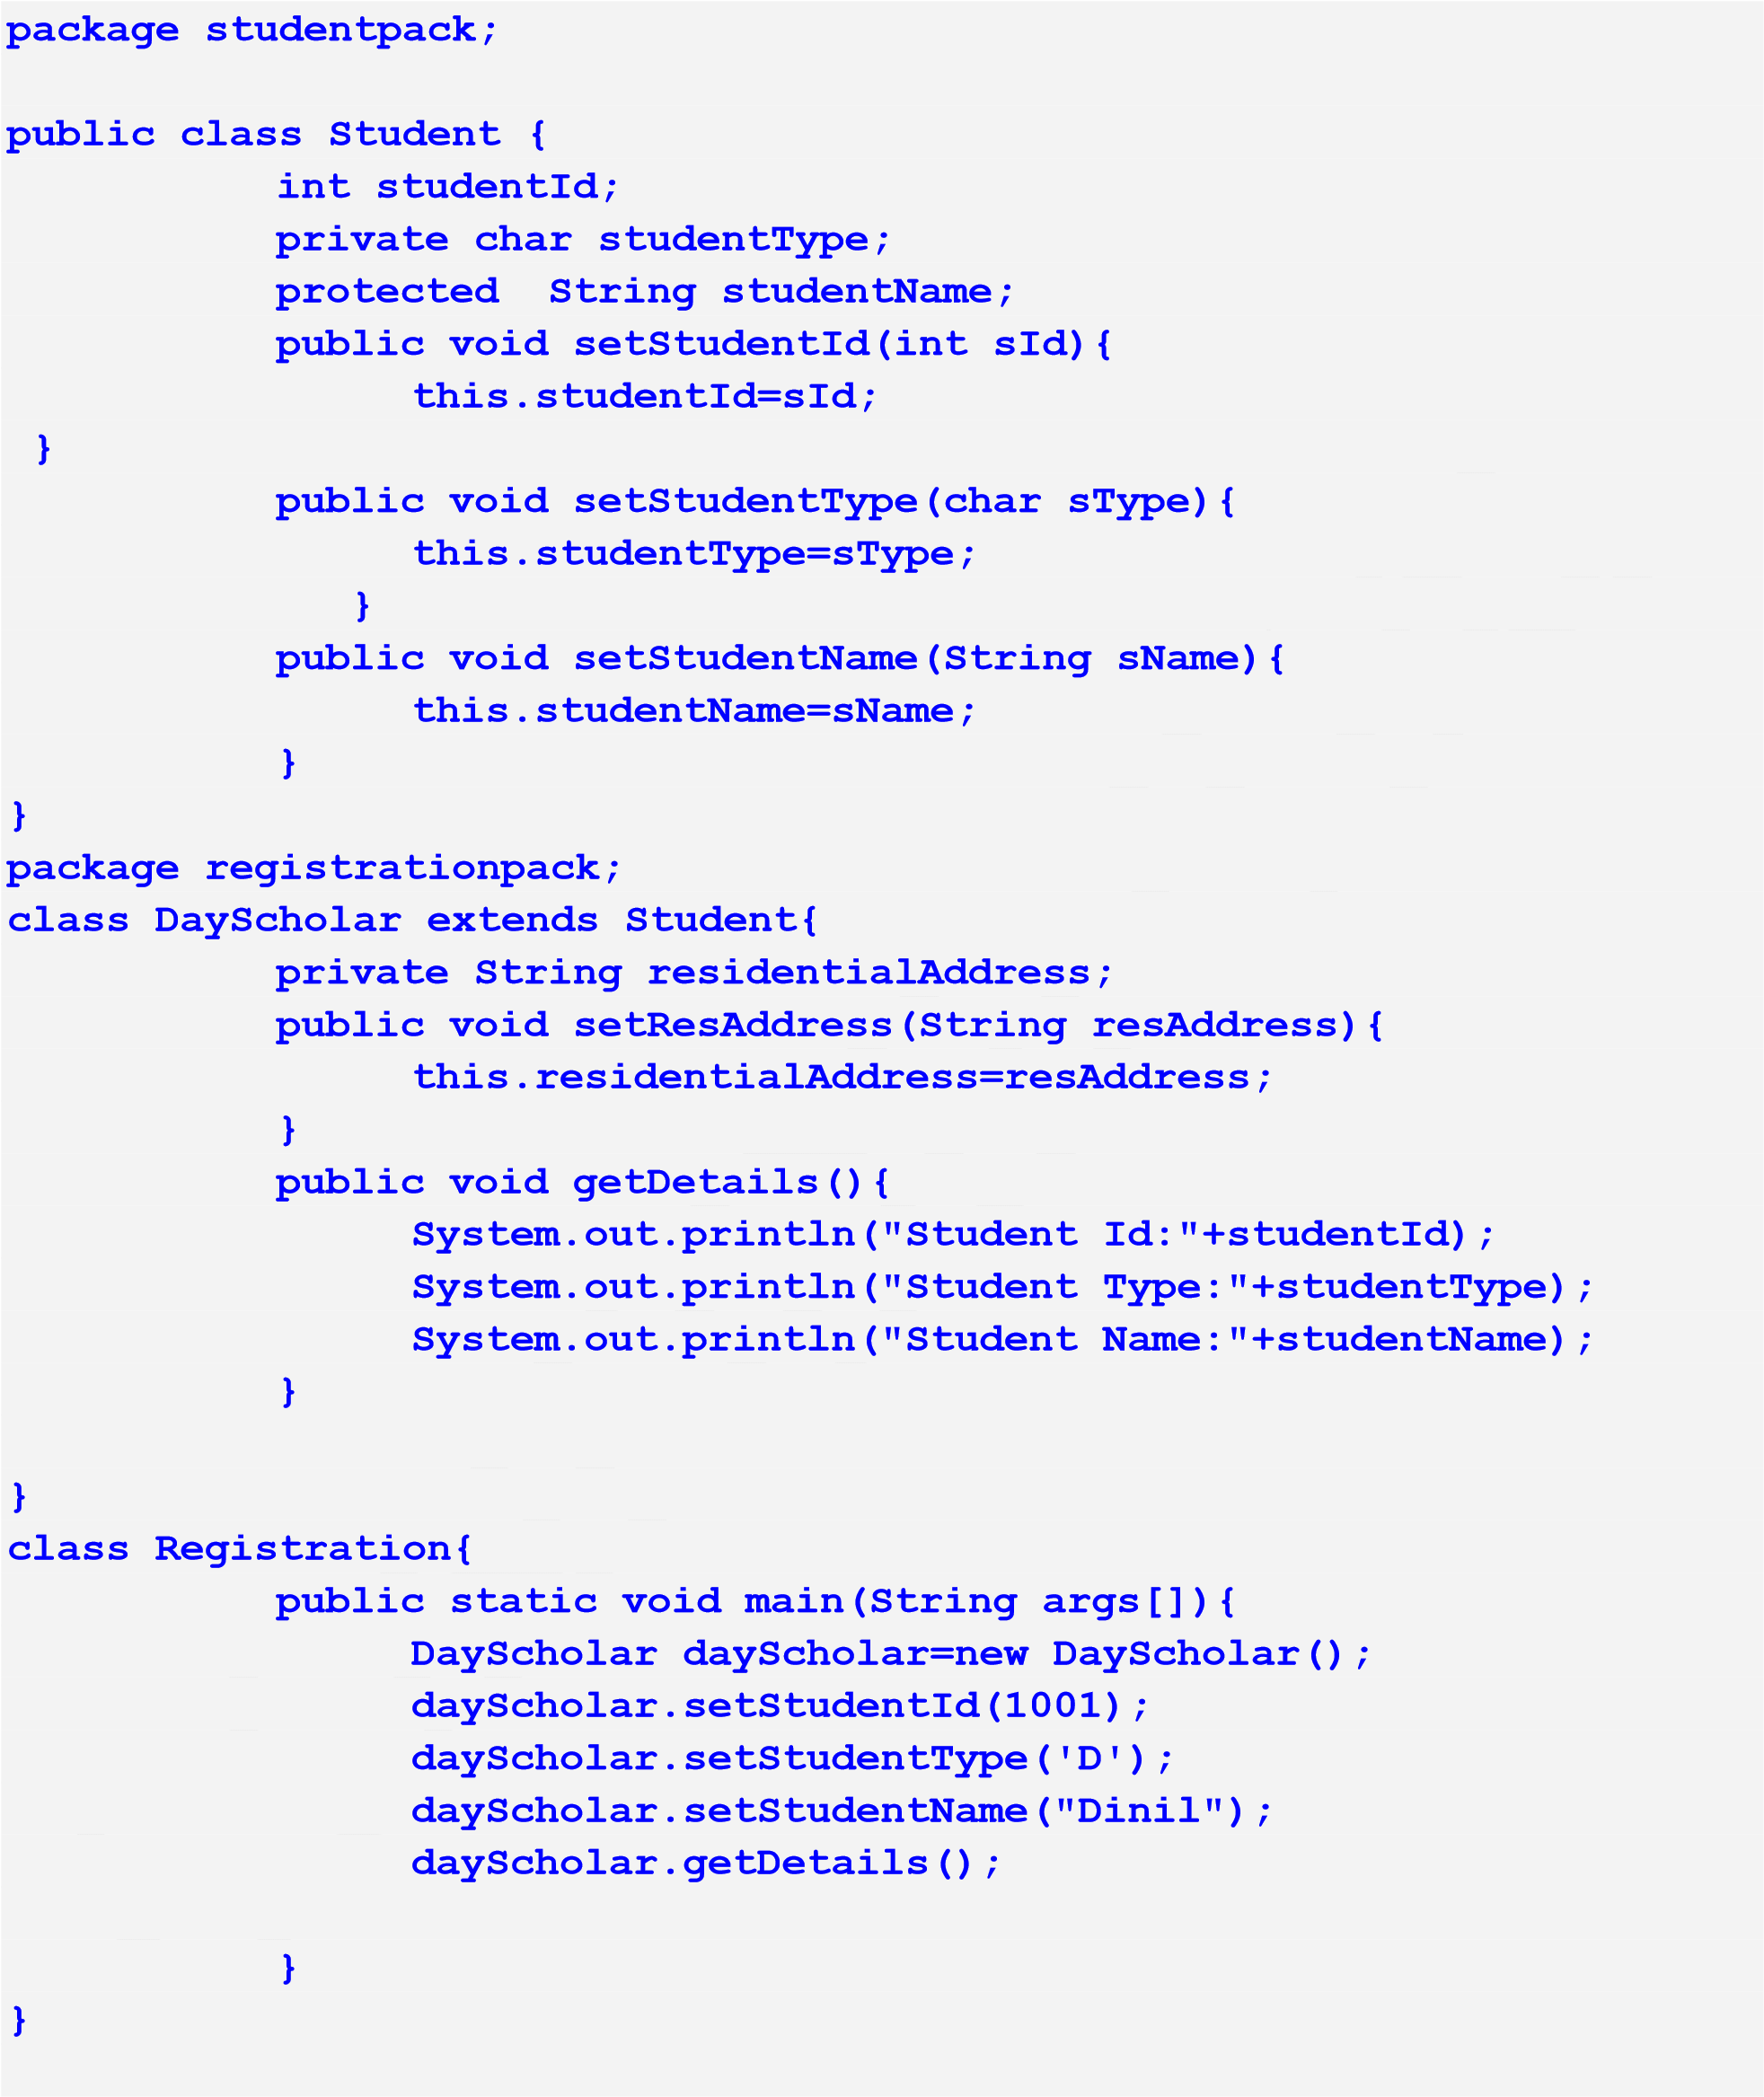

Note: Compile the class Student separately in a package called courseregistration. There is no error in this code. Compile the DayScholar and Registration classes separately in the package registrationpack. There are some access related errors, analyse them, debug and execute to get the output.

Estimated time: 20 mins

Summary of this assignment:

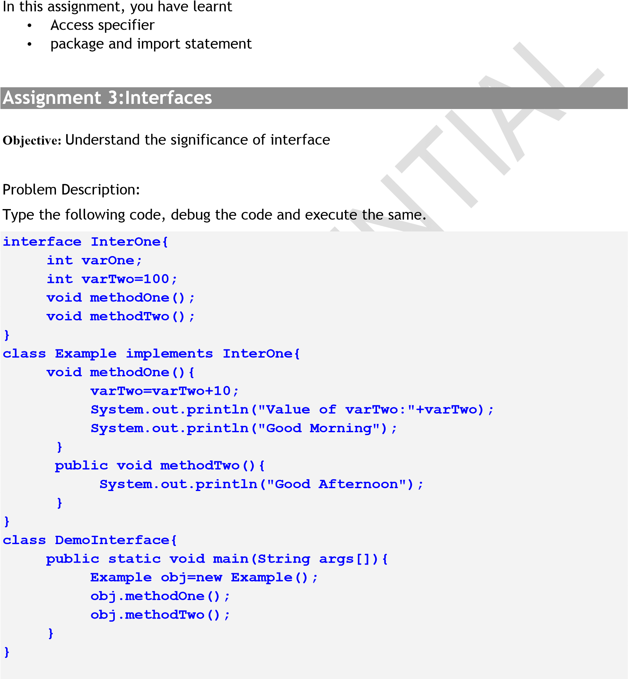

Estimated time: 15 mins

Summary of this assignment:

In this assignment, you have learnt

Interfaces

Assignment 4: UML – Use Case Diagram

Objective: Analysis of the case study and design the Use Case Diagram.

Problem Description: Course Management System

A Course Management System needs to be developed for a~~n engineering~~ college. The college wants an automated system to replace its manual system for purpose of allocation of students to courses and lecturers to courses. There are around 10000 students and 500 faculty members in the college. The engineering college provides graduation and post graduation in the various branches of engineering.

In any branch, the entire duration is divided into semesters. Each semester includes various courses. Students admitted into the college can apply for various courses. The courses are elective in nature. The student needs to select two electives. The electives are offered from 5th semester onwards for graduate students and from 3rd semester onwards for the post graduate students. The graduate students need to undergo a final year project in the fourth year of engineering where~~as the po~~st graduate student undergoes a thesis submission in the second year. The complete list of courses, lecturers and students is maintained in the college. The list is constant and cannot be updated by the system. The automated system uses this list for allocation of courses.

The lecturers can be categorized into full time lecturers and visiting members. The full time lecturers have target days of course delivery and are paid salary every month. The visiting members ge~~t paid per le~~cture basis and do not have any target days.

The system is used by the admin staff to register students admitted to college to the courses they opted. The system needs to be authenticated with a login id and password. The system would be used by the students to view the marks and the attendance details also. The system is used by the HOD (Head of the department) to allocate courses to the lecturers. At the beginning of the semester, the HOD will do the allocation of lecturers to the classes for his department. The HOD may make changes in the allocation during the progress of the course. The system maintains a history of all the lecturers who have handled the courses throughout the semester .The lecturer will use the system to update the marks of the student (project, assignment, internal test marks and the semester end examination marks). The lecturer will also mark the attendance of the students through the system.

In addition to the above, the system also keeps track of the residential status of the student. The student may be a host-elite or a day scholar. If (s)he is host-elite, the system will maintain his / her hostels name, room number and the fees pertaining to the same.

Note: This is the same case study provided in Day 1 assignment.

Step 1: Identify all the ‘nouns’ i.e. the actors in the problem statement.

Step 2: Identify the activities i.e. the use cases. Connect the actors to the use cases.

Step 3: Identify the relationships.(Generalization, specialization, Includes)

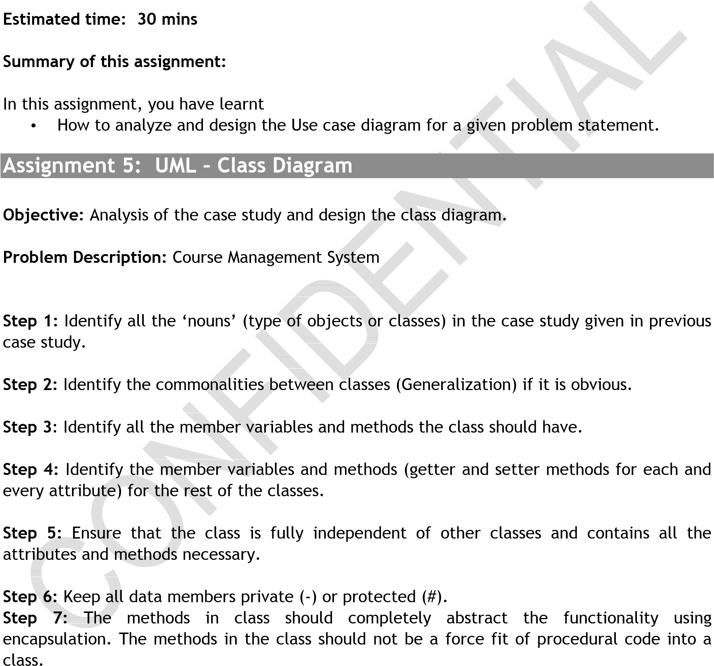

Step 8: Inherit and extend classes from the base class ONLY IF situation has scope for it. Shift the commonalities among classes to the base class

Step 9: Define the “Has-A” and “Uses-A” relationship among classes

(Is-A has been defined already in previous step)

Step 10: Keep the number of classes in your application under check (Do not create any unnecessary classes)

Step 11: Review your design

Estimated time: 30 mins

Summary of this assignment:

In this assignment, you have learnt

• How to analyze design a class diagram for the given problem statement.

Assignment 6: Case study of D-Rail Inc.

D-Rail Inc. is a metropolitan railway corporation op~~erating in a lar~~ge city and its suburbs. DRail has an ambitious plan to computerize its ticketing system. The IT department of D-Rail has come up with an OO design for their ticketing system. Now, they require the design to be validated for correctness.

The ticketing system addresses the needs of the metro rail service of D-Rail between the city and its suburbs.

Requirements of the Ticketing System:

A Ticketing Clerk at one of the D-Rail counters can issue the following kinds of tickets to commuters:

One Time ticket: Used for one way travel. It has to be used the same day it is issued.

Return ~~ticket: Used~~ for two way travel. Onward journey has to be done on the date of issue. However, the return journey can be done any time within a week from the date of issue.

Multi-use ticket: Used for traveling many times between an origin and destination stations (onward or return). Multi-use tickets are available 10, 15 and 20 trips denominations, which are also specified in the ticket. However the ticket has an expiry date which is two months from the date of issue. Every time the ticket is used, one trip is deducted.

All tickets have information on the origin and destination stations.

All the tickets issued are magnetic tickets which store the entire ticket information. This information will be verified by the ticket reading machine at the entry points.

Step 1: Design the Class diagram

Step 2: Implement the Class diagram using Java

Estimated time: 30 mins

Summary of this assignment:

In this assignment, you have learnt

• To understand a complex software system and design the Use Case and Class diagrams

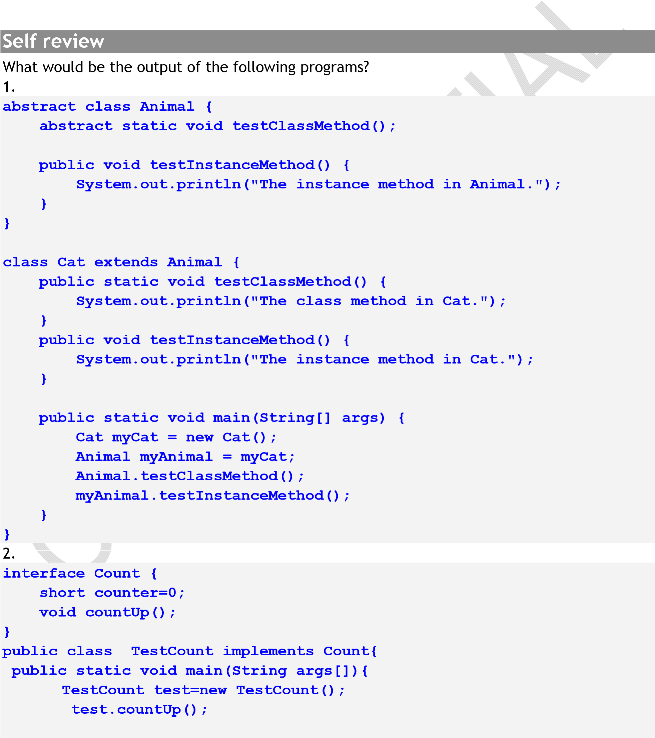

|  |
| --- |
| **} public void countUp(){**  **for (int x=6;x>counter;x--,++counter){**  **System.out.println(" "+counter);**  **}**  **}**  **}** |

3.

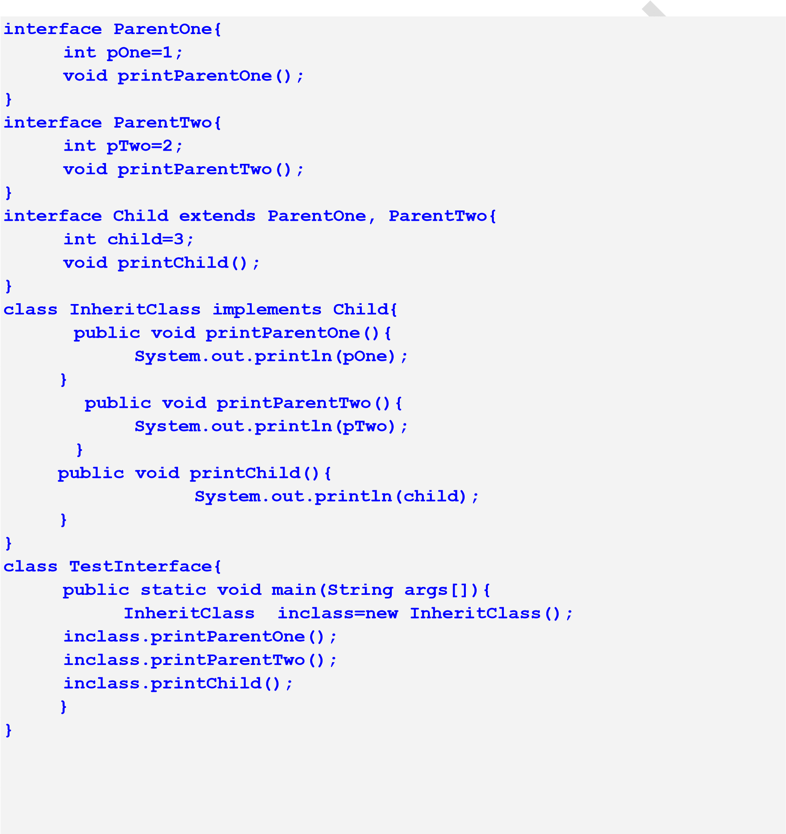

Case Study based Assignments

Case Study 1 – Banking System

Day 2 Assignment 1: If-else condition

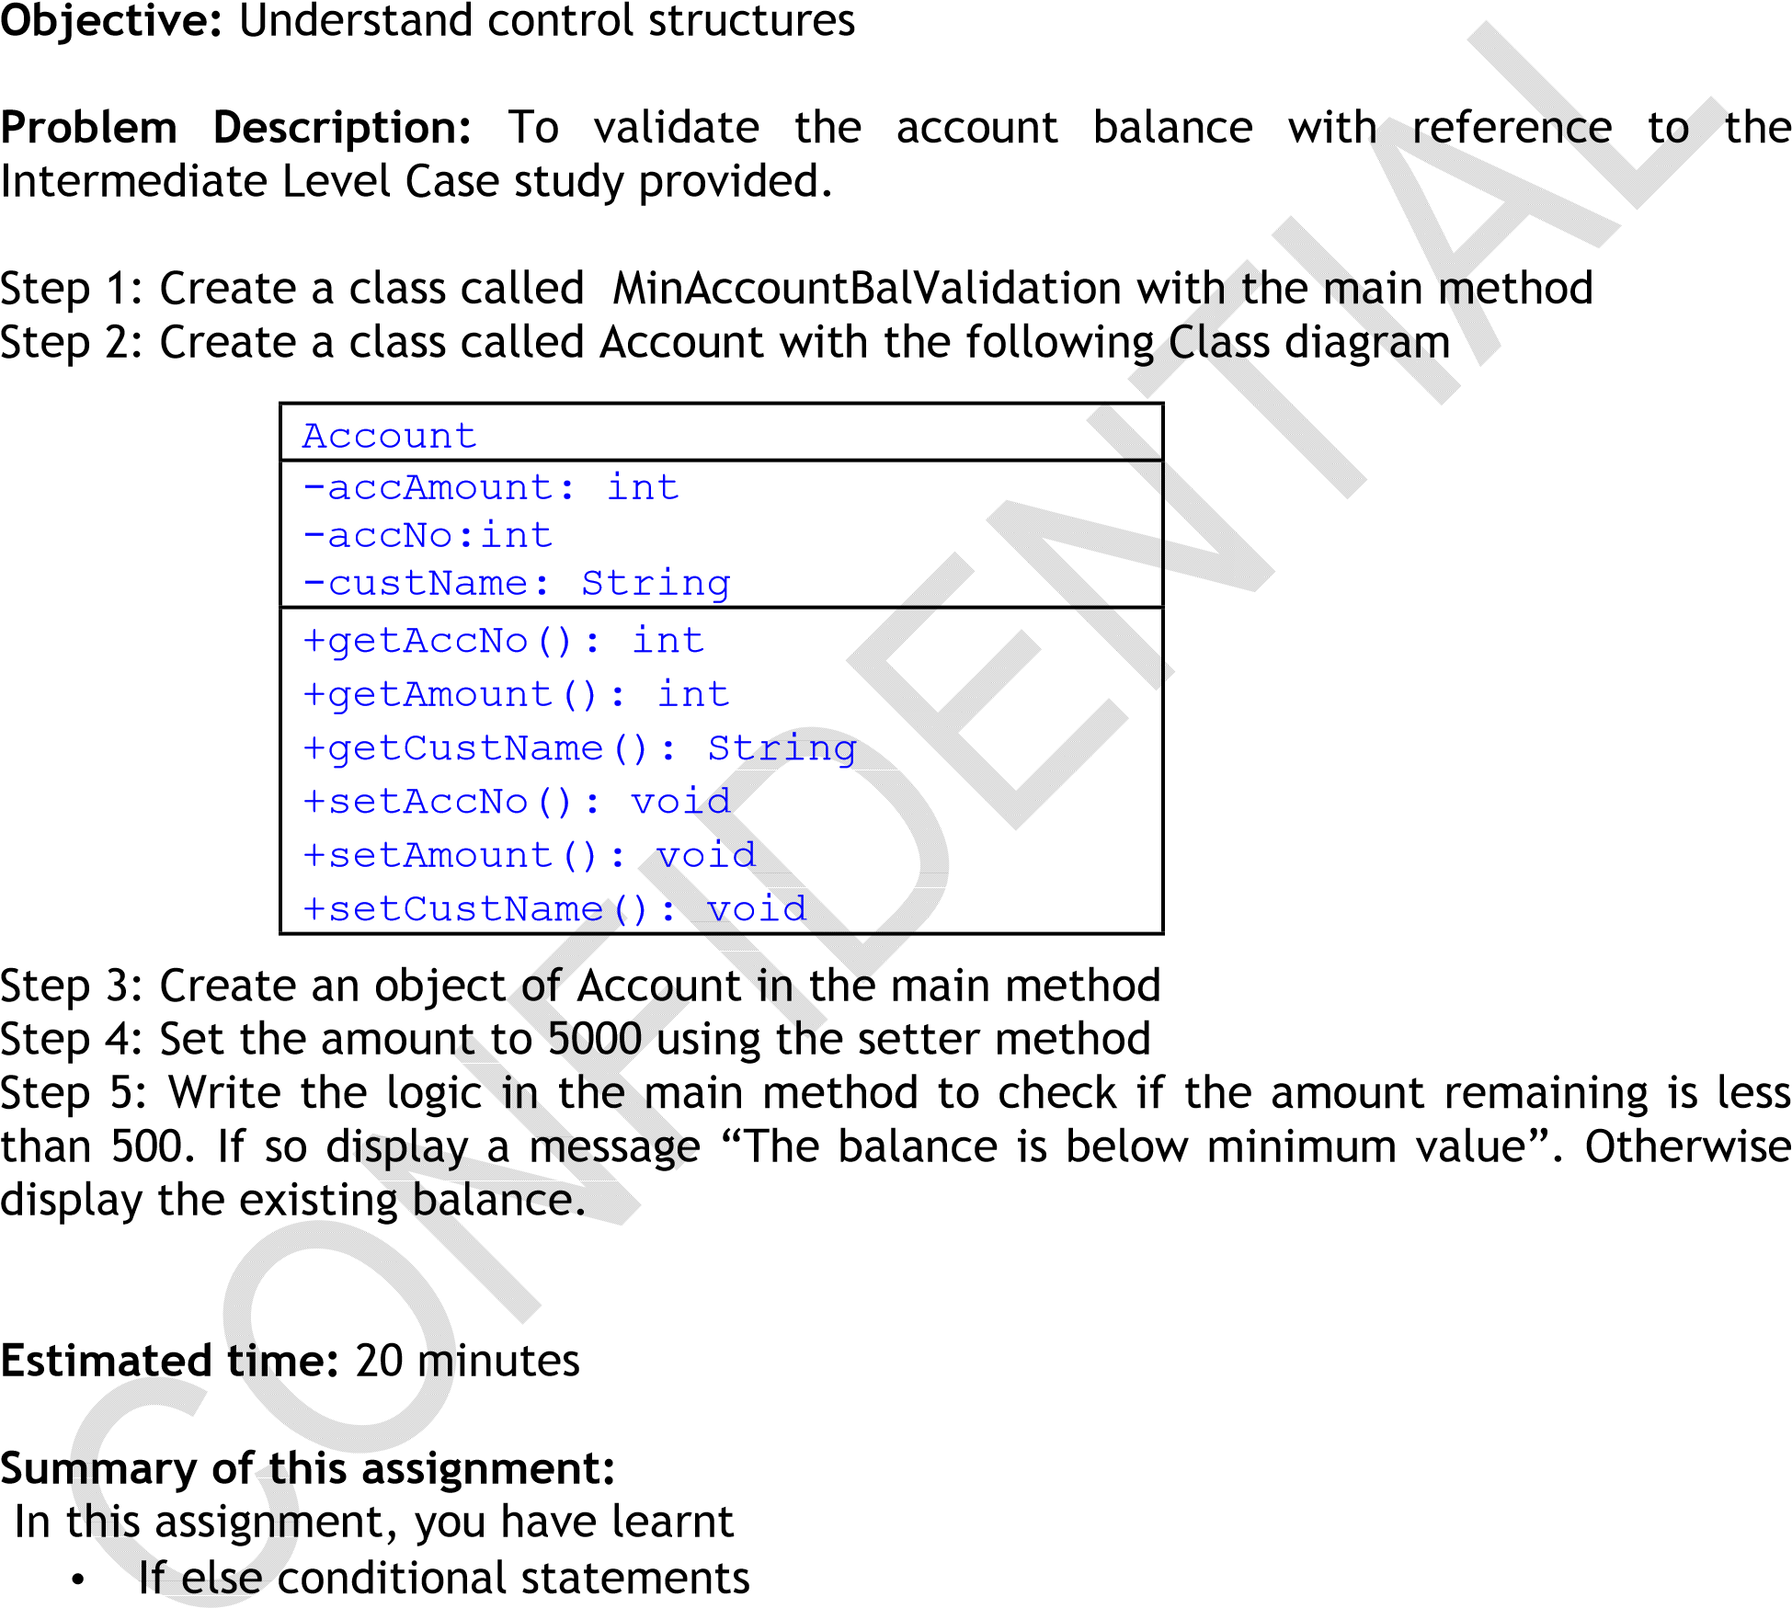

Case Study 2 – Travel Management System

Day 2 Assignment 1: If-else condition

Objective: Understand control structures

Problem Description: To validate the mode of travel with reference to the Intermediate Level Case study provided.

Step 1: Create a class called Demo with the main method

Step 2: Create a class called Travel with the following Class diagram

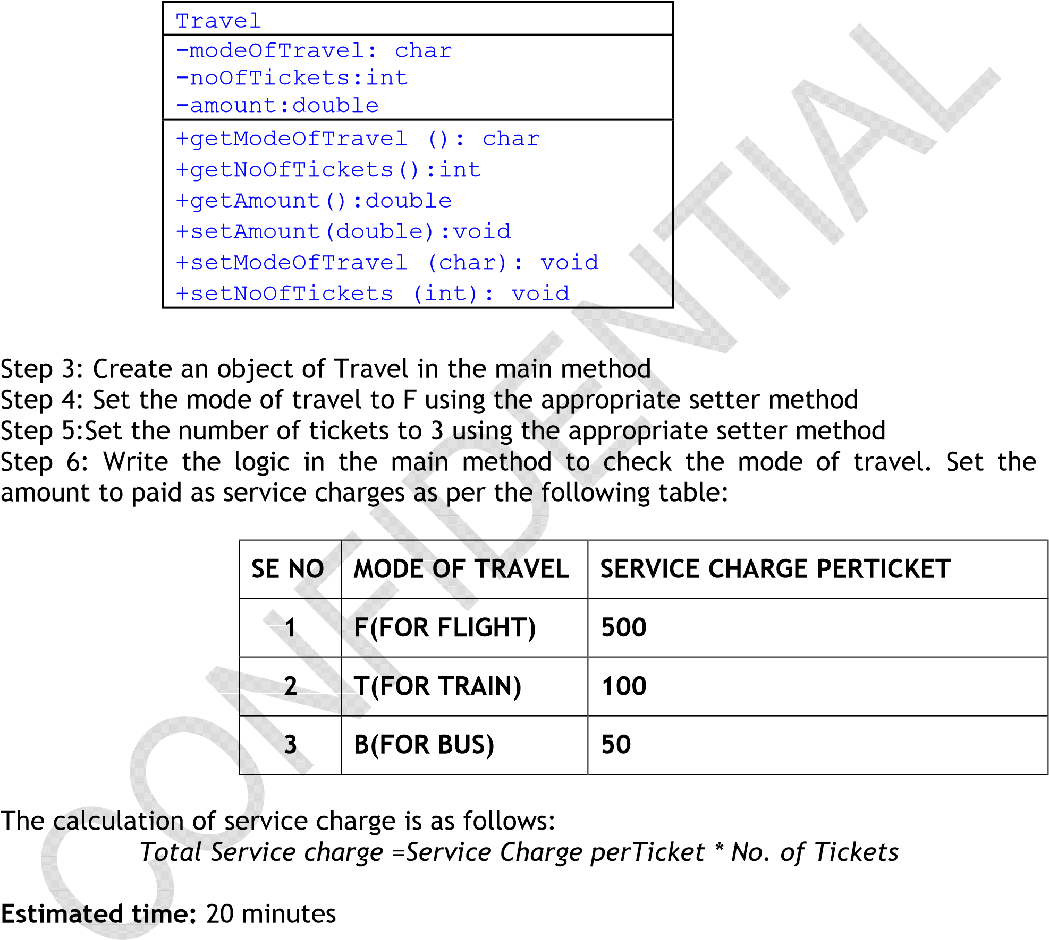

Summary of this assignment:

In this assignment, you have learnt

* If else conditional statements

Day 3 Assignment 2: Strings

Objective: To understand Strings

Problem Description: To write the autogeneration of the ticket number based on some criterion.

Step 1: Create a class called AutoGenerate with the main() method

Step 2: Write the logic to autogenerate the booking confirmation number as follows:

Format of Booking confirmation number:

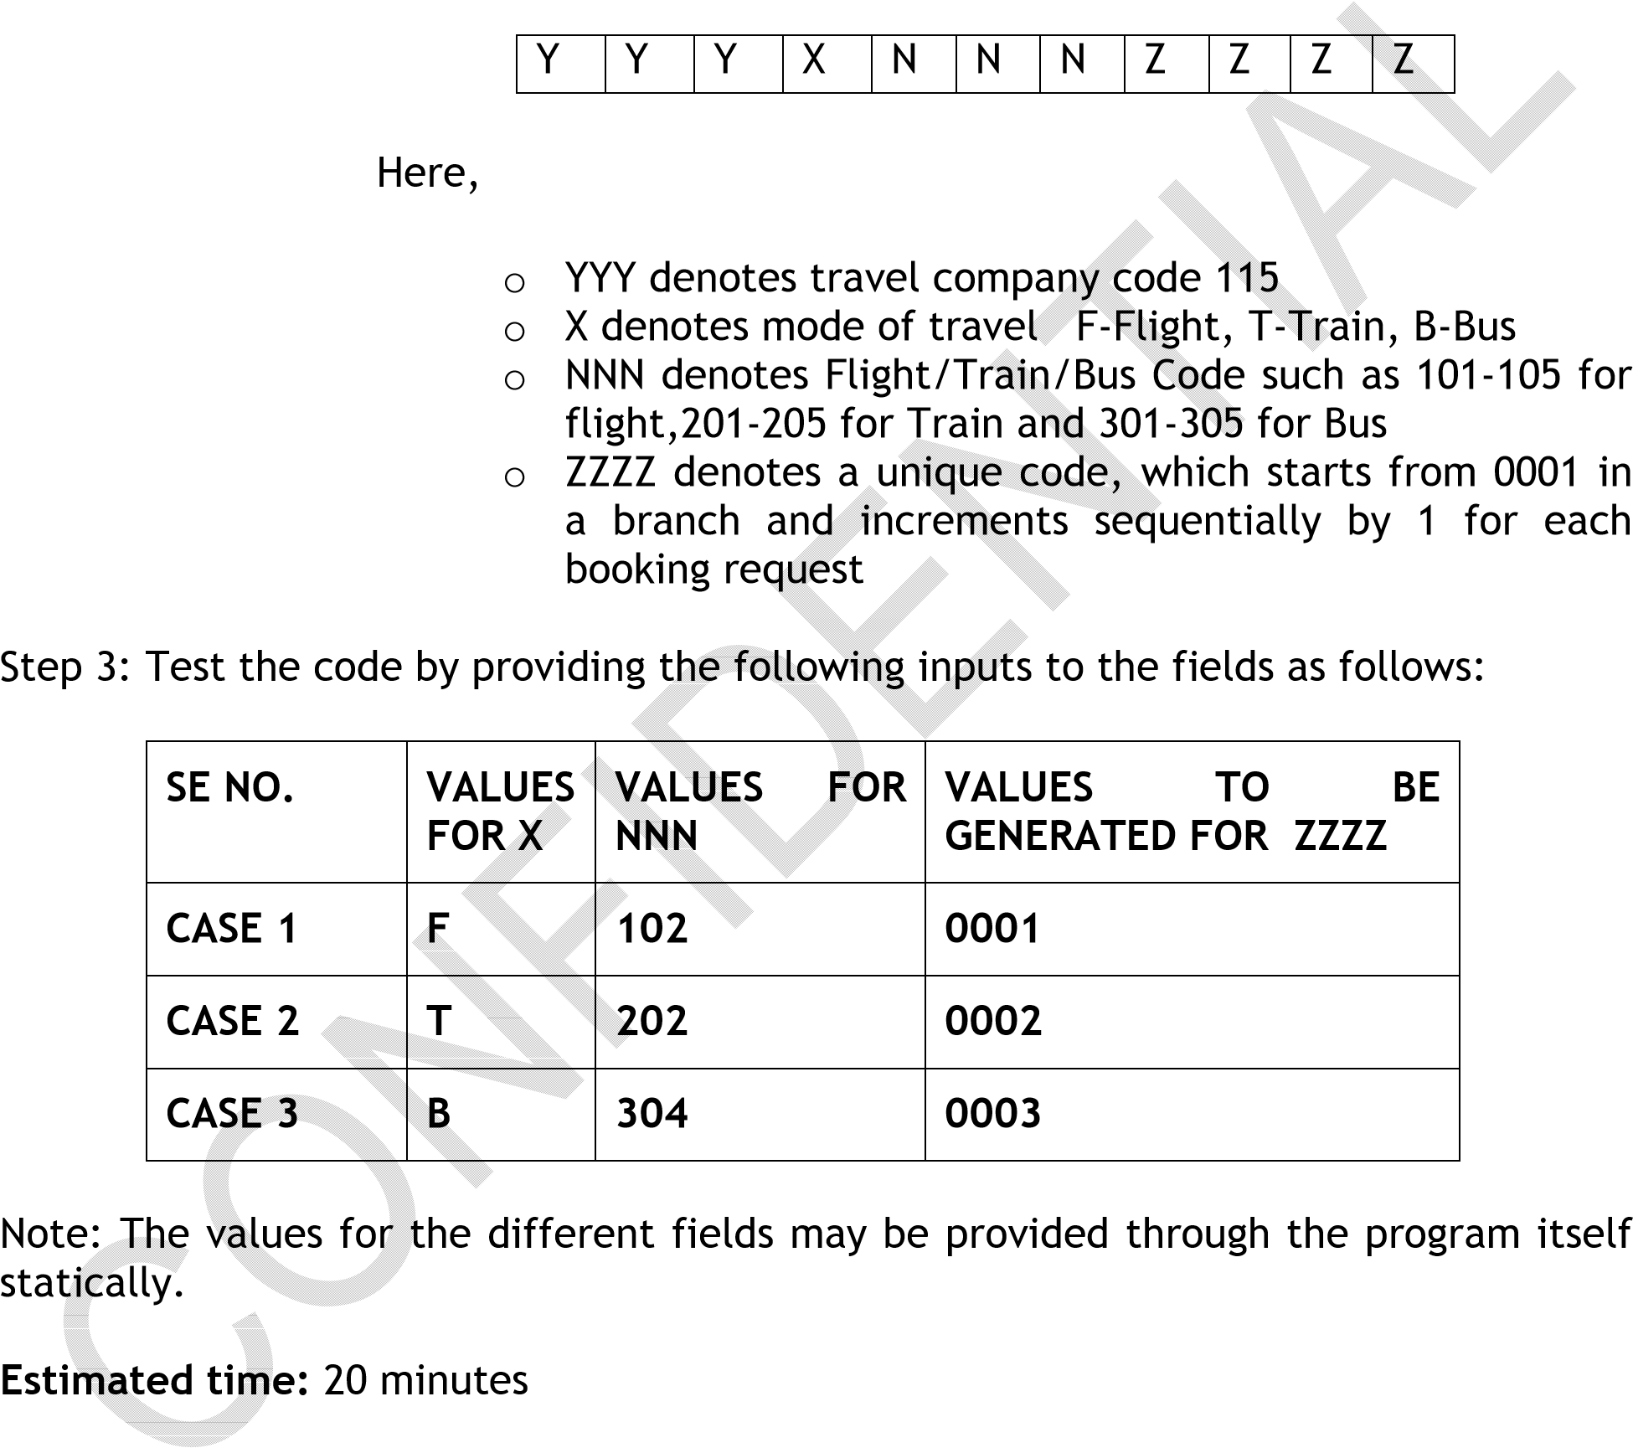

Summary of this assignment:

In this assignment, you have learnt

* If else conditional statements and Strings

Day 4 Assignment 3: Inheritance

Objective: To understand the application of Inheritance concept

Problem Description: To identify situations where Inheritance is to be applied with respect to Intermediate Case study provided.

Scenario 1: A user needs to provide details of the travel. The travel details include mode of travel, source, and destination, date and time, ticket details and travel class type. The type can be

Flight-Economy( less expensive) or Business (upper or executive class)

Train-II Class (less expensive) or I Class(upper or executive class)

Bus – Non-AC (ordinary) or AC (Air Conditioned)

The difference in the travel type amount to the ~~difference in~~ ~~the fares~~ only.

What will be the structure of the class and would Inh~~eritance co~~ncept be applicable to the mentioned scenario?

Scenario 2:

The taxi can be booked for difference kinds of tours. The tours are as follows: o One way travel o One day travel o Package tour (more than one day travel)

The One way travel has a dest~~ination, the~~ charges are calculated based on the number of kilometers multiplied by two. The one day travel consists of starting time, bus number, sight seeing locations and the charge is a lumpsum amount per person. The package tour is a part of the stay in the hotel and contains the locations to be visited, the travel schedule and the number of persons to travel.

What will be the class structure and would inheritance concept be applicable to this scenario?

Estimated time: 20 minutes

Summary of this assignment:

In this assignment, you have learnt

• Inheritance concept and its application